**Table of Contents**

1. **Chapter One: Project Introduction**
   * Introduction
   * Objective and Scope
   * Importance of Detecting and Mitigating Brute Force Attacks
   * Methodology and Approach
   * Business Justification
   * Splunk's Capabilities
   * Project Deliverables
   * Project Timeline
   * Team Composition and Expertise
   * Organizational Impact
2. **Chapter Two: Preparation and Installation of Virtual Machines**
   * System Specifications for All Machines
   * Creating NAT Network in Hyper-V with PowerShell
   * Creating Virtual Machines in Hyper-V
   * Installing All Virtual Machines
   * Enabling Guest Services for Easy File and Text Transfer
3. **Chapter Three: Configuration of Network and Domain Controller**
   * Setting Up Network Configuration, Assign Names on Each Machine
   * Altering Firewall Settings in Machines as Needed
   * Installing Active Directory Domain Services (AD DS) on Windows Server 2019
   * Promoting the Server to a Domain Controller
   * Creating 1000 Random Users Using PowerShell Script in Domain Controller
   * Adding Manually Four Server and Service Users to Domain Controller (Splunk, FTP, SSH, SMB)
   * Adding All Machines to Domain Controller (Excluding Commando VM)
4. **Chapter Four: Setting Up Servers, Splunk Enterprise, and Detection Rules**
   * Installing Splunk Enterprise in Windows Server 2019 Splunk
   * Configuring Splunk Enterprise
   * Installing Universal Forwarder on Each Windows 10 Machine (Except Commando VM)
   * Setting Up Enhanced Session and Group Policy for Domain Users
   * Setting Up Universal Forwarder in Each Windows 10 Machine
   * Testing If All Windows 10 Machines Are Added to Splunk Enterprise
   * Creating Appropriate Query for Detecting Brute Force Attack
   * Creating an Alert Based on This Query
   * Creating Visual Dashboard for Monitoring in Splunk Enterprise
5. **Chapter Five: Executing and Monitoring a Brute Force Attack**
   * Launching Brute Force Attack Using Commando VM
   * Monitoring the Results in the Splunk Enterprise Dashboard
6. **Mitigation**
7. **Personal Growth, Technical Insights, and Future Recommendations**

This structure provides a clear path from initial setup to executing and monitoring the simulated attack. Each chapter details a specific aspect of the process, facilitating a focused, step-by-step approach to the lab.

**Contents**

Chapter 1: Project Introduction 4

1.1. Introduction 4

1.2. Objective and Scope 4

1.3. Importance of Detecting and Mitigating Brute Force Attacks 4

1.4. Methodology and Approach 4

1.5. Business Justification 5

1.6. Splunk's Capabilities 6

1.7. Project Deliverables 6

1.8. Project Timeline 7

1.9. Team Composition and Expertise 8

1.10. Organizational Impact 8

Chapter 2: Preparation and Installation of Virtual Machines 9

1.1. System Specifications for All Machines: 9

1.2. Creating NAT Network in Hyper-V with PowerShell 9

1.3. Creating Virtual Machines in Hyper-V 11

1.4. Installing All Virtual Machines 14

1.5. Enabling Guest Services for Easy File and Text Transfer 16

Chapter 3: Network Configuration and Domain Controller Setup 18

1.1. Setting Up Network Configuration and Assigning Names on Each Machine 18

1.2. Altering Firewall Settings in Machines as Needed 21

1.3. Installing Active Directory Domain Services (AD DS) on Windows Server 2019 DC 25

1.4. Promoting the Server to a Domain Controller 27

1.5. Adding All Machines to Domain Controller (Excluding Commando VM) 30

1.6. Shutting Down All Machines and Taking Checkpoints for Each Machine 33

1.7. Creating 1000 Random Users Using PowerShell Script in Domain Controller 36

1.8. Adding Manually Four Server and Service Users to Domain Controller (Splunk, FTP, SSH, SMB) 38

Chapter 4: Setting Up Servers, Splunk Enterprise, and Detection Rules 42

1.1. Installing and Configuring FTP, SSH, SMB on Appropriate Windows Machines: 42

1.2. Installing Splunk Enterprise in Windows Server 2019 Splunk: 62

1.3. Configuring User Permissions and Access in Windows Server 2019 Splunk 67

1.4. Installing Universal Forwarder on Each Windows 10 Machine (Except Commando VM): 69

1.5. Setting Up Enhanced Session and Group Policy for Domain Users 74

1.6. Change the time zone of machines to Coordinated Universal Time (UTC), follow these steps: 79

1.7. Setting Up Universal Forwarder in Each Windows 10 Machine: 79

1.8. Installing Commando VM in the Windows 10 21H1 Commando VM machine. 96

1.9. Creating Appropriate Query for Detecting Brute Force Attack: 104

1.10. Creating Visual Dashboard for Monitoring in Splunk Enterprise: 109

1.11. Step-by-step guide on how to customize and enhance your Splunk dashboard: 116

Chapter 5: Executing and Monitoring a Brute Force Attack 121

1.1. Launching Brute Force Attack Using Commando VM 121

1.2. Monitoring the Results in the Splunk Enterprise Dashboard: 122

Chapter 6: Mitigation 124

1.3. Mitigating brute force attacks on a Splunk 124

1.4. Implementing Strong Password Policies: 124

1.5. Enforcing Multi-Factor Authentication (MFA): 125

1.6. Implementing Account Lockout Policies: 125

1.7. Monitoring and Alerting: 126

1.8. Regular Patching and Updates: 126

1.9. Employee Education and Awareness: 127

Chapter 7: Personal Growth, Technical Insights, and Future Recommendations 128

1.1. Literature Review and References 128

1.2. Project Plan Reflection 129

1.3. Personal Learnings and Experiences 130

# Chapter 1: Project Introduction

## Introduction

The objective of this project was to develop a detection mechanism for brute force attacks using Splunk, a powerful security information and event management (SIEM) platform. The scope of the project focused specifically on identifying and mitigating brute force attacks against user accounts and passwords within an Active Directory Domain Services (AD DS) environment.

## Objective and Scope

Brute force attacks are one of the most common methods used by attackers to gain unauthorized access to systems and sensitive data. By systematically attempting multiple combinations of usernames and passwords, attackers exploit weak credentials and security vulnerabilities. The consequences of successful brute force attacks can be severe, including unauthorized access, data breaches, and compromised user accounts.

The primary objective of this project was to enhance the security posture of the organization by developing an effective detection mechanism for brute force attacks within the AD DS environment. The focus was on quickly identifying and mitigating such attacks to prevent unauthorized access to user accounts and passwords.

## Importance of Detecting and Mitigating Brute Force Attacks

In an AD DS environment, where user accounts and passwords play a vital role in granting access to resources, detecting and mitigating brute force attacks is of paramount importance. The AD DS infrastructure forms the backbone of user authentication and authorization, making it a prime target for attackers seeking to exploit weak credentials.

By effectively detecting and responding to brute force attacks, organizations can mitigate the risks associated with compromised user accounts, unauthorized access, and potential data breaches. Timely detection allows security teams to identify and neutralize attacks before they cause significant damage, protecting the organization's sensitive data, intellectual property, and reputation.

## Methodology and Approach

To achieve the project objective, a systematic and comprehensive approach was adopted. The methodology involved the following key steps:

* Environment Setup: A fully featured AD DS environment was created, including the deployment of domain controllers, user accounts, and associated policies. This environment closely resembled a real-world scenario, ensuring the validity and accuracy of the project findings.
* SIEM Deployment: A centralized SIEM server was deployed, leveraging the capabilities of Splunk. The SIEM server acted as a central hub for collecting and analyzing logs from various endpoints within the AD DS environment.
* Brute Force Attack Simulations: Various types of brute force attacks were simulated against the AD DS environment, targeting user accounts and passwords. These simulated attacks represented common techniques used by attackers and helped evaluate the effectiveness of the detection mechanism.
* EventID Identification: Through extensive analysis of the generated logs, specific EventIDs associated with brute force attacks were identified. These EventIDs served as indicators of compromise and formed the basis for detection and alert generation in Splunk.
* Detection Mechanism and Alert Generation: Using Splunk, a detection mechanism was implemented to identify and correlate the identified EventIDs in real-time. Custom alert rules and dashboards were created to promptly notify security personnel of potential brute force attacks, allowing them to initiate appropriate response measures.
* Verification and Mitigation: The effectiveness of the detection mechanism was verified by conducting additional brute force attack simulations and assessing the system's ability to detect and respond to them. Mitigation measures, such as account lockouts, password complexity policies, and multi-factor authentication, were recommended to enhance the security posture and resilience against brute force attacks.

## Business Justification

Recent security incidents and industry trends highlight the increasing threat of brute force attacks, emphasizing the need for organizations to strengthen their security measures and proactively detect and mitigate such attacks. In the past year, there have been several high-profile data breaches where attackers gained unauthorized access to systems through brute force attacks on user accounts and passwords. These incidents have resulted in significant financial losses, reputational damage, and legal repercussions for the affected organizations.

Industry reports and studies also indicate a rise in the frequency and sophistication of brute force attacks. Attackers are leveraging automated tools and compromised credentials obtained from data breaches to launch large-scale and persistent attacks against organizations. These attacks target various sectors, including finance, healthcare, government, and retail, underscoring the widespread impact and universal applicability of this threat.

Given this landscape, organizations must take proactive measures to detect and mitigate brute force attacks effectively. By doing so, they can protect their sensitive data, maintain customer trust, and avoid the financial and legal implications of data breaches. This project addresses the urgent need to develop a robust detection mechanism using Splunk to enhance the organization's security posture and resilience against brute force attacks.

## Splunk's Capabilities

Splunk is a leading SIEM platform that offers powerful capabilities for detecting and responding to security incidents, including brute force attacks. Its key features include:

1. **Log Collection**: Splunk can collect logs from various sources, including network devices, servers, and applications, allowing comprehensive monitoring and analysis of events within the AD DS environment.
2. **Log Analysis:** Splunk's advanced analytics capabilities enable the detection of patterns and anomalies in log data. This helps in identifying indicators of compromise associated with brute force attacks, such as repeated failed login attempts or unusual login behavior.
3. **Visualization:** Splunk provides interactive and customizable dashboards, visualizations, and reports that allow security teams to gain real-time insights into the security posture of the AD DS environment. This facilitates rapid identification and response to potential brute force attacks.
4. **Custom Alerts and Correlation**: Splunk allows the creation of custom alert rules that trigger notifications when specific EventIDs associated with brute force attacks are detected. This enables security teams to promptly respond to potential threats and take appropriate mitigation actions.

The robustness and flexibility of Splunk as a SIEM platform make it an ideal choice for developing a detection mechanism tailored to the organization's AD DS environment and its unique security requirements.

## Project Deliverables

The project aimed to deliver the following key deliverables:

* Identification of Relevant EventIDs: Through extensive analysis of log data, the project identified specific EventIDs associated with brute force attacks in the AD DS environment. These EventIDs serve as critical indicators for detecting and alerting potential brute force attacks.
* Custom Alert Rules: Custom alert rules were developed and implemented in Splunk, enabling real-time detection and notification of brute force attacks. These rules trigger alerts based on the identified EventIDs and other relevant log patterns, ensuring timely incident response.
* Dashboards for Real-time Monitoring: Customized dashboards were created in Splunk to provide a centralized view of the AD DS environment's security status. These dashboards present visualizations and metrics that allow security teams to monitor and track potential brute force attacks in real-time.
* By delivering these outcomes, the project establishes a comprehensive detection mechanism using Splunk, empowering organizations to proactively identify and respond to brute force attacks in their AD DS environment.

**System Architecture Diagram**

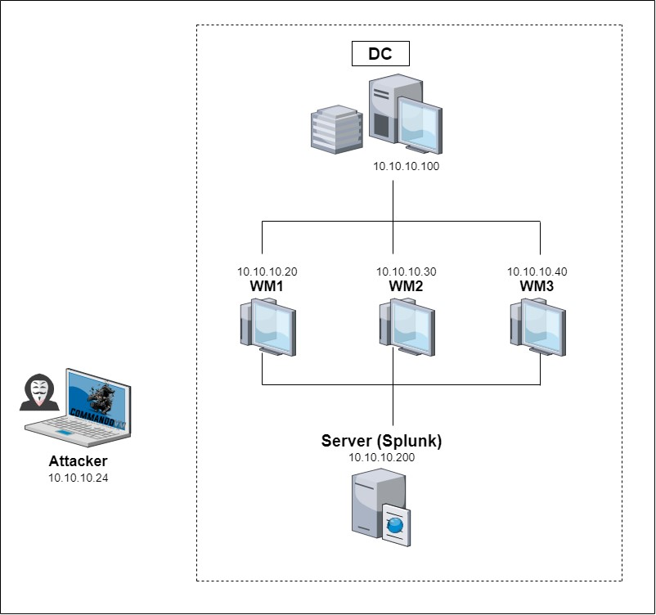

## Project Timeline

The project was executed over a period of 15 days, following a phased approach:

1. **Phase 1:** Environment Setup - Setting up the AD DS infrastructure and configuring the Splunk SIEM server.
2. **Phase 2:** Brute Force Attack Simulations - Conducting simulated brute force attacks against the AD DS environment to evaluate the detection mechanism.
3. **Phase 3**: EventID Identification and Alert Generation - Analyzing the generated logs to identify relevant EventIDs associated with brute force attacks and configuring custom alert rules in Splunk.
4. **Phase 4:** Verification and Mitigation - Verifying the effectiveness of the detection mechanism by conducting additional brute force attack simulations and evaluating the system's response. Recommending and implementing mitigation measures to enhance the organization's security.

The project timeline was carefully planned to ensure thorough testing, validation, and refinement of the detection mechanism, ultimately delivering a reliable and effective solution.

## Team Composition and Expertise

The project team consisted of highly skilled professionals with expertise in cybersecurity and system administration. The team members listed below:

* Agil Safarov
* Farid Dunyamaliyev (PM)
* Fuad Rajabov
* Gunduz Salimli
* Rafayil Hajiyev
* Tural Yarmammadov

Group members brought in-depth knowledge of various attack vectors, including brute force attacks, and possessed experience in designing and implementing robust security measures. These professionals had extensive experience in configuring and managing AD DS environments, ensuring the project's technical feasibility and alignment with industry best practices. They successfully managed to configure the SIEM platform, creating custom alert rules, and developing the dashboards for real-time monitoring. The diverse skill sets and collective knowledge of the team played a crucial role in the successful implementation of the detection mechanism using Splunk.

## Organizational Impact

The potential impact of the project on the organization is significant. The detection mechanism developed using Splunk equips the organization with the capability to:

* **Enhance Security Posture:** By proactively detecting and mitigating brute force attacks, the organization can strengthen its security posture, reducing the risk of unauthorized access to sensitive systems and data.
* **Prevent Data Breaches:** Swift detection and response to brute force attacks reduce the likelihood of successful data breaches, safeguarding the organization's confidential information and protecting its reputation.
* **Maintain Regulatory Compliance:** Implementing effective detection mechanisms aligns the organization with regulatory requirements and industry standards, ensuring the protection of customer data and meeting compliance obligations.
* **Reduce Financial Losses:** By mitigating the risk of brute force attacks, the organization can avoid financial losses associated with data breaches, including potential fines, legal costs, and reputational damage.

Overall, the project's outcomes have far-reaching implications for the organization, enabling it to proactively defend against brute force attacks, protect critical assets, and maintain a robust security posture in the face of evolving cyber threats.

# Chapter 2: Preparation and Installation of Virtual Machines

## System Specifications for All Machines:

Ensure that each system involved in the lab meets the following specifications and is connected to the Capstone NAT network (10.10.10.0/24):

1. **Domain Controller (Windows Server 2019):**
   * **CPUs:** 2 CPUs.
   * **RAM:** 2048 MB (2GB).
   * **Disk Space:** 40 GB.
   * **Hyper-V Virtual Machine:** Generation 1.
   * **Network Connection:** Connected to the Capstone NAT network.
2. **Splunk Machine (Windows Server 2019):**
   * **CPUs:** 4 CPUs.
   * **RAM:** 8 GB.
   * **Disk Space:** 40 GB.
   * **Hyper-V Virtual Machine:** Generation 1.
   * **Network Connection:** Connected to the Capstone NAT network.
3. **Windows 10 Machines (3):**
   * **CPUs:** 2 CPUs each.
   * **RAM:** 2048 MB (2GB) each.
   * **Disk Space:** 40 GB each.
   * **Hyper-V Virtual Machine:** Generation 1.
   * **Network Connection:** Each machine is connected to the Capstone NAT network.
4. **Commando VM Machine (Windows 10 21H1):**
   * **CPUs:** 2 CPUs.
   * **RAM:** 4+ GB.
   * **Disk Space:** 80+ GB.
   * **Network Connection:** Initially, select the Default Switch during Commando VM installation. After installation, change this to the Capstone NAT network.

## Creating NAT Network in Hyper-V with PowerShell

Use PowerShell to configure the NAT network within your Virtual Machine (VM). Set the network address to 10.10.10.0/24, with all machines to be included in this network. In the below you can see the steps for creating NAT network:

1. **Step 1:** Create an Internal Virtual Switch

* New-VMSwitch -Name Capstone -SwitchType Internal

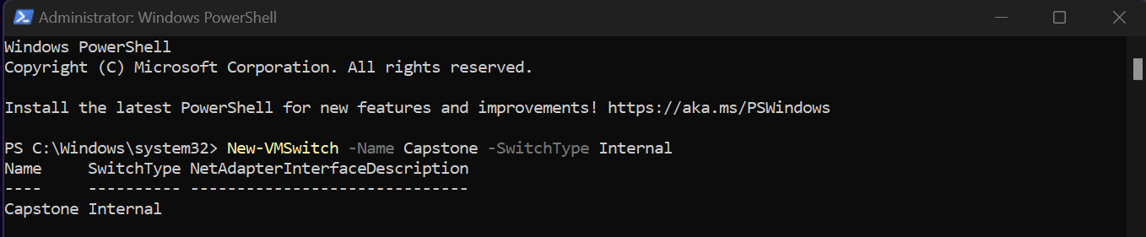

1. **Step 2:** Get the Interface Index Number (ifIndex)

* Get-NetAdapter -Name *Capstone*

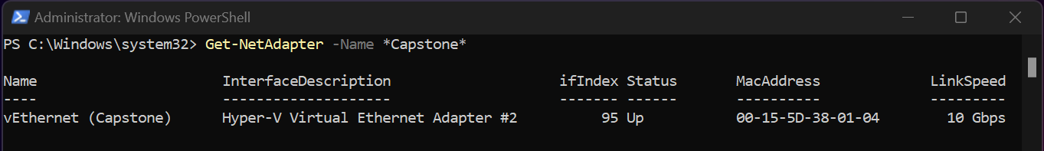

1. **Step 3:** Configure NAT Gateway

* New-NetIPAddress –IPAddress 10.10.10.1 -PrefixLength 24 -InterfaceIndex YourIfIndex

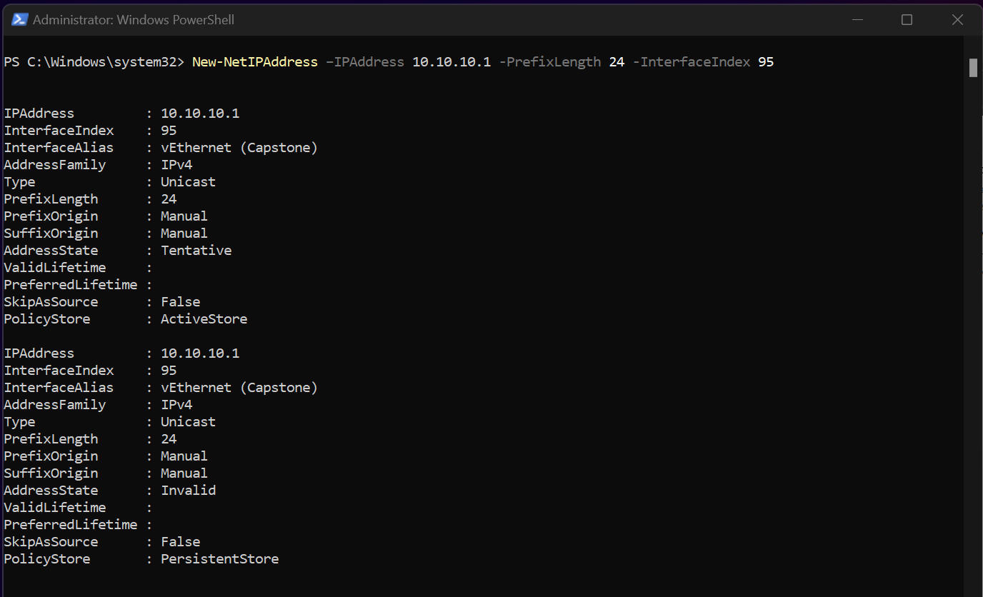

1. **Step 4:** Configure NAT Network

* New-NetNat -Name Nat-Switch-Outside -InternalIPInterfaceAddressPrefix 10.10.10.0/24

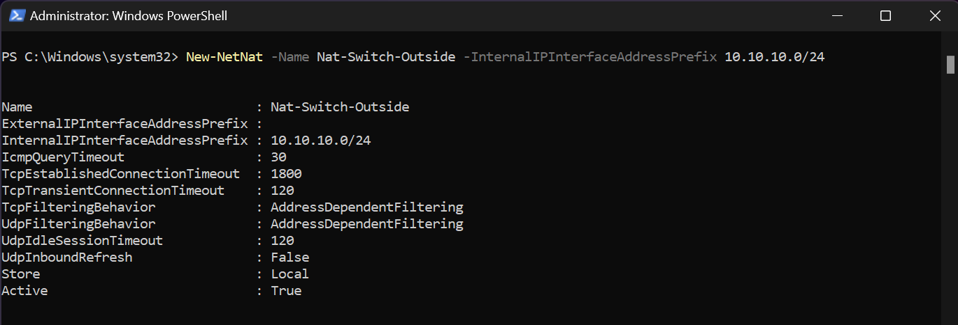

## Creating Virtual Machines in Hyper-V

**Creating Virtual Machines in Hyper-V**

In this step, we'll illustrate how to create a virtual machine for Windows Server 2019 DC in Hyper-V. The process for creating the other virtual machines will be the same, however, do pay attention to the specific system specifications required for each machine.

* Open Hyper-V Manager.
* Click on "New" and then "Virtual Machine".

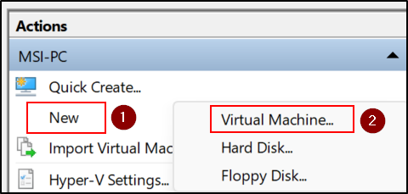

* In the Wizard that opens, click Next.
* Enter a name for the virtual machine, for example, "Windows Server 2019 DC".

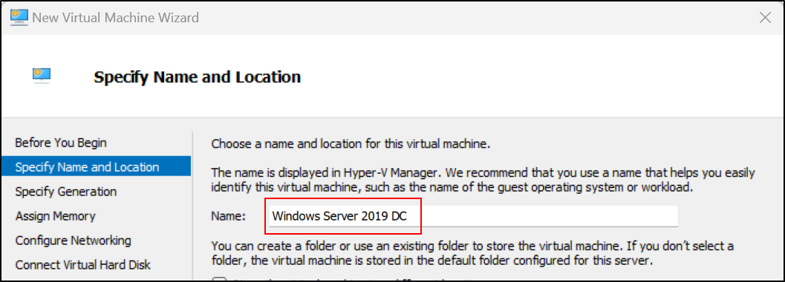

* Select "Generation 1" and click Next.

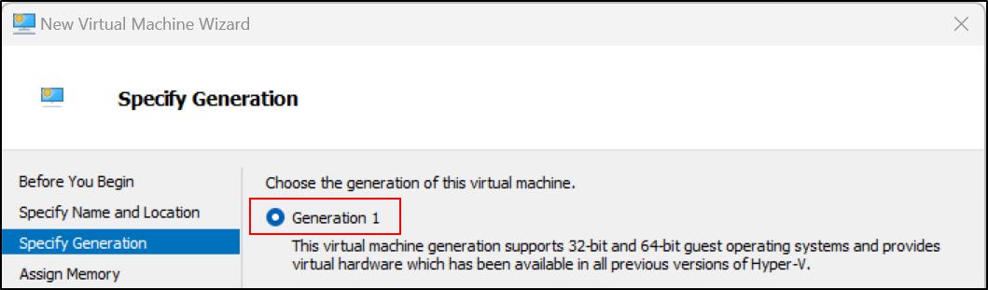

* Assign memory according to the recommended specifications (2048 MB for the DC machine).

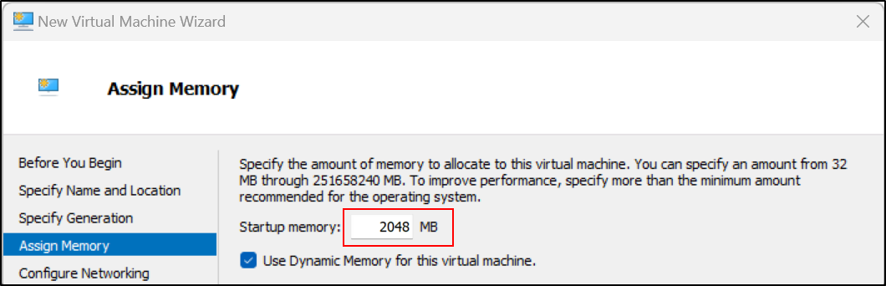

* Connect it to the previously created NAT network (Capstone).

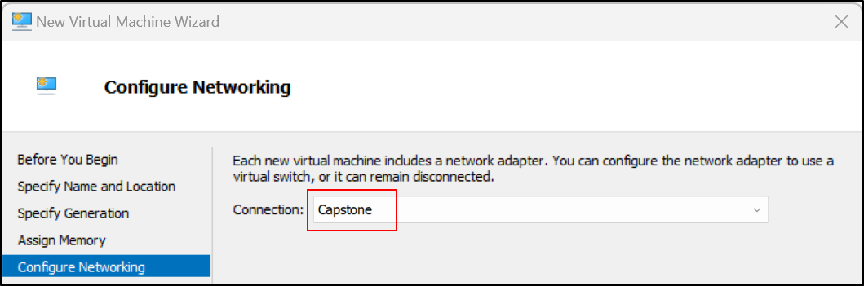

* Create a virtual hard disk and set its size (40 GB for the DC machine).

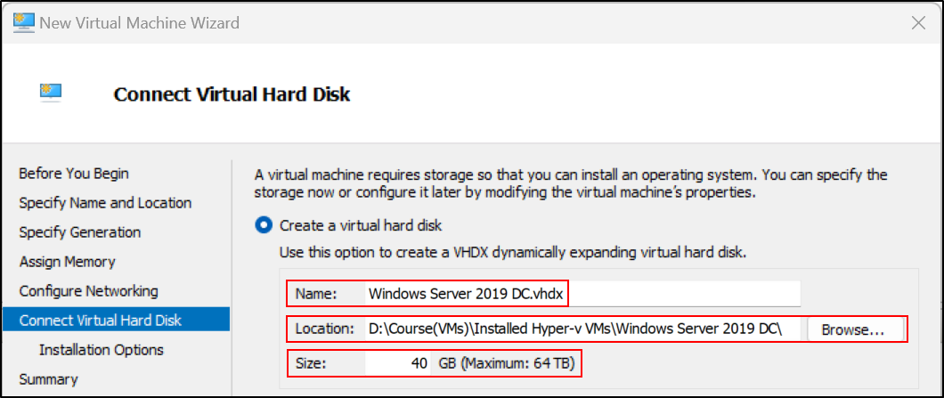

* Install the OS from an ISO file, select the path to the ISO file for Windows Server

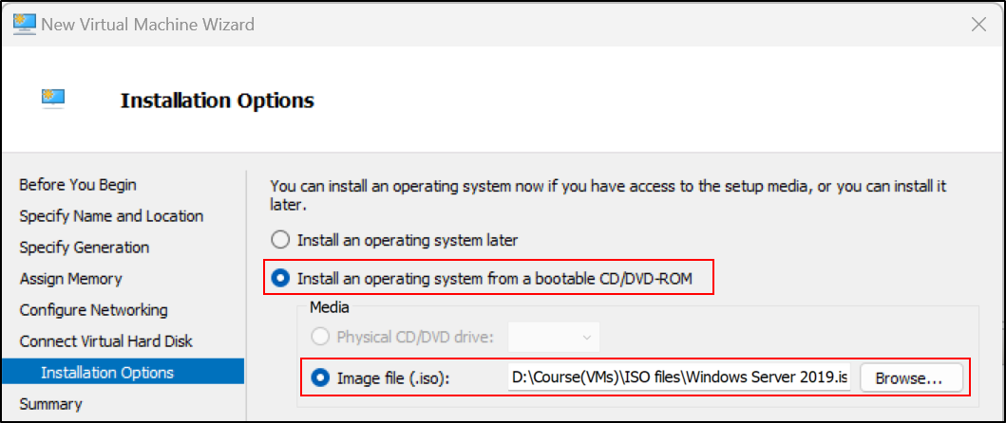

* Complete the Wizard, then the virtual machine will be created.

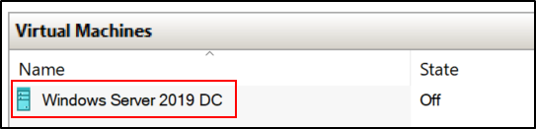

After the virtual machine is created, right-click on the machine name in the Hyper-V Manager and select "Settings". In the Processor section, you can adjust the number of virtual processors according to the system specifications for each machine.

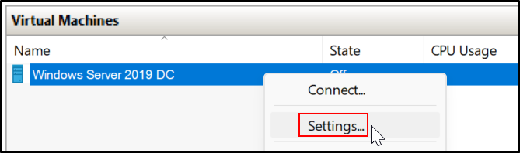

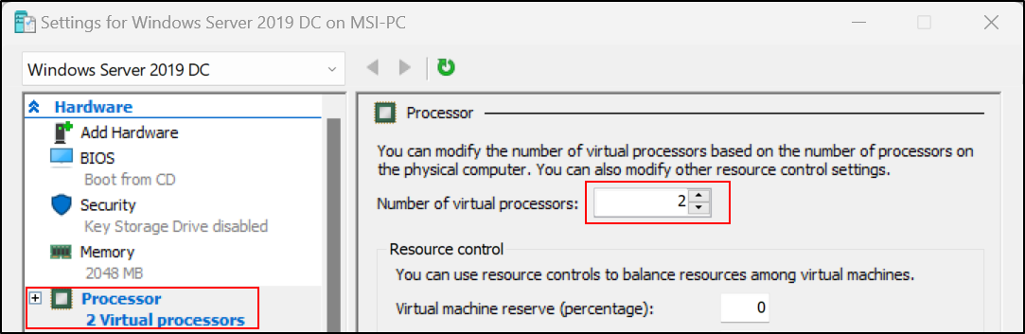

Repeat this process for each of the other machines: the Splunk server, the three Windows 10 machines, and the Commando VM. However, when creating these, ensure you match the system specifications as mentioned earlier in the chapter.

When all virtual machines are created, the Hyper-V Manager should look something like this:

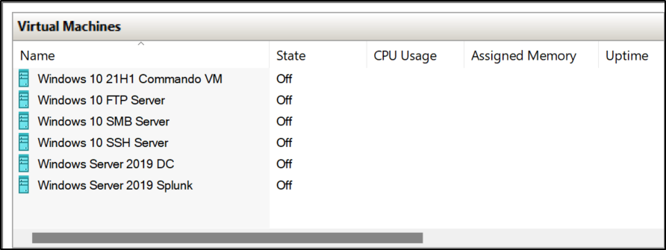

## Installing All Virtual Machines

This section covers the basic installation process for all virtual machines. Keep in mind, when installing Windows Server 2019, you should choose "Windows Server 2019 Datacenter Evaluation (Desktop Experience)". When installing Windows 10, select "Windows 10 Pro".

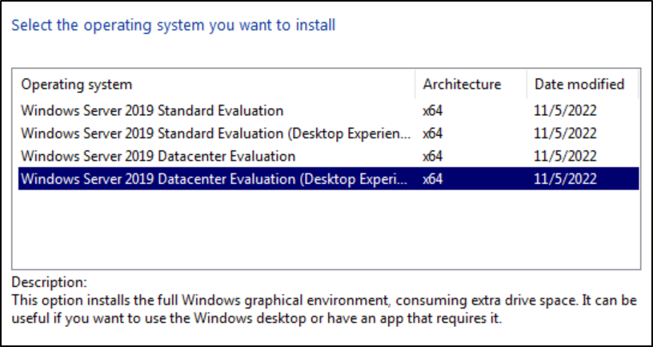

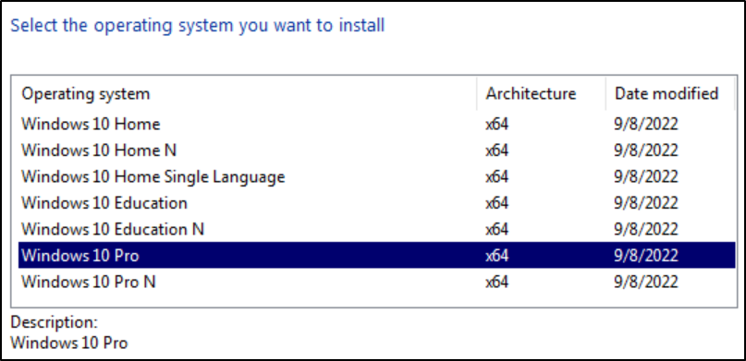

During the installation process, you'll be asked to create a new user. Name these users appropriately as listed below:

* Windows Server 2019 DC and Windows Server 2019 Splunk: Default unchangeable username – "Administrator"
* Windows 10 FTP Server: Username – "FTPLocalAdmin"
* Windows 10 SSH Server: Username – "SSHLocalAdmin"
* Windows 10 SMB Server: Username – "SMBLocalAdmin"
* Windows 10 21H1 Commando VM – Username: "Commando-VM"

Use "**Pa$$word**" as the password for all these users.

Proceed with the rest of the installation process, and repeat these steps for each virtual machine, remembering to change the username as needed.

After installation is complete, each machine is ready for the next phase of setup and configuration.

## Enabling Guest Services for Easy File and Text Transfer

Before you proceed to Chapter 3, it is recommended to enable the Guest Services feature on each of your machines. This will simplify the process of transferring files and text between the host and the virtual machines.

When transferring files between the host machine and your virtual machines, please note that you must use the copy and paste method. The drag and drop functionality is not supported for file transfers in this setup.

Here's how to enable Guest Services:

* In Hyper-V Manager, right-click on the virtual machine you want to configure.
* Click on "Settings".

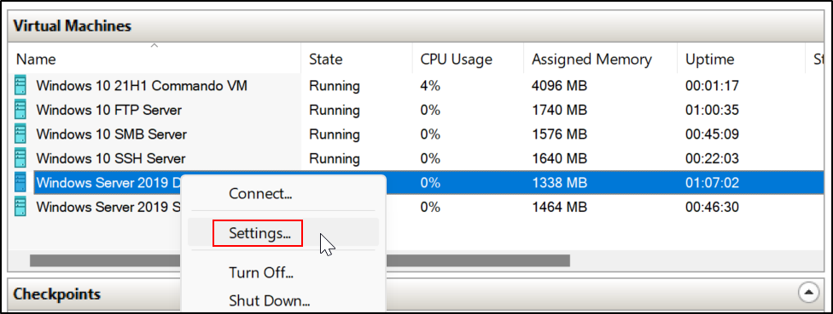

* In the left pane, click on "Integration Services" under the "Management" section.
* In the right pane, check the box for "Guest services".

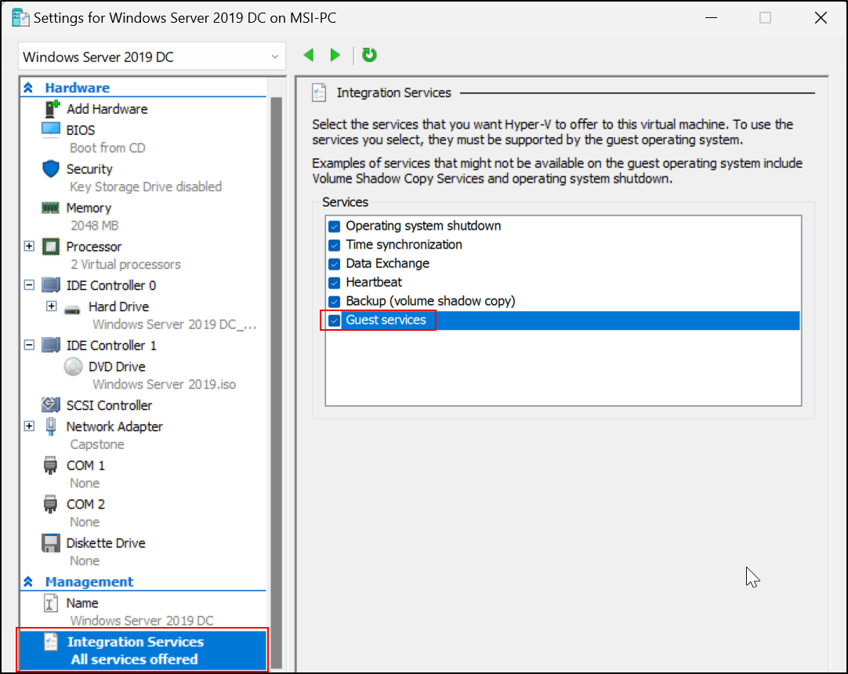

* Click "OK" to save the changes.

If you want to take advantage of these features, you'll need to have Enhanced Session Mode enabled.

Remember, this change can be made while the virtual machines are running; there is no need to turn off the machines.

Once Guest Services are enabled, you can now proceed to Chapter Two. Keep in mind that enabling Guest Services enhances the interactive management of the VMs, allowing for operations such as the copy and paste of files and text, which can be especially useful throughout the setup and configuration process.

# Chapter 3: Network Configuration and Domain Controller Setup

## Setting Up Network Configuration and Assigning Names on Each Machine

After installing the operating systems, the next step is to set up the network configuration and assign names for each machine. This includes setting up the IP configuration, DNS settings, and adjusting firewall settings as required.

Here are the paths to adjust the network configuration (IPv4) in Windows Server 2019 and Windows 10:

1. Right-click on the network icon in the system tray at the bottom-right corner of your screen, then click "Open Network & Internet settings".
2. Click "Change adapter options".
3. Right-click on the network interface that you want to configure, then click "Properties".
4. Click "Internet Protocol Version 4 (TCP/IPv4)", then click the "Properties" button.
5. In the Internet Protocol Version 4 (TCP/IPv4) Properties window, select the "Use the following IP address" option, then enter the desired IP address, Subnet mask, and Default gateway.
6. In the "Use the following DNS server addresses" option, enter the desired Preferred DNS server and Alternate DNS server.
7. Click "OK" to save the changes, then click "Close" to close the network interface properties window.

Configure the IP addresses, subnet masks, default gateways, and DNS servers for each of your virtual machines as follows:

|  |  |  |  |  |  |
| --- | --- | --- | --- | --- | --- |
| **Machine Name** | **IP Address** | **Subnet Mask** | **Default Gateway** | **Preferred DNS Server** | **Alternate DNS Server** |
| **Windows Server 2019 DC** | 10.10.10.10 | 255.255.255.0 | 10.10.10.1 | 8.8.8.8 | - |
| **Windows Server 2019 Splunk** | 10.10.10.20 | 255.255.255.0 | 10.10.10.1 | 10.10.10.10 | 8.8.8.8 |
| **Windows 10 FTP Server** | 10.10.10.11 | 255.255.255.0 | 10.10.10.1 | 10.10.10.10 | 8.8.8.8 |
| **Windows 10 SSH Server** | 10.10.10.12 | 255.255.255.0 | 10.10.10.1 | 10.10.10.10 | 8.8.8.8 |
| **Windows 10 SMB Server** | 10.10.10.13 | 255.255.255.0 | 10.10.10.1 | 10.10.10.10 | 8.8.8.8 |
| **Windows 10 21H1 Commando VM\*** | 10.10.10.100 | 255.255.255.0 | 10.10.10.1 | 8.8.8.8 | - |

*Network configuration for the Commando VM should be set after switching from the default switch to the Capstone NAT.

By following these configurations, each machine should be properly set up for communication within your network.

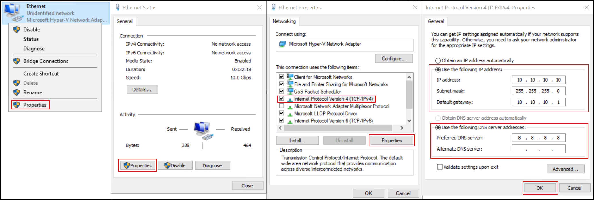

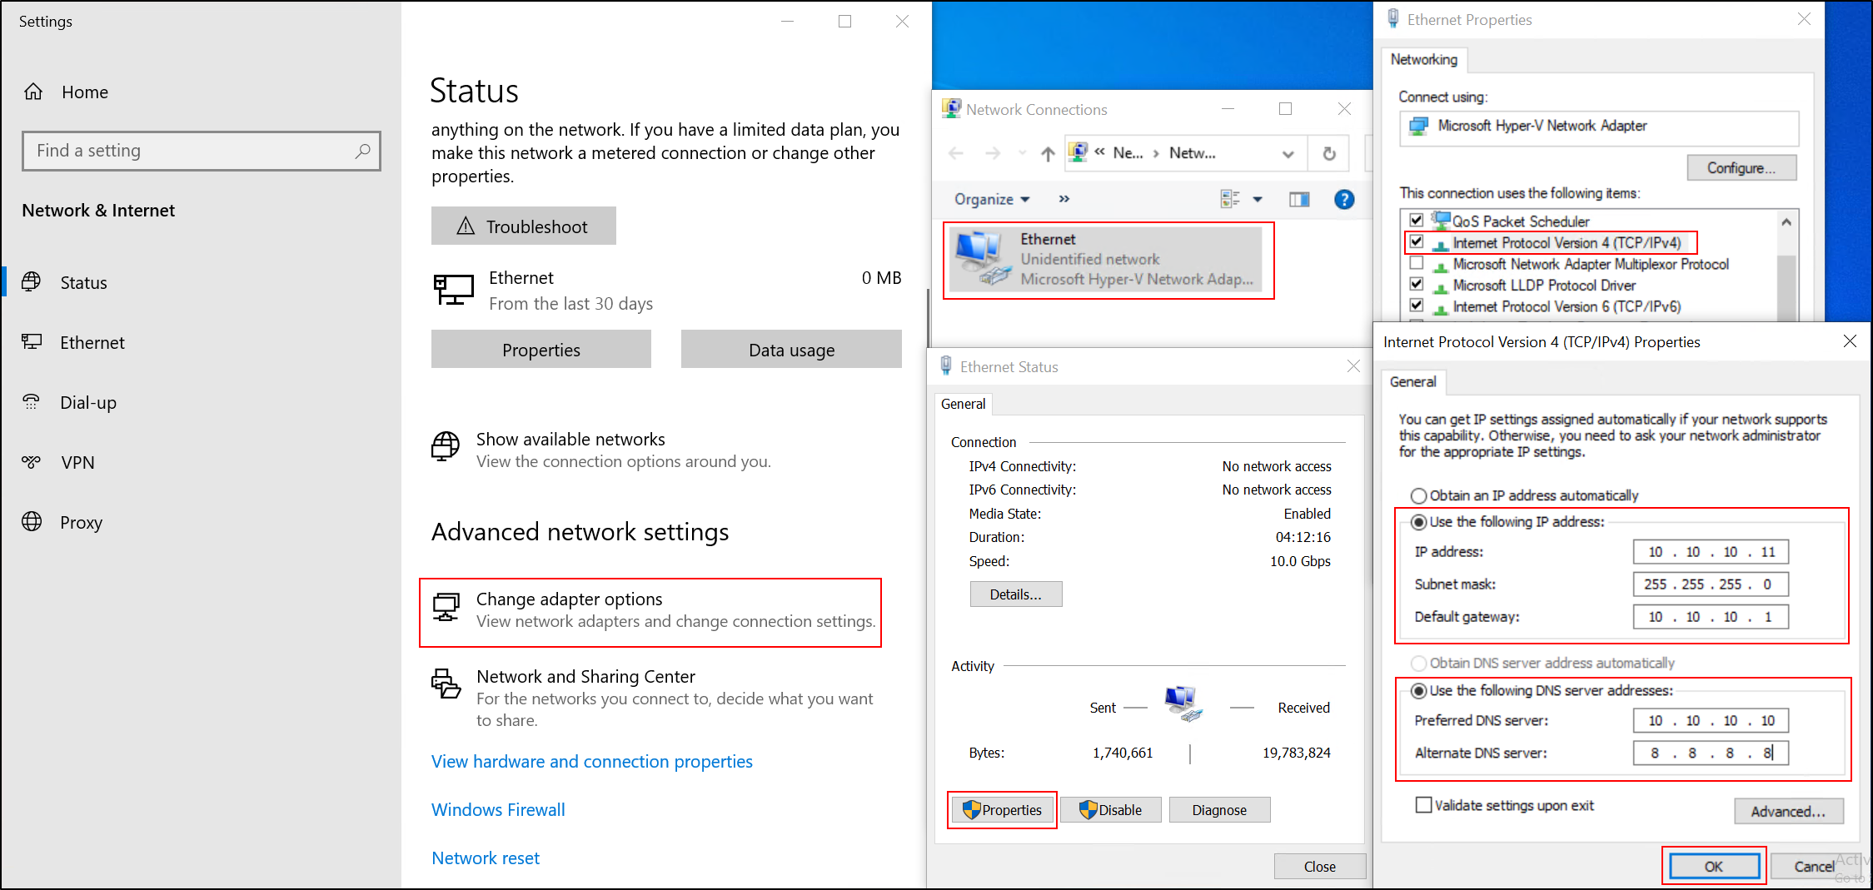

Additionally, you may want to install a web browser that you are comfortable using on the Windows Server 2019. To do this, you will first need to disable the Internet Explorer Enhanced Security Configuration. Here's how:

* Open Server Manager.
* On the Server Manager dashboard, click on "Local Server".
* In the Properties pane, locate "IE Enhanced Security Configuration" and click on "On" next to it.
* In the window that appears, set the option to "Off" for both Administrators and Users.
* Click "OK" to save the changes.

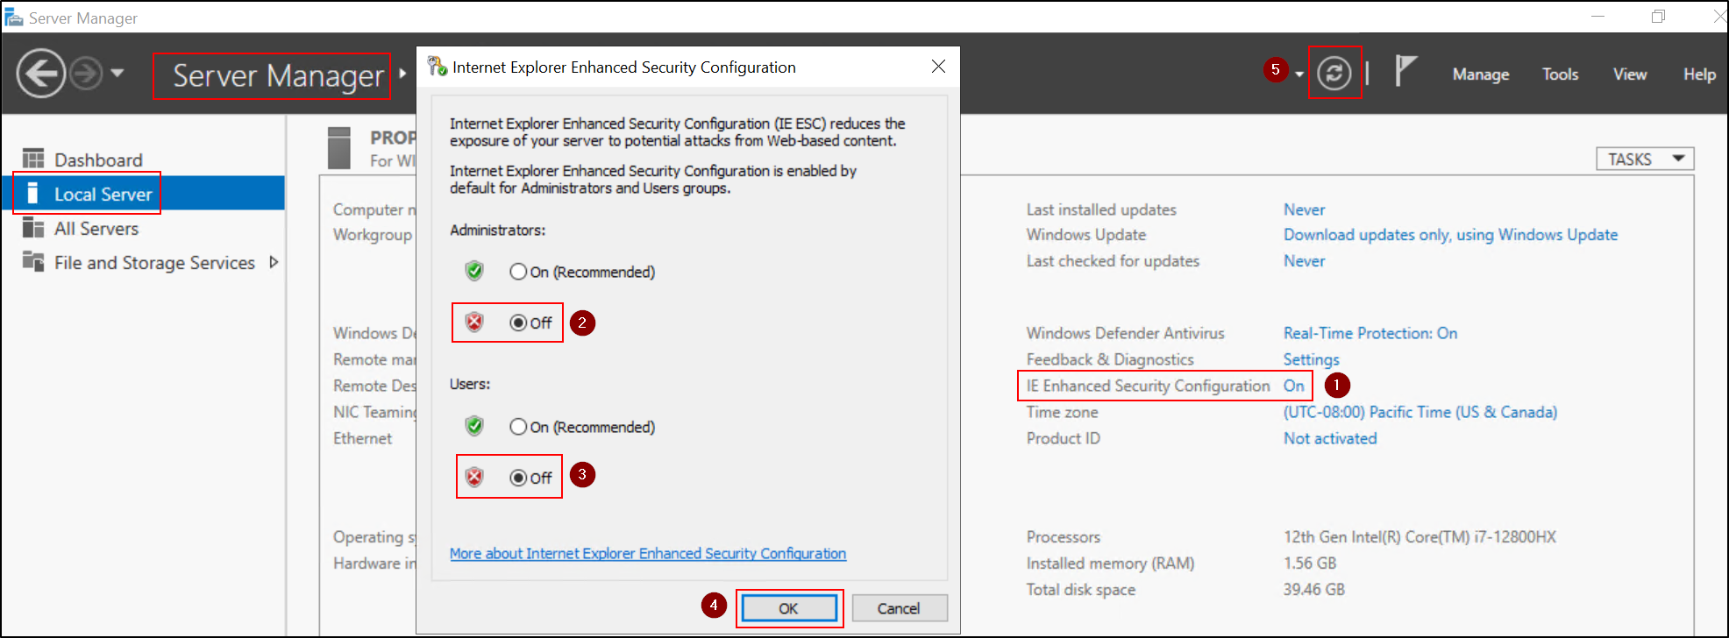

Assigning appropriate names to each machine is an important part of your setup process. Here's how to do it:  
  
For Windows Server 2019:

1. Open Server Manager. You can do this by clicking on the Server Manager icon on the taskbar, or searching for it in the Start menu.
2. In Server Manager, click on 'Local Server' on the left pane.
3. On the 'Local Server' page, next to 'Computer name', click on the current name. This will open the 'System Properties' window.
4. In the 'System Properties' window, click on 'Change...'.
5. Enter the new name for the server in the 'Computer name' field and click 'OK'.
6. You will need to restart the server for the changes to take effect.

For Windows 10:

1. Right-click on the 'Start' button and click on 'System'. This directly opens the 'About' page.
2. Under 'Device specifications', next to 'Device name', click on 'Rename this PC'.
3. Enter the new name for the PC and click 'Next'.
4. You will need to restart the PC for the changes to take effect.

Please use the following names when naming your machines:

* **Windows Server 2019 DC:** DC
* **Windows Server 2019 Splunk:** SPLUNK
* **Windows 10 FTP Server:** FTP
* **Windows 10 SSH Server:** SSH
* **Windows 10 SMB Server:** SMB
* **Windows 10 21H1 Commando VM:** COMMANDO

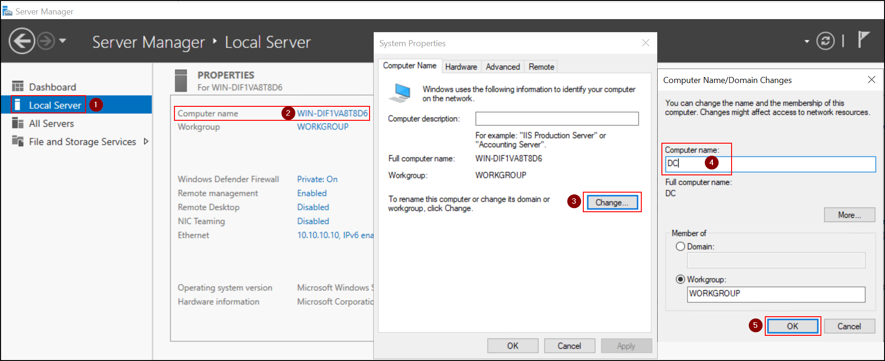

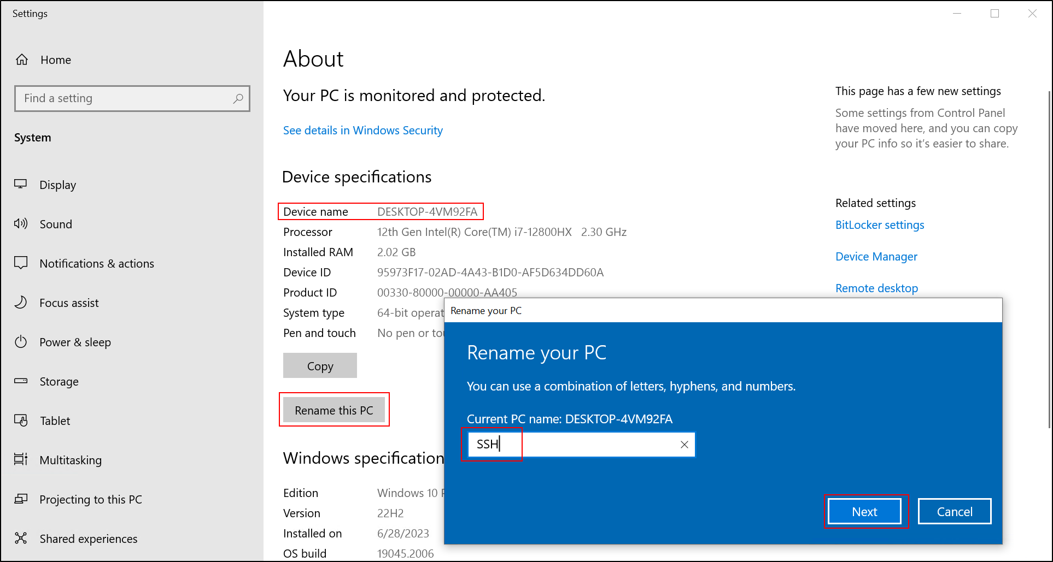

## Altering Firewall Settings in Machines as Needed

Firewall settings need to be adjusted as per the requirements of your services and applications. You must maintain a balance between accessibility and security while altering the firewall settings.

**Opening ICMP Ports for Ping Testing:**

This needs to be done for both Windows Server 2019 machines and the 3 Windows 10 machines (FTP, SSH, SMB, COMMANDO).

To enable ICMP protocol in your inbound rules for ping testing, follow these steps:

1. Open Windows Defender Firewall with Advanced Security.
2. In the left pane, click on Inbound Rules.
3. In the middle pane, scroll down to the rule named "File and Printer Sharing (Echo Request - ICMPv4-In)".
4. Right-click on this rule and click on Enable Rule.

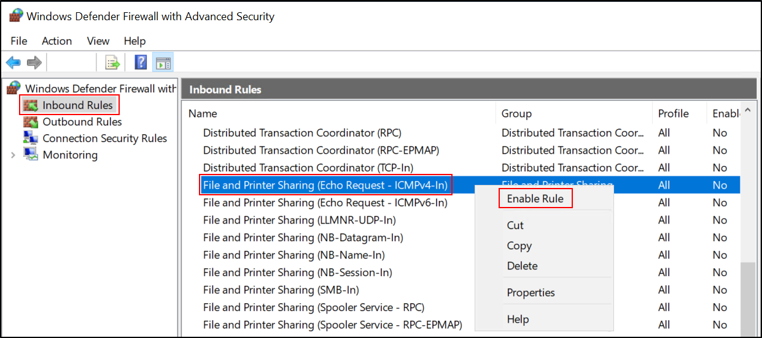

**Creating Rules for Splunk:**

Another important firewall setting involves creating rules for Splunk on Windows Server 2019 (SPLUNK) and three Windows 10 machines (FTP, SSH, SMB). You need to open ports 8089 and 9997 for both inbound and outbound connections.

Here's how to do it:

1. Open Windows Defender Firewall with Advanced Security.
2. In the left pane, click on either Inbound Rules (to create an inbound rule) or Outbound Rules (to create an outbound rule).
3. In the right pane, click on New Rule.
4. In the New Rule wizard that opens, select Port and click Next.
5. Specify the ports you want to open (8089, 9997), select TCP or UDP as required, and click Next.

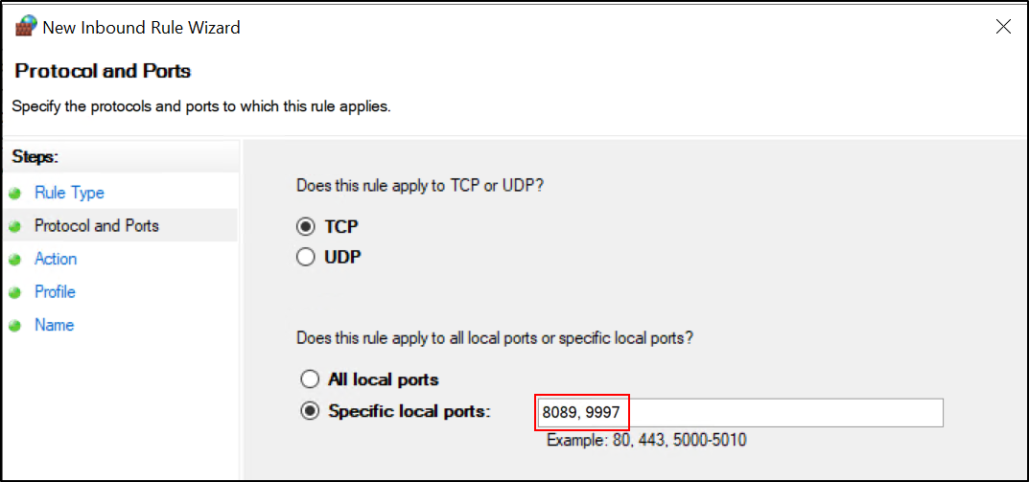

1. Select Allow the connection or Allow the connection if it is secure and click Next.

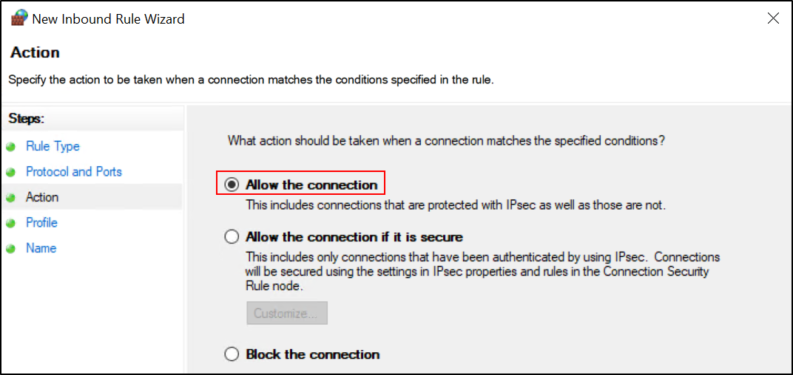

1. Select when the rule applies (Domain, Private, Public) and click Next.

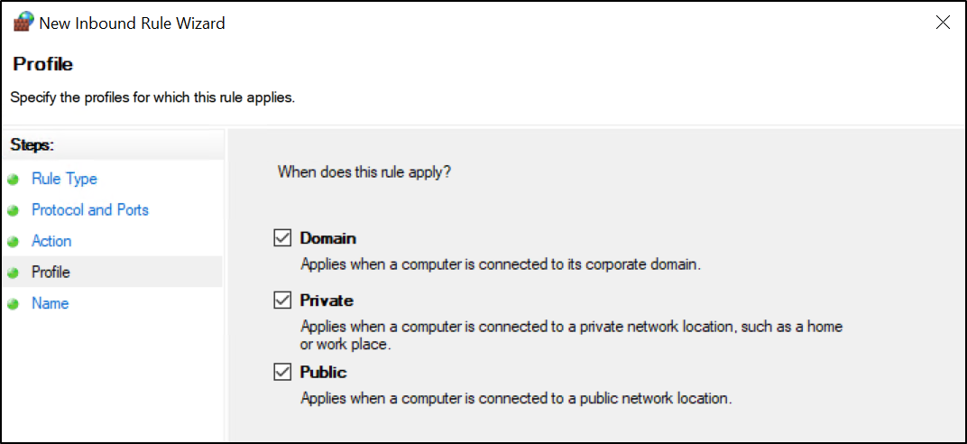

1. Give the rule a name (Splunk), then click Finish.

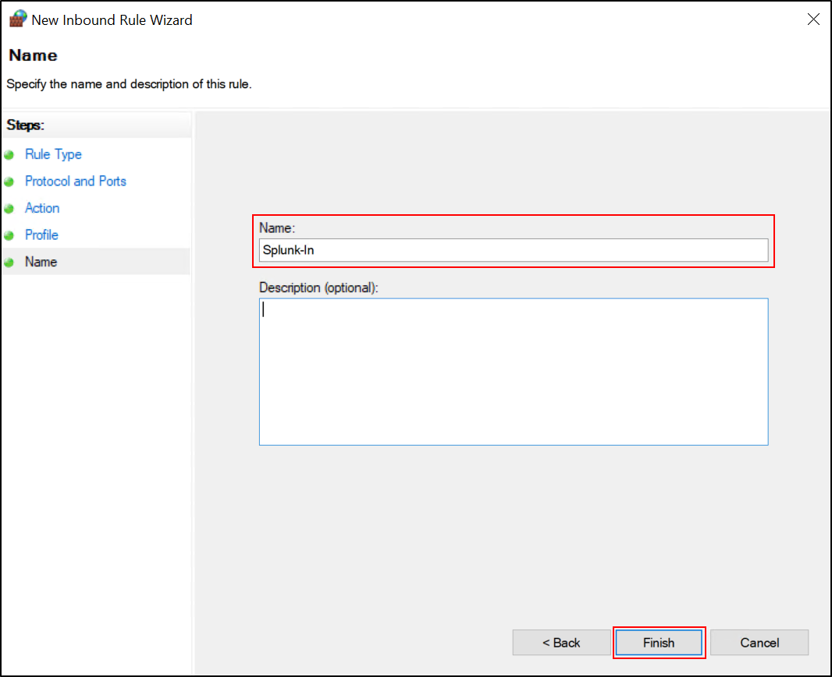

## Installing Active Directory Domain Services (AD DS) on Windows Server 2019 DC

Active Directory Domain Services (AD DS) is a server role in Windows Server that allows admins to manage and store information about resources from a network, as well as application data in a distributed database. AD DS also allows administrators to handle user data security and single sign-on for user access to network resources.

To install AD DS on Windows Server 2019 DC, you can follow these general steps:

1. Open 'Server Manager'.
2. In 'Server Manager', select the 'Manage' menu and then choose 'Add Roles and Features'.

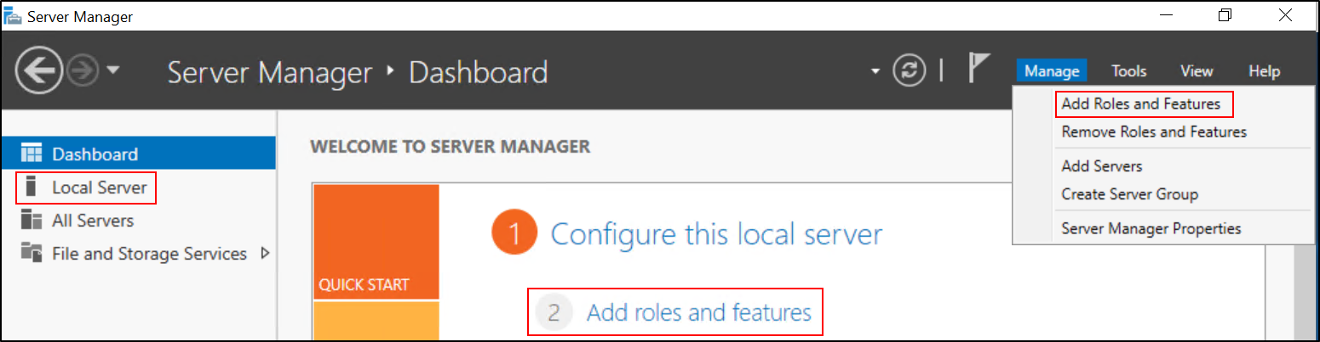

1. This will launch the 'Add Roles and Features Wizard'. In this wizard, ensure the 'Role-based or feature-based installation' is selected.

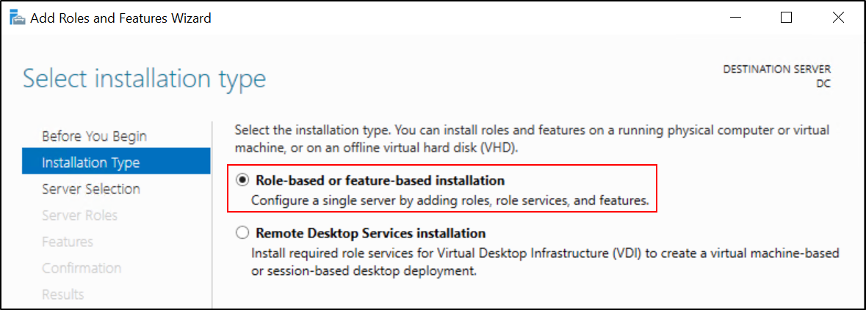

1. Select the current server from the server pool.

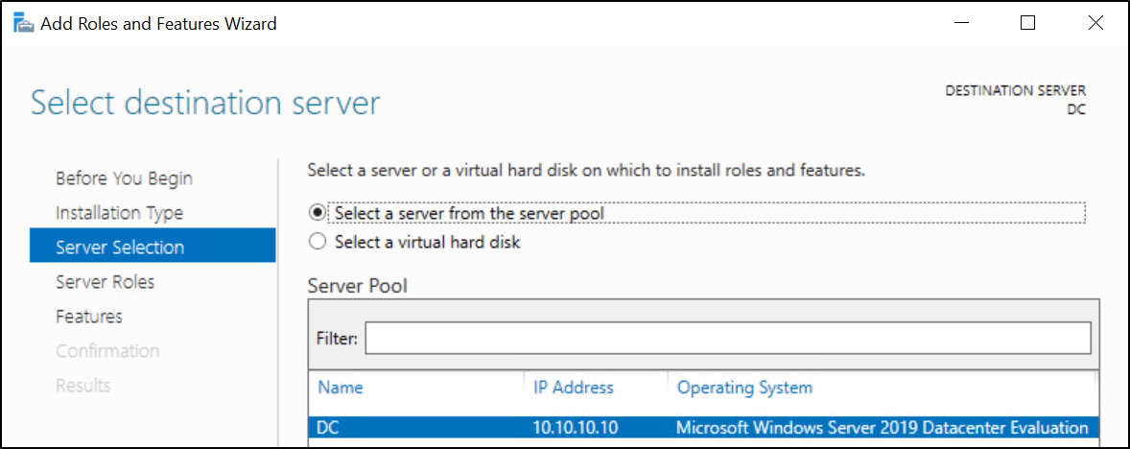

1. From the roles list, check 'Active Directory Domain Services'. This will open a new window showing additional features that are required for AD DS. Click 'Add Features' then 'Next'.

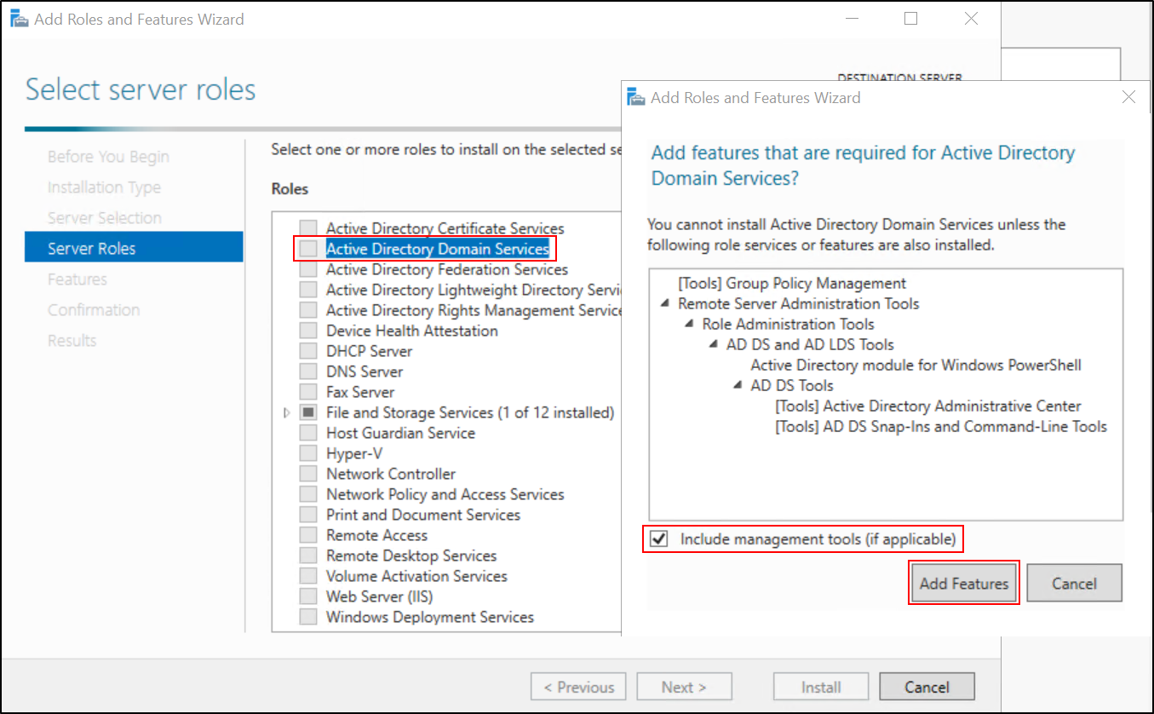

1. Proceed through the wizard by clicking 'Next', until you reach the 'Install' button.
2. Click 'Install' to begin the installation process. The process might take some time to complete.

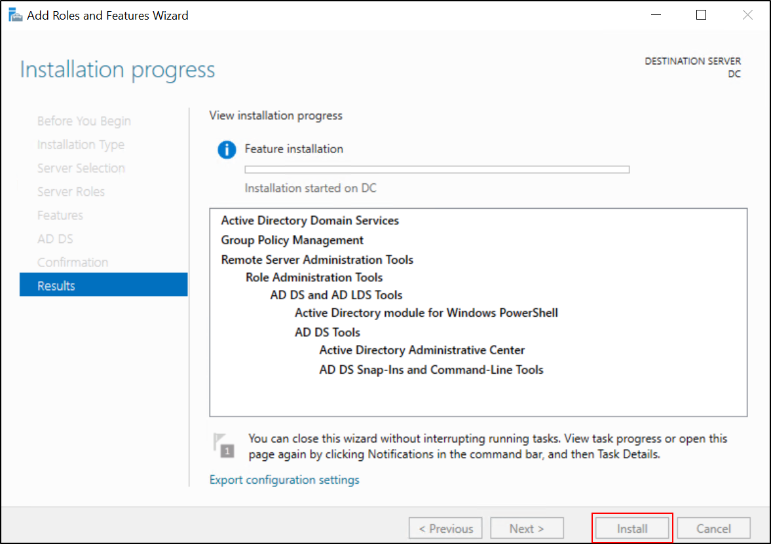

After AD DS is installed, the server will need to be promoted to a domain controller, which will be discussed in the next section.

## Promoting the Server to a Domain Controller

After successfully installing Active Directory Domain Services (AD DS) role on your Windows Server 2019 DC, the next step is to promote your server to a domain controller. Here's how you can do it:

1. In the 'Server Manager' dashboard, you will see a notification indicating that post-deployment configuration is required for Active Directory Domain Services. Click on the 'Promote this server to a domain controller' link.

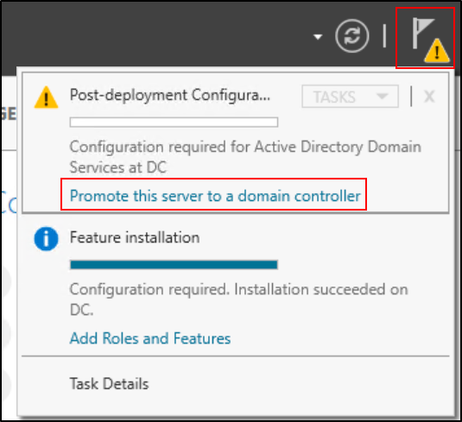

1. You'll now see the 'Active Directory Domain Services Configuration Wizard'. Here, you have to specify deployment operations. As we're creating a new forest, choose 'Add a new forest' and provide a Root domain name ('capstone.local').

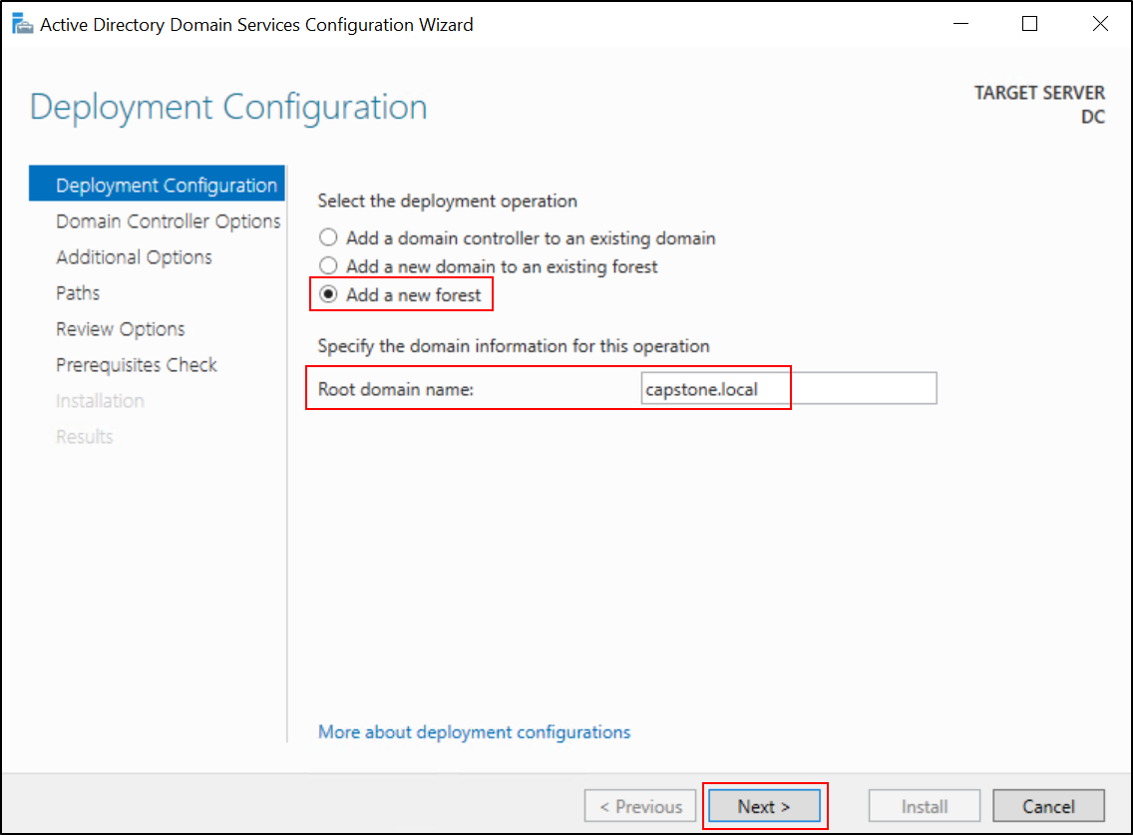

1. Under 'Domain Controller Options', ensure that 'DNS server' and 'Global Catalog (GC)' are checked. Set the DSRM (Directory Services Restore Mode) password, which is used for recovery purposes ('Pa$$word').

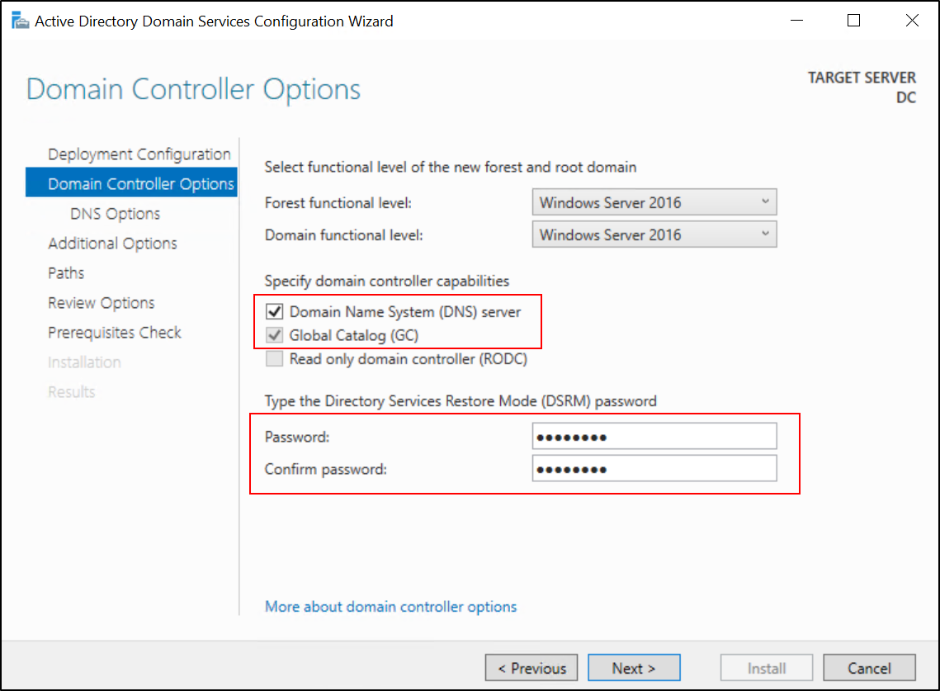

1. Proceed through the wizard by clicking 'Next', until you reach the 'Install' button.
2. If all prerequisite checks pass successfully, click on the 'Install' button. The server will automatically reboot after the AD DS installation completes.

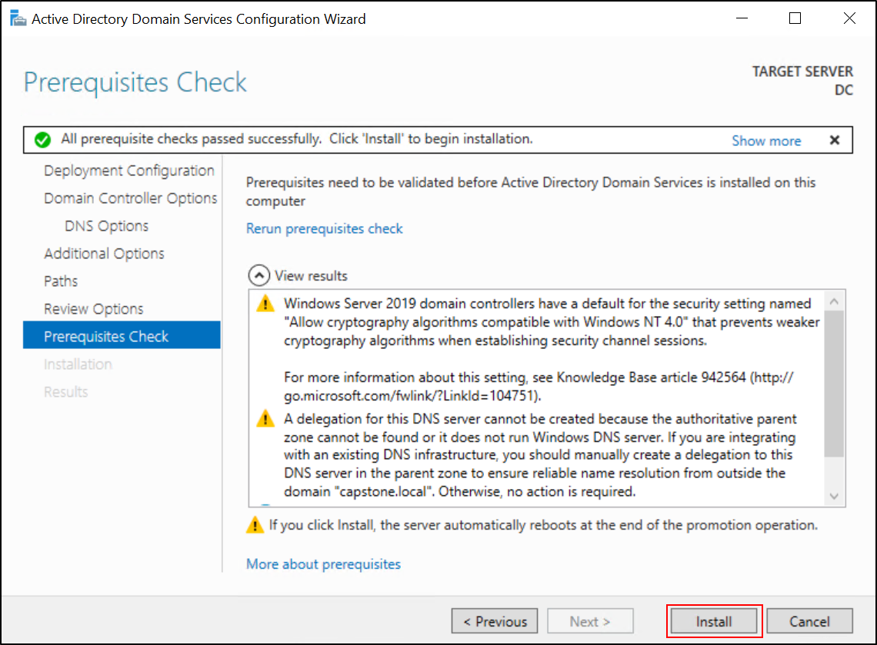

1. After the server reboots, you can log in to the server with domain admin credentials, and the server is now promoted as a domain controller.

You have now successfully promoted your Windows Server 2019 DC to a domain controller. You can confirm this by opening 'Active Directory Users and Computers' from the 'Server Manager' dashboard and checking that your domain is listed.

## Adding All Machines to Domain Controller (Excluding Commando VM)

Here's how you can add each machine to the domain:

**Windows Machines (FTP, SSH, SMB)**

1. Open the 'System Properties' window. This can be done by right-clicking on 'This PC' or 'My Computer' on the desktop or in the Start menu, then selecting 'Properties'. From here, select 'Change settings' or 'Advanced System Settings', then the 'Computer Name' tab.

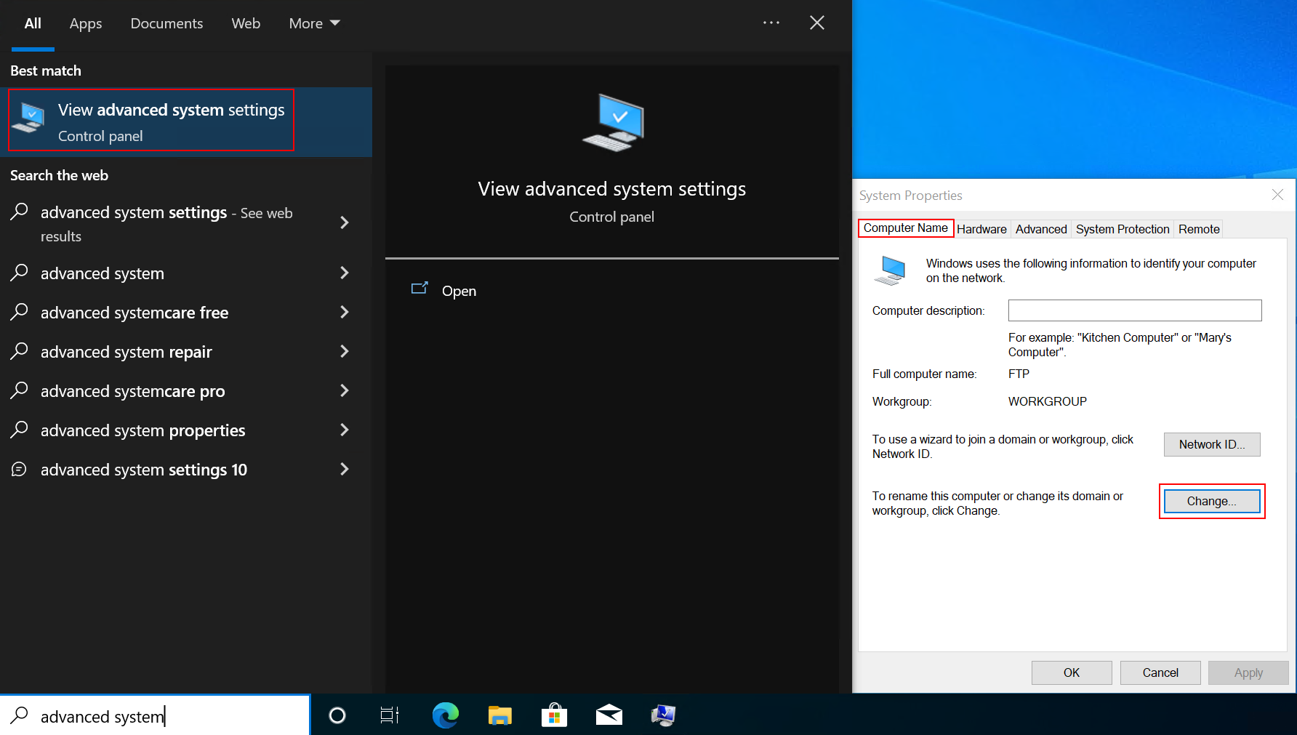

1. In the 'Computer Name' tab, click on the 'Change' button.
2. In the 'Member of' section, select 'Domain' and enter your domain name, in this case, "capstone.local".
3. Click 'OK'. You will then be asked to enter the username and password of a domain administrator account. This is required to join a computer to the domain.

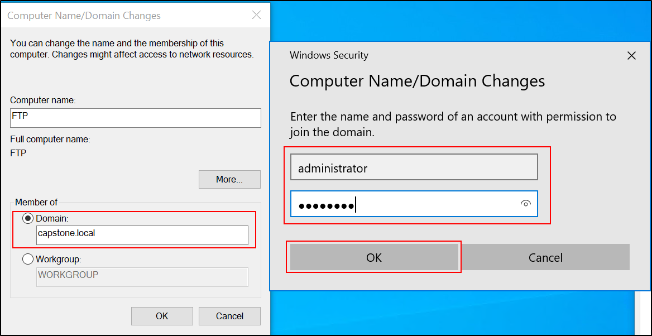

1. Once entered, click 'OK'. You should receive a message welcoming you to the domain.
2. Click 'OK', then when prompted to restart, click 'Restart Now'.

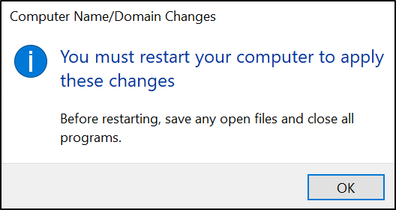

**Windows Server 2019 Splunk**

The process is the same as for other Windows machines. Ensure you're logged in with administrative rights, then:

1. Open 'Server Manager'. You can do this by clicking the 'Server Manager' icon on the taskbar or searching for it in the Start menu.
2. In the 'Server Manager' window, click on 'Local Server' in the left-hand pane.
3. In the main pane, you'll see a 'Properties' section. Find 'Computer name' and click on the blue 'Workgroup' link.

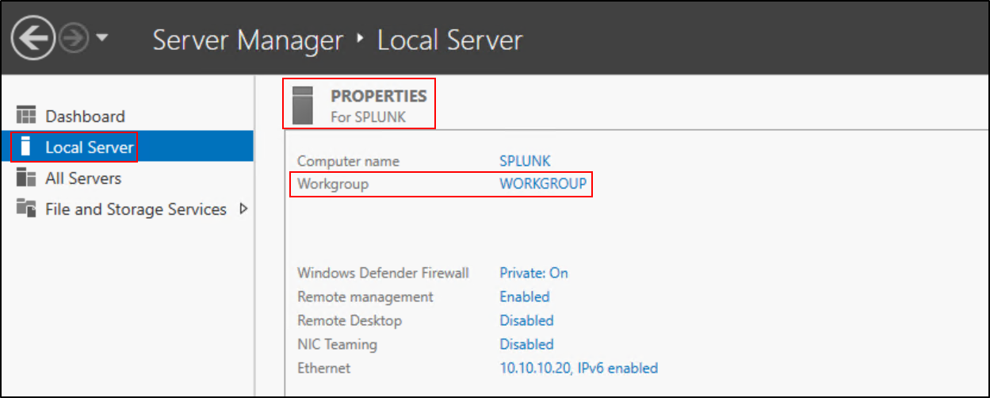

1. In the 'System Properties' window that appears, click on the 'Change' button.
2. Select 'Domain', enter "capstone.local" in the text field, and click 'OK'.
3. You will be prompted to enter the username and password of a domain administrator account.

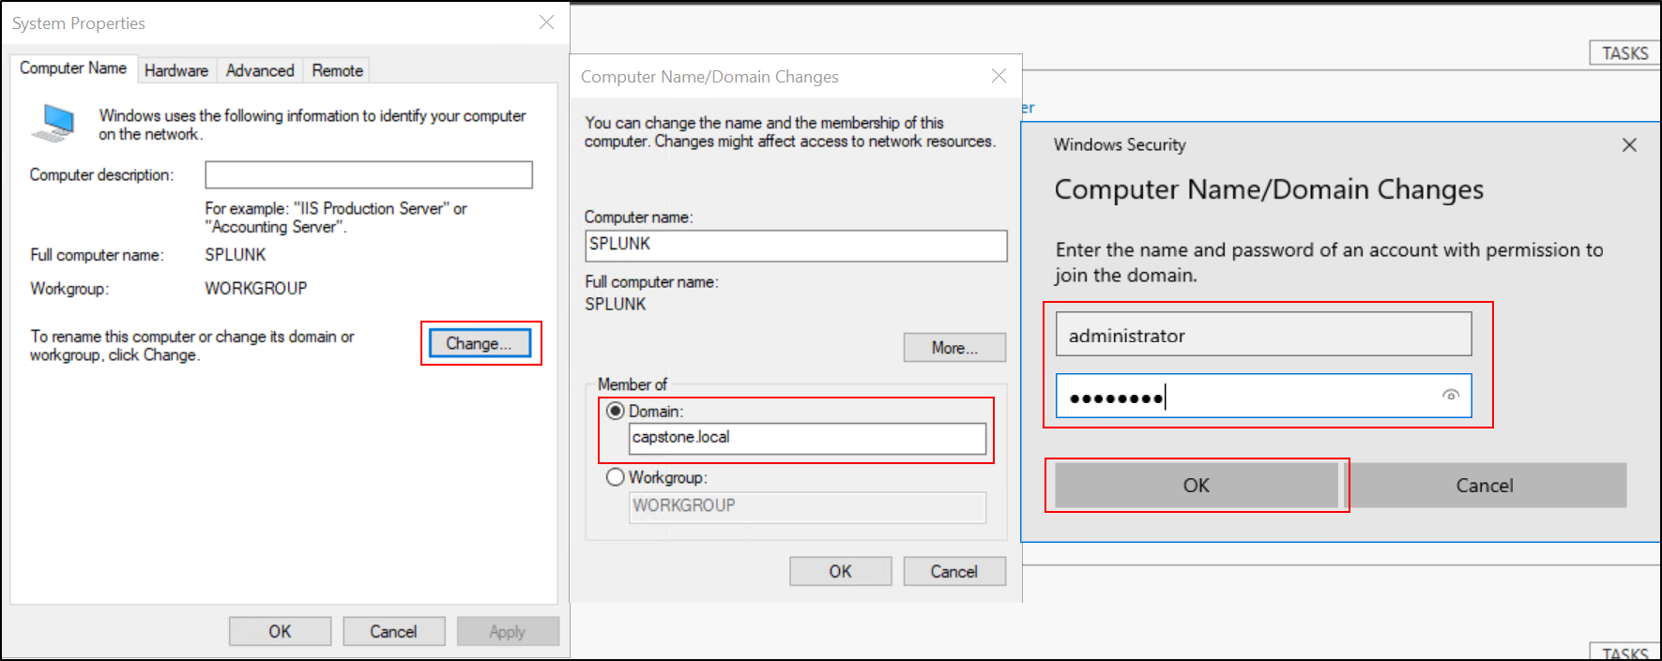

1. After entering these, click 'OK'. A dialog box should appear, welcoming you to the domain.
2. Click 'OK', then when prompted to restart, click 'Restart Now'.



Remember, for changes to take effect, the machines need to be restarted after they are added to the domain. Once restarted, they will be a part of the "capstone.local" domain.

Once restarted, they will be a part of the "capstone.local" domain.

## Shutting Down All Machines and Taking Checkpoints for Each Machine

Shutting down all machines and creating checkpoints for each is an essential. It allows you to save the current state of each machine, which can be very beneficial in a lab or testing environment.

Creating a checkpoint in Hyper-V is a straightforward process. Here are the steps:

1. **Open Hyper-V Manager:** Click on the Start menu and type 'Hyper-V Manager'. Click on it to open.
2. **Select the virtual machine:** In the Hyper-V Manager, you'll see a list of your virtual machines in the center pane. Right-click on the one for which you want to create a checkpoint.

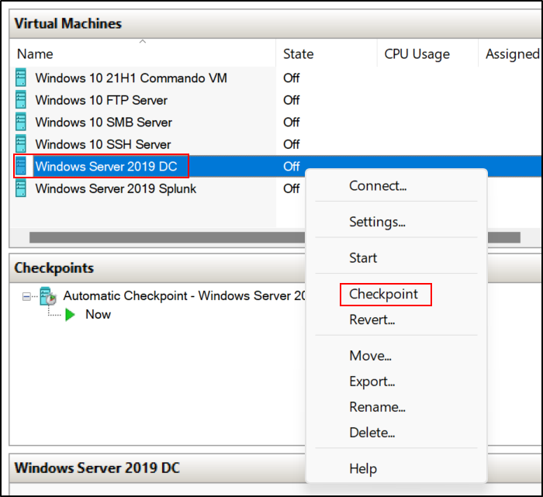

1. **Create the checkpoint:** In the right-click menu, hover over 'Checkpoint' and then click on 'Create Checkpoint'. This action will create a checkpoint for the selected virtual machine.

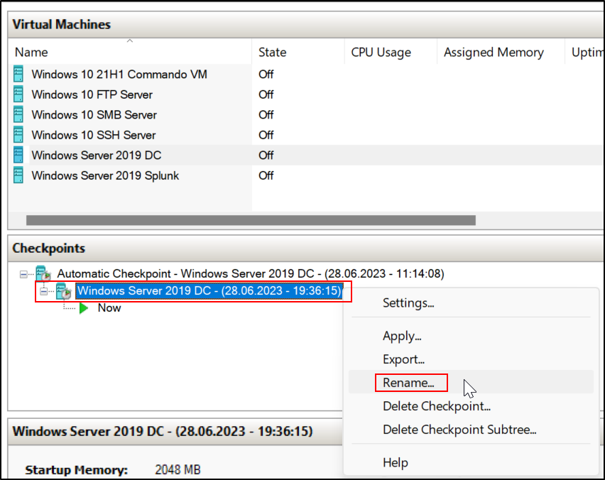

1. **Rename the checkpoint:** Right-click on the checkpoint you want to rename, then click on 'Rename'. In the dialog box that appears, type the new name for your checkpoint, then click 'OK'.

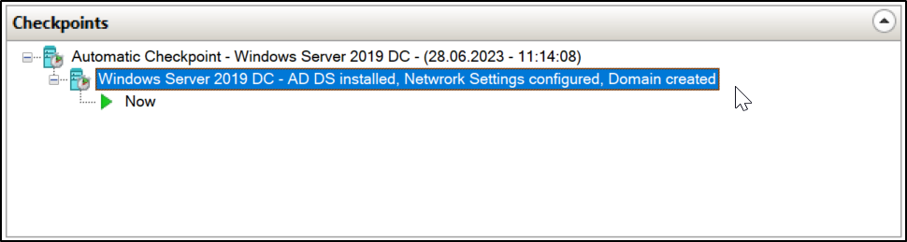

Repeat this process for each virtual machine you want to create a checkpoint for.

It's worth noting that while the virtual machine is running, you can still create a checkpoint. This is referred to as a "live" or "online" checkpoint and includes the VM's memory state. But if you want to save resources or if you're not interested in the VM's current active state, you should shut down the VM before creating the checkpoint.

## Creating 1000 Random Users Using PowerShell Script in Domain Controller

In this stage, create 1000 random users using a PowerShell script for testing purposes. The PowerShell script from MartynKeigher's ADUser_Generator repository is a useful tool for generating Active Directory users in bulk (<https://github.com/MartynKeigher/ADUser_Generator>)

Open PowerShell with administrator privileges.

iex (new-object Net.WebClient).DownloadString('https://raw.githubusercontent.com/MartynKeigher/ADUser_Generator/main/ADUserGenerator.ps1'); ADUser-Generation -Company 'Capstone' -UserCount 1000 -Password 'Pa$$word' -OU ‘Capstone’

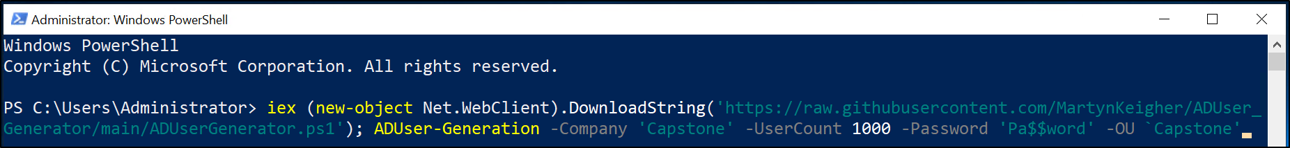

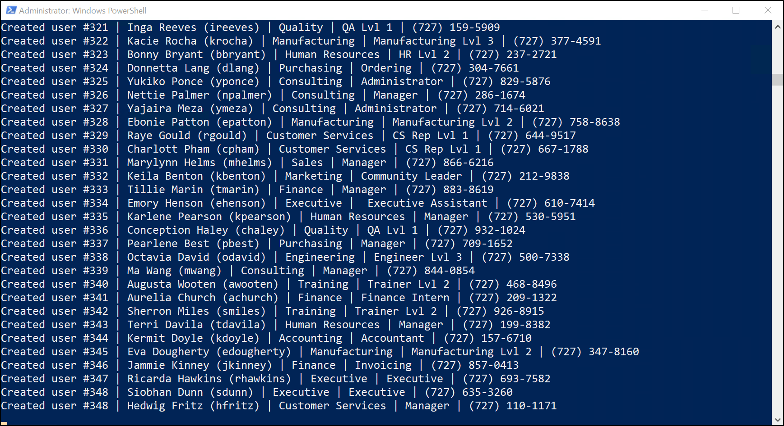

iex (new-object Net.WebClient).DownloadString('https://raw.githubusercontent.com/MartynKeigher/ADUser_Generator/main/ADUserGenerator.ps1');

This part of the command is used to download and execute the PowerShell script located at the provided URL.

* new-object Net.WebClient: This is creating a new instance of the WebClient .NET class which can be used to send data to and receive data from a resource specified by a URL.
* .DownloadString('https://...'): This method downloads the resource specified by the URL as a string.
* iex: This stands for Invoke-Expression. It takes the string downloaded by the previous part, interprets it as a PowerShell script, and then executes it. This means it's loading the functions defined in the script into your PowerShell session so they can be used.

ADUser-Generation -Company 'Capstone' -UserCount 1000 -Password 'Pa$$word' -OU ‘Capstone’

This part of the command is invoking the ADUser-Generation function that was defined in the script that was just downloaded and executed.

* -Company 'Capstone': This sets the $Company parameter of the function. It's a string indicating the name of the company.
* -UserCount 1000: This sets the $UserCount parameter of the function. It's an integer indicating the number of user accounts to generate.
* -Password 'Pa$$word': This sets the $Password parameter of the function. It's a string indicating the password for the generated users.
* -OU ‘Capstone’: This sets the $OU parameter of the function. It's a string indicating the name of the Organizational Unit (OU) where you want to place your users. By default, it's 'Staff', but in this command, you're setting it to 'Capstone'.

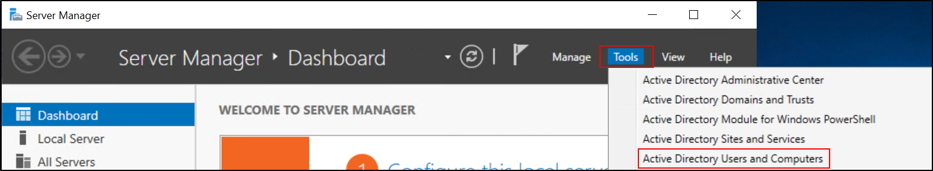

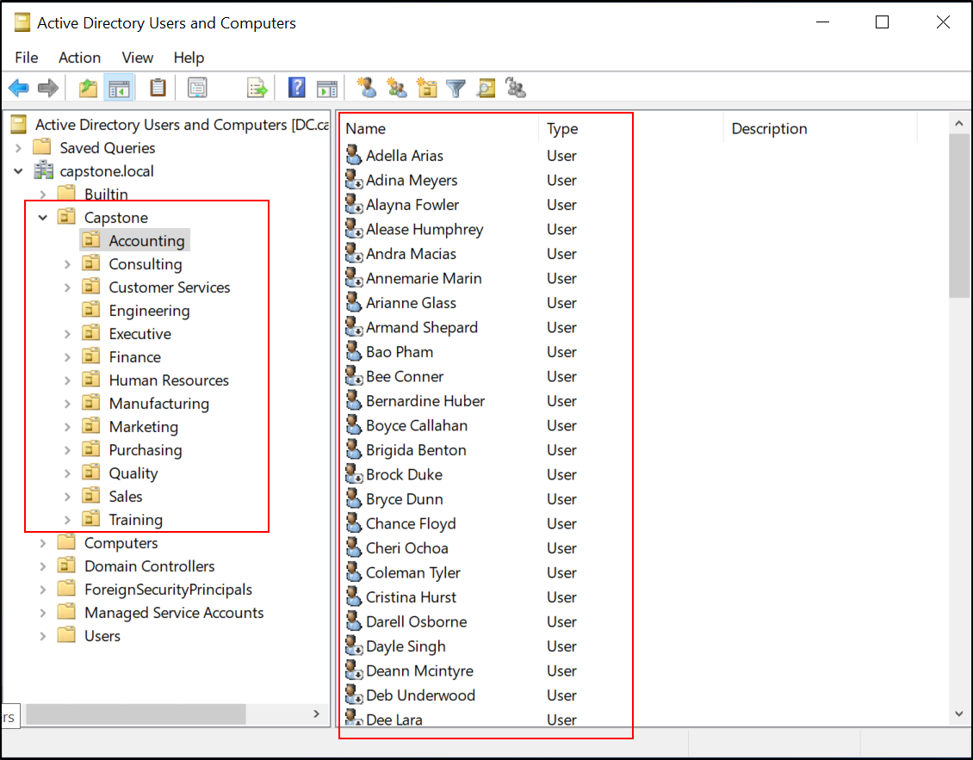

## Adding Manually Four Server and Service Users to Domain Controller (Splunk, FTP, SSH, SMB)

Apart from the random users, you will need to add four specific server and service users to the domain controller. These are: Splunk, FTP, SSH, SMB.

To manually create four server and service users on the Domain Controller (Windows Server 2019 DC), you can follow the steps below:

1. **Open Active Directory Users and Computers:** You can do this by clicking on the Start menu and typing "Active Directory Users and Computers" and select it from the results list.

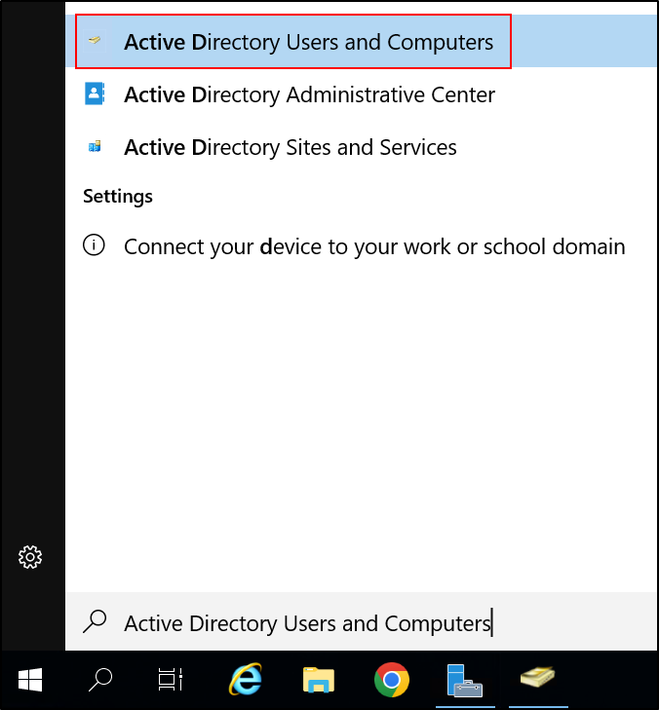

1. **Navigate to the "Capstone" OU:** In the Active Directory Users and Computers window, navigate to the "Capstone" OU under which you want to create the "Server Management" OU.

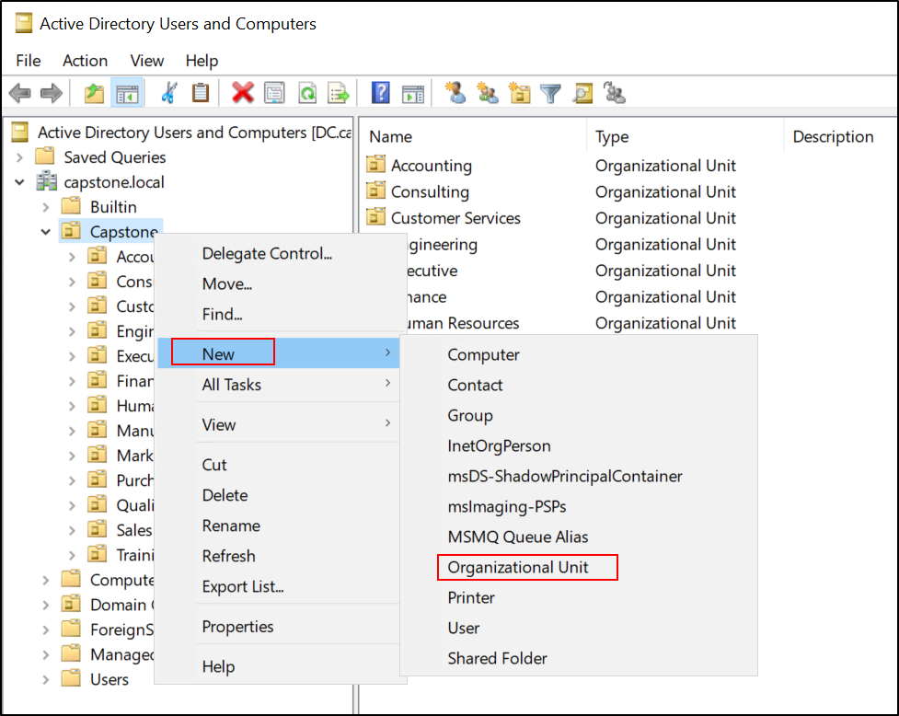

1. Create the new OU:

* Right-click on the "Capstone" OU, hover over "New", and then click on "Organizational Unit".
* In the "New Object - Organizational Unit" window, enter "Server Management" as the name of the OU.
* Click "OK" to create the new OU.

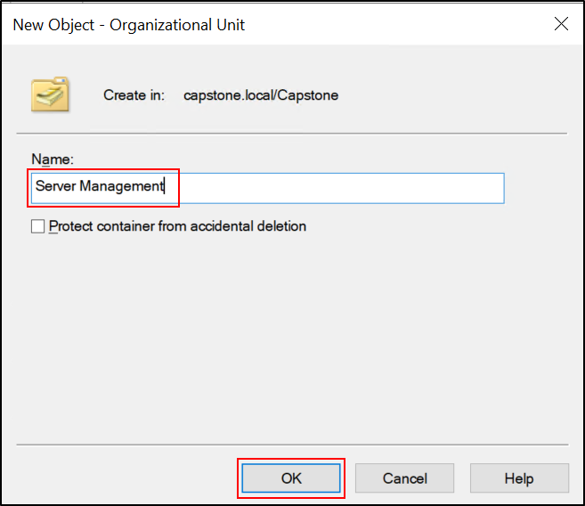

1. Create the new user:

* Right-click on the OU or container where you want to create the new user, hover over "New", and then click on "User".

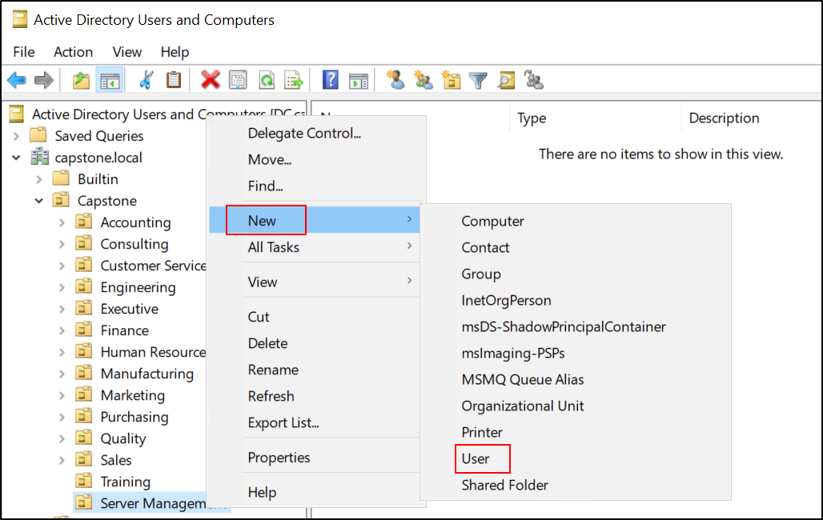

* In the "New Object - User" window, fill in the user's first name, last name, and user logon name (for example, "SplunkAdmin", "FTPAdmin", "SSHAdmin", "SMBAdmin"), then click "Next".

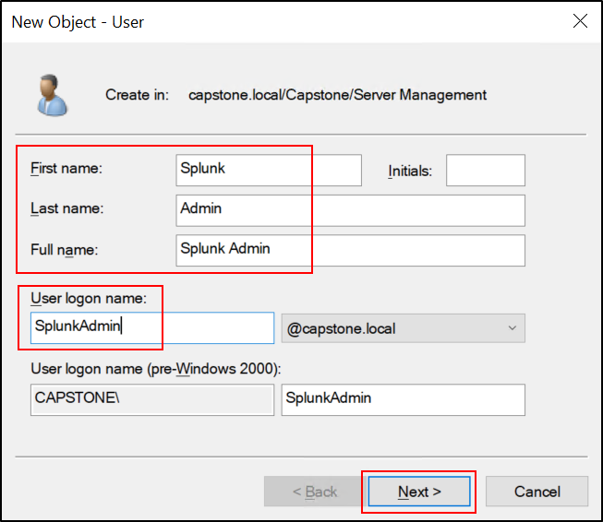

* On the next screen, enter a password for the new user, confirm it, and then set the password options according to your organization's policy. Typically, you might want to uncheck "User must change password at next logon" and check "Password never expires", unless your organization's policy dictates otherwise.

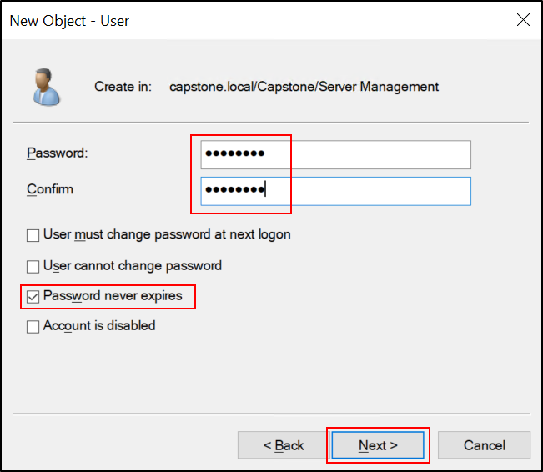

* Click "Next", review the settings, and then click "Finish" to create the new user.
* Repeat these steps for each of the four service users.

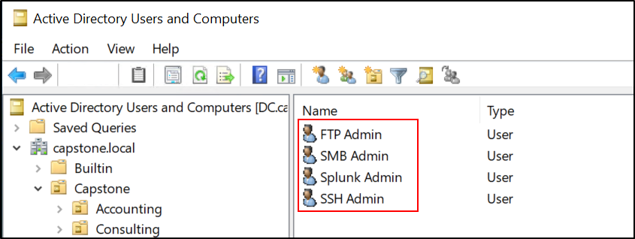

Remember, the principle of least privilege suggests that these accounts should have only the permissions they need to perform their duties and no more. Always follow your organization's policy when creating service accounts.

# Chapter 4: Setting Up Servers, Splunk Enterprise, and Detection Rules

## **Installing and Configuring FTP, SSH, SMB on Appropriate Windows Machines:**

This step will guide you on how to install and configure FTP, SSH, and SMB on their respective Windows machines. Each of these services will require its own unique set of installation steps and configurations.

First and foremost, it's essential to understand that server installation processes typically require administrative privileges due to the changes they make to system files and settings. Hence, to install server software (like FTP, SSH, SMB, Splunk, etc.), you need to use an account with administrative privileges.

However, once the server software is installed, it's recommended to run the server processes under a user account that possesses the least privileges necessary for performing the server's tasks. This security best practice is known as the principle of least privilege (PoLP), which helps limit potential damage if the server process gets compromised.

So, for our case, we should follow the below steps:

1. **Install the server software:** Under the capstone.local administrator account, install the FTP, SSH, SMB, and Splunk software on each machine as required.
2. **Configure the server software:** After the server software is installed, continue to use the Administrator account to configure each server. The exact steps to do this vary depending on the server software.
3. **Set up FTP client authentication:** When configuring the FTP server, you can specify that clients should authenticate using the FTPAdmin account.

The server itself will still run under a system account, not FTPAdmin, but FTP clients will connect and perform actions as FTPAdmin, which is a more limited account than Administrator. This setup maintains the principle of least privilege while allowing you to manage the server as needed.

By doing so, we use an account with high privileges to install the software (which is necessary), but then you run the software under accounts with lower privileges for everyday operation (which is good for security).

Now that we've discussed this crucial point, let's move on to the installation and configuration of the individual servers:

**Installing and Configuring FTP Server on Windows 10 FTP Server:**

1. Log in with the capstone.local administrator account.

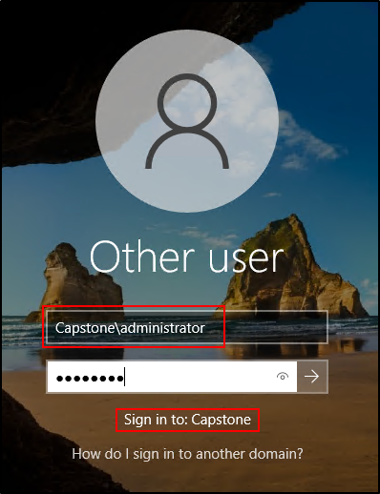

1. Open Control Panel, click on 'Programs'.
2. Click on 'Turn Windows features on or off'.

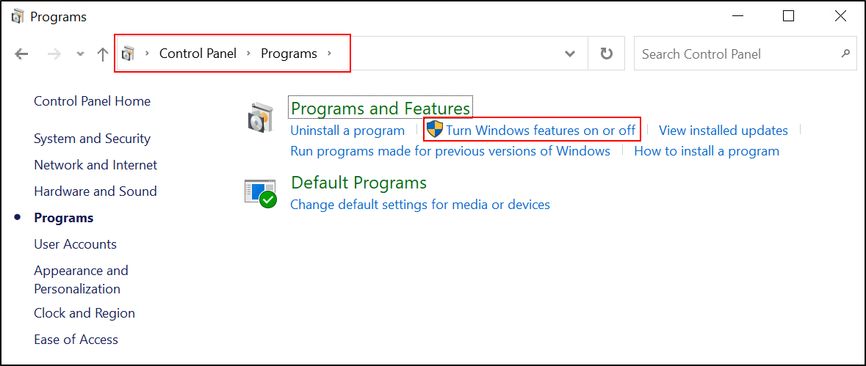

1. Scroll down and check 'Internet Information Services' and also 'FTP Server' under it. Click 'OK' and wait for it to install.

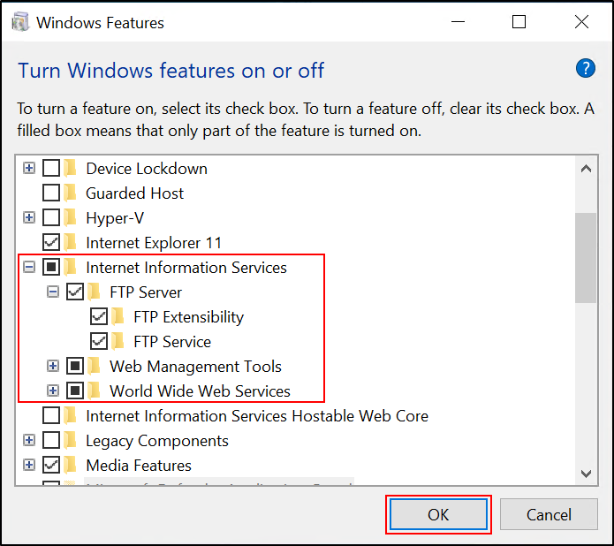

1. Configure your FTP server through the IIS Manager.
   1. Open IIS Manager from Start Menu (type IIS Manager in Start Menu).
   2. In the 'Connections' pane, click the server-level node in the tree.

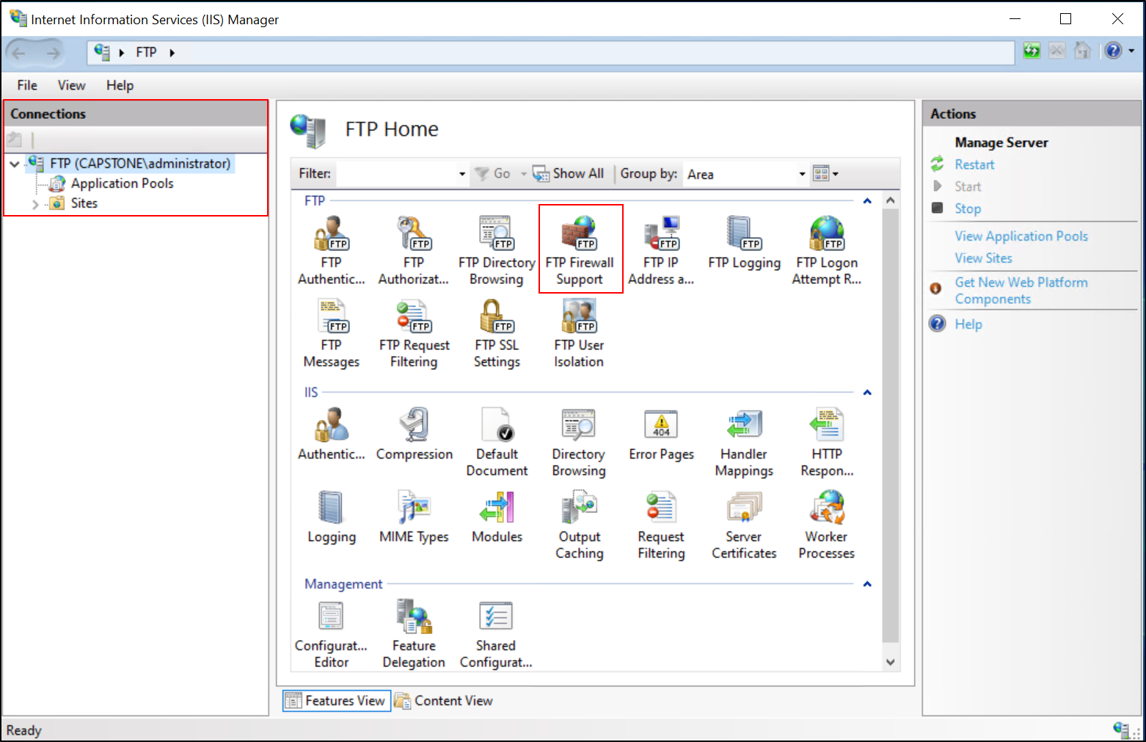

* 1. Double-click the 'FTP Firewall Support' feature.
  2. Enter the range of port numbers for the data channel port range, and then click 'Apply'.

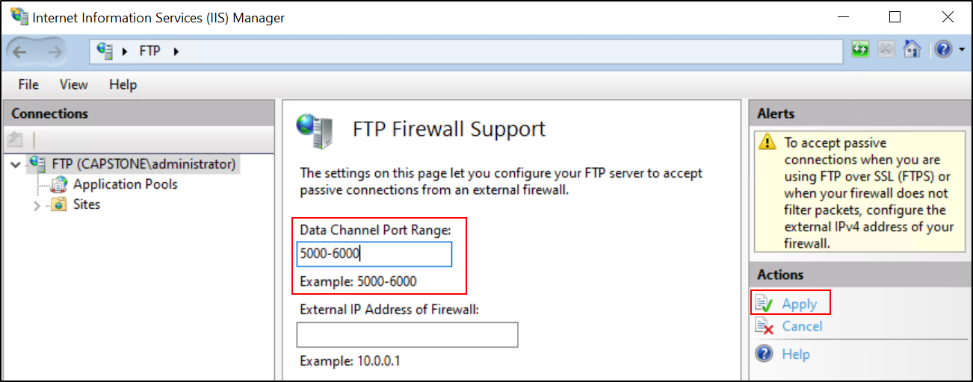

1. Now create an FTP site.
   1. Right-click 'Sites' and select 'Add FTP Site' from the context menu.

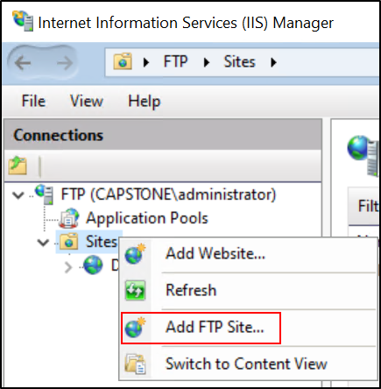

* 1. Give your FTP site a name, for instance "Capstone".
  2. For the "Content Directory", click the "..." button and navigate to C:\FTP. Click OK (I created FTP directory in my C disk).

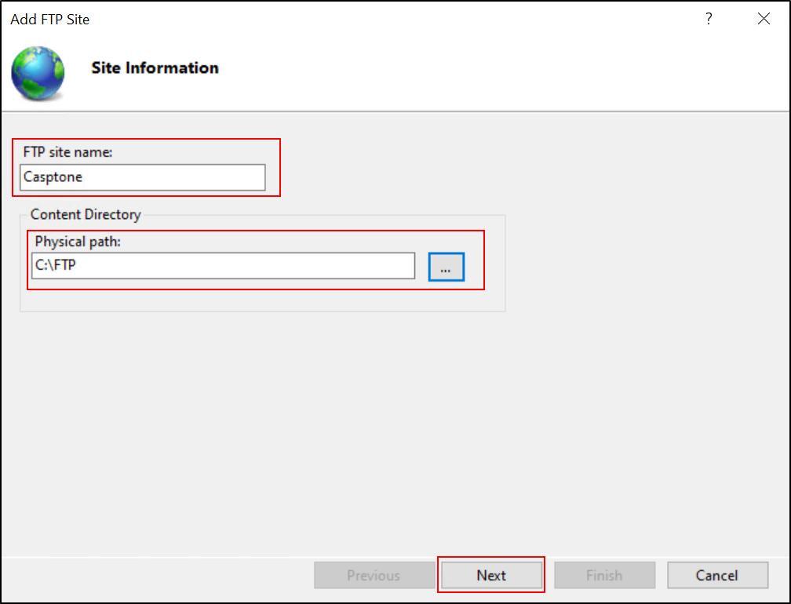

* 1. In the next step, define your FTP server’s IP address and the port on which it will listen for client connections (the default FTP port is 21).
  2. Choose either 'No SSL' if you don’t have an SSL certificate to encrypt your FTP connections, or 'Allow SSL' if you do have a certificate.

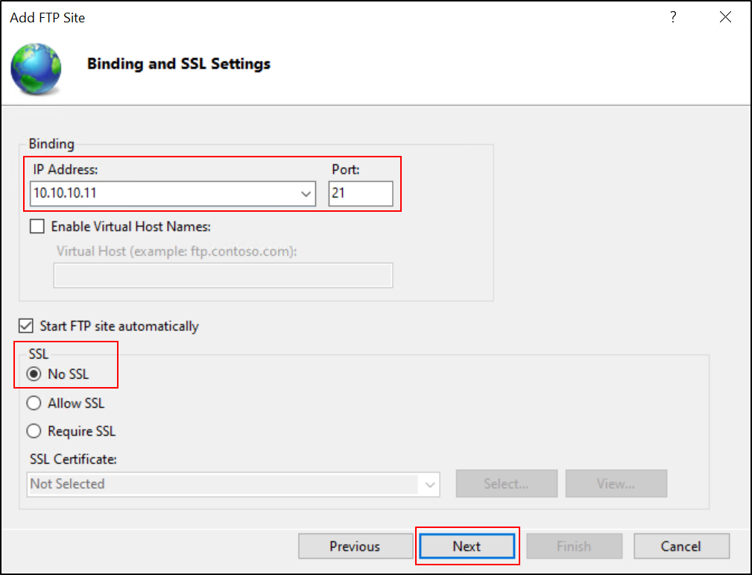

* 1. In the 'Authentication and Authorization Information' screen, select 'Basic' for the Authentication settings. For 'Authorization', select 'All Users' to allow all authenticated users to access your FTP server. Ensure to grant both 'Read' and 'Write' permissions, then click 'Finish'.

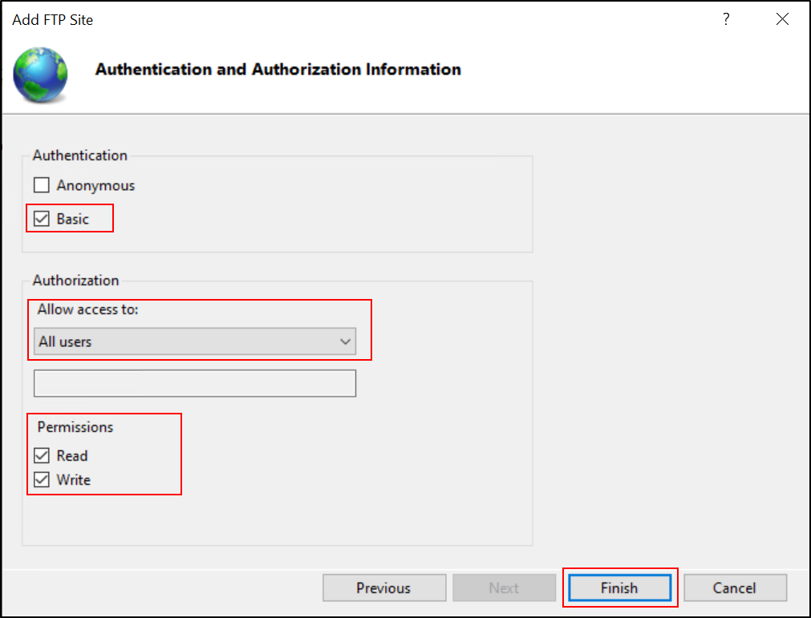

1. Adjusting FTP Folder Permissions

Follow the steps below to adjust permissions for your FTP folder:

* 1. Navigate to the 'FTP' folder that you created on your C drive (C:\FTP), right-click it and select 'Properties'.

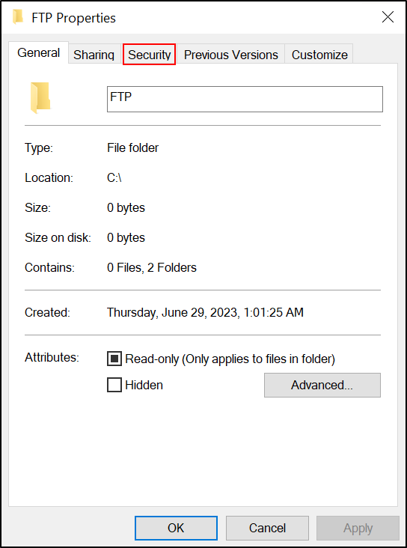

* 1. Switch to the 'Security' tab. You will see a list of user groups and user names. Find and select the user group named 'Users (FTP\Users)'. If you do not see it, you may need to add it.
  2. Click the 'Edit' button, which will open a new window. In this window, select 'Users (FTP\Users)' again.
  3. In the lower section of the window, you will see a list of permissions. Find 'Write' and check the box under the 'Allow' column.
  4. Click 'Apply' and then 'OK' to close the windows.

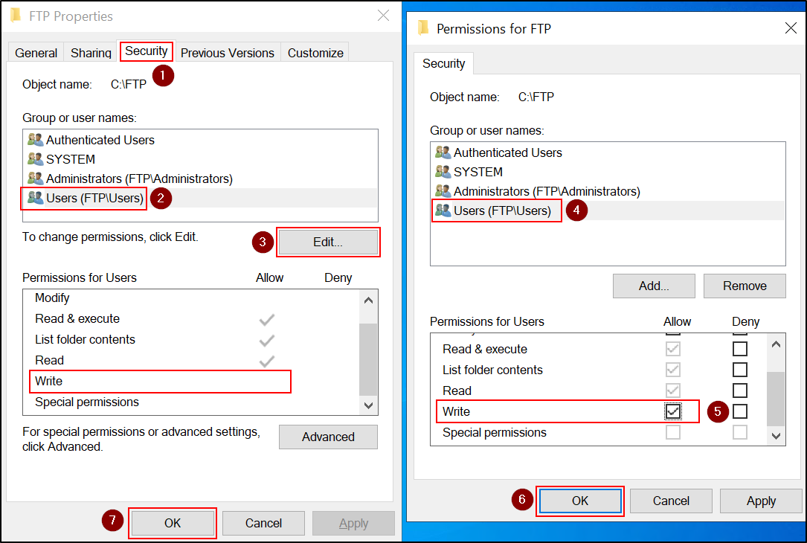

**Configuring Firewall Settings for FTP Server**

For the FTP server to function properly, you must configure specific inbound and outbound rules in your firewall. These rules have already been created during the FTP Server installation process, and we will now activate them.

Follow these steps:

1. Open 'Windows Firewall with Advanced Security'. You can find this by searching for 'Firewall' in the Start menu.
2. On the left pane, click on 'Inbound Rules'. In the middle pane, scroll down until you find the rules 'FTP Server (FTP Traffic-In)' and 'FTP Server Passive (FTP Passive Traffic-In)'.
3. For each of these two rules, right-click on it and then click 'Enable Rule'. This allows inbound FTP traffic to reach your server.

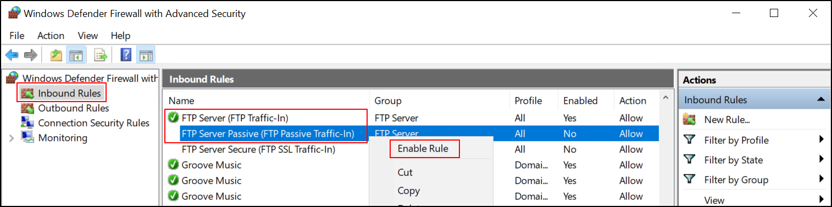

1. On the left pane, click on 'Outbound Rules'. In the middle pane, scroll down until you find the rule 'FTP Server (FTP Traffic-Out)'.
2. Right-click on this rule and then click 'Enable Rule'. This allows your server to send outbound FTP traffic.

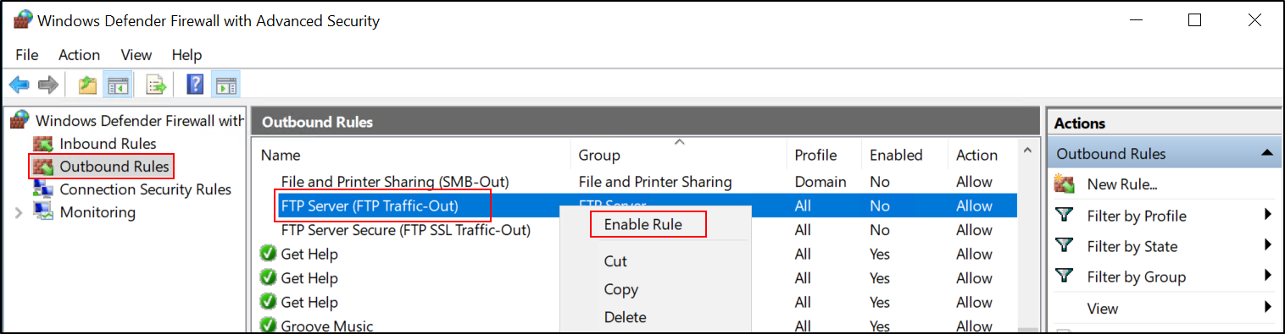

**Testing FTP Server Connection**

Once you have finished configuring the FTP server on the Windows 10 machine using the capstone\administrator account, sign out from this account. Sign back into the same machine, this time using the capstone\ftpadmin account. Open File Explorer, navigate to the C:\FTP directory, and create a new folder named "Test". If desired, add a new text document within this folder for testing file retrieval.

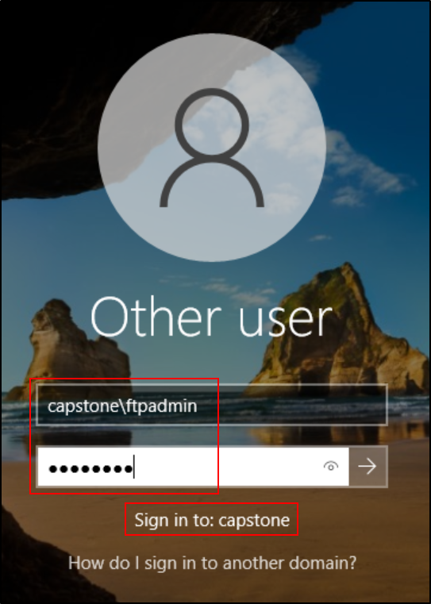 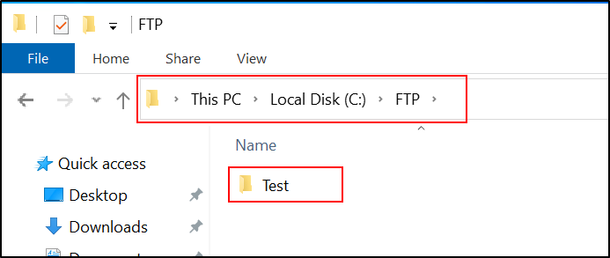

Now that you have installed the FTP Server and configured the necessary settings, you can test the connection from the Domain Controller or any other machine in your network.

Follow these steps:

1. Open File Explorer.
2. Click on the address bar at the top (where the folder path is usually displayed).
3. Delete any existing text and type ftp://10.10.10.11. Press Enter.

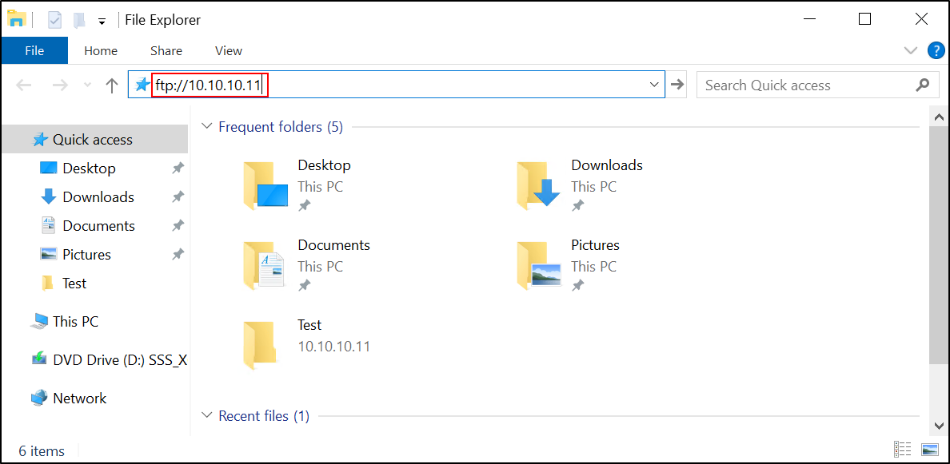

1. You will be prompted to enter a username and password. You can use any of the domain users' credentials for this test. Remember, we have granted all users access to the FTP server with read and write permissions.

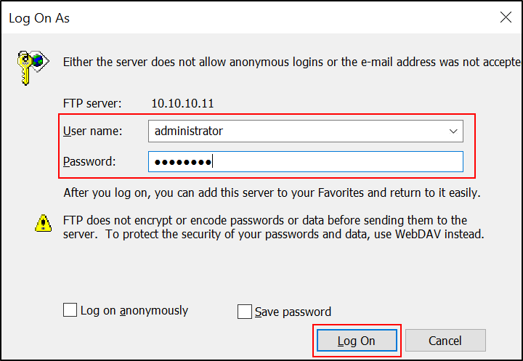

1. After entering the credentials, you should be connected to the FTP server and see the contents of the FTP directory that you've set up.

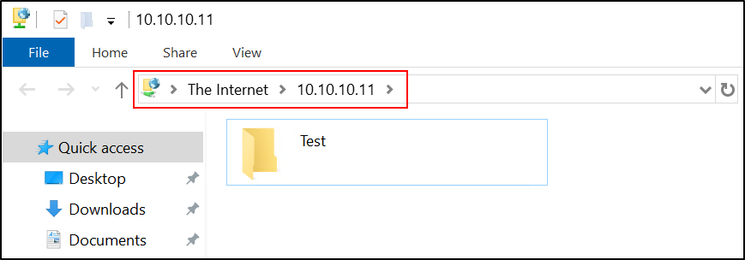

This means that your FTP Server is working correctly and ready to be used! It can be accessed from any machine in your network using the IP address and credentials of a valid domain user.

Please note that in a real-world scenario, you might want to restrict FTP access to specific users for security reasons. However, for this testing purpose, we allowed all domain users to access it.

**Installing and Configuring SSH Server on Windows 10 SSH Server:**

1. Before installing SSH Server on Windows 10 SSH Server machine I tried to create SSH connection from Windows Server 2019 DC machine. Here is the result:

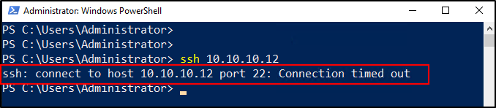

1. Log in to your Windows 10 SSH Server machine with the capstone\administrator account.
2. Go to the Start Menu, type Optional features and select it.

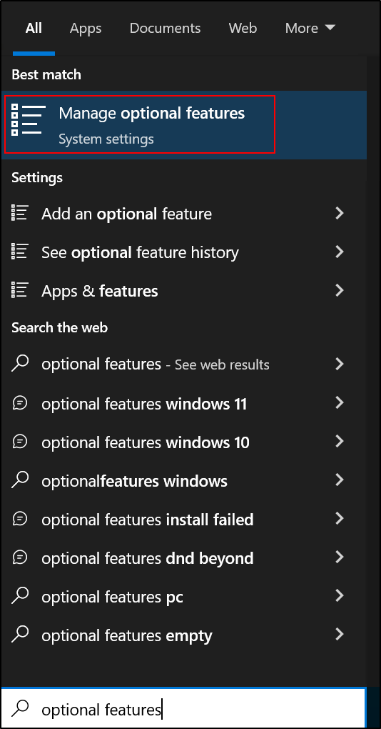

1. Click on Add a feature.

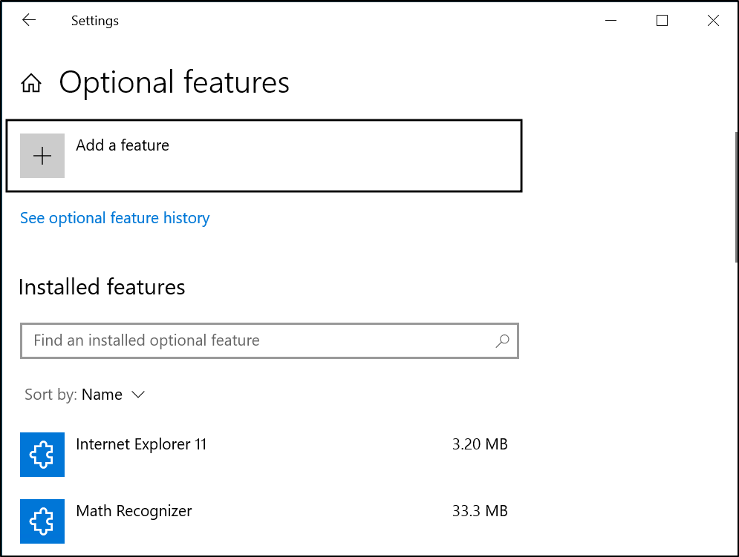

1. In the list of features, find OpenSSH Server. Click on it, then select Install.

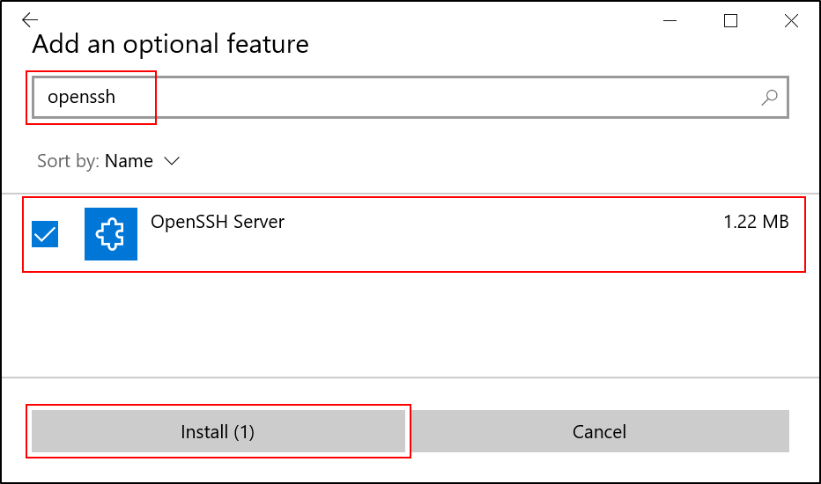

1. After the installation is complete, you need to start the SSH Server service. Click on the Start button, type Services into the search box and select it.

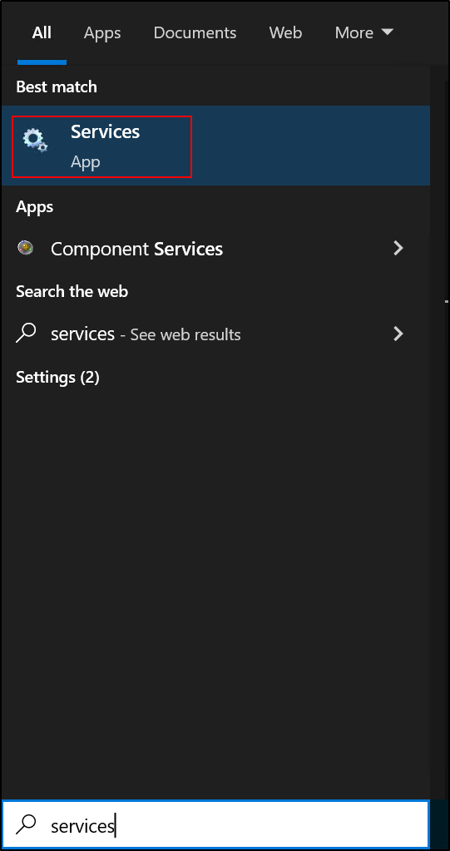

1. In the Services window, scroll down and find OpenSSH SSH Server.
2. Right-click on OpenSSH SSH Server, select Properties.

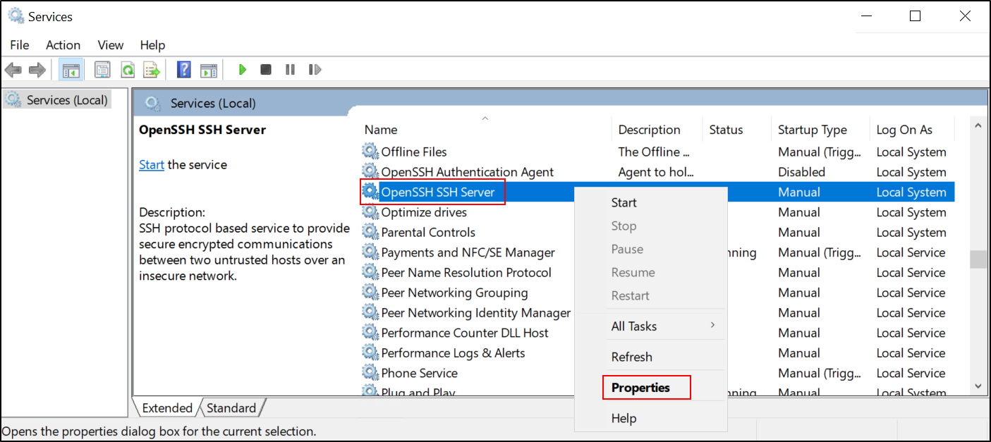

1. In the OpenSSH SSH Server Properties window, set Startup type to Automatic, if the service status is stopped, click Start, then click OK.

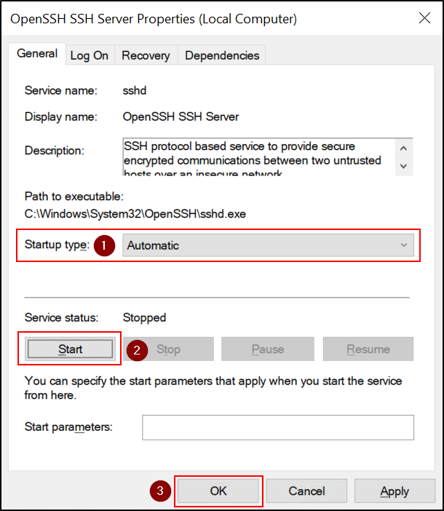

1. Verify the Windows Firewall rules. Open the Windows Defender Firewall settings and ensure that the rules for OpenSSH Server are enabled in the inbound rules. The OpenSSH Server rules should have been automatically created and activated during the installation.

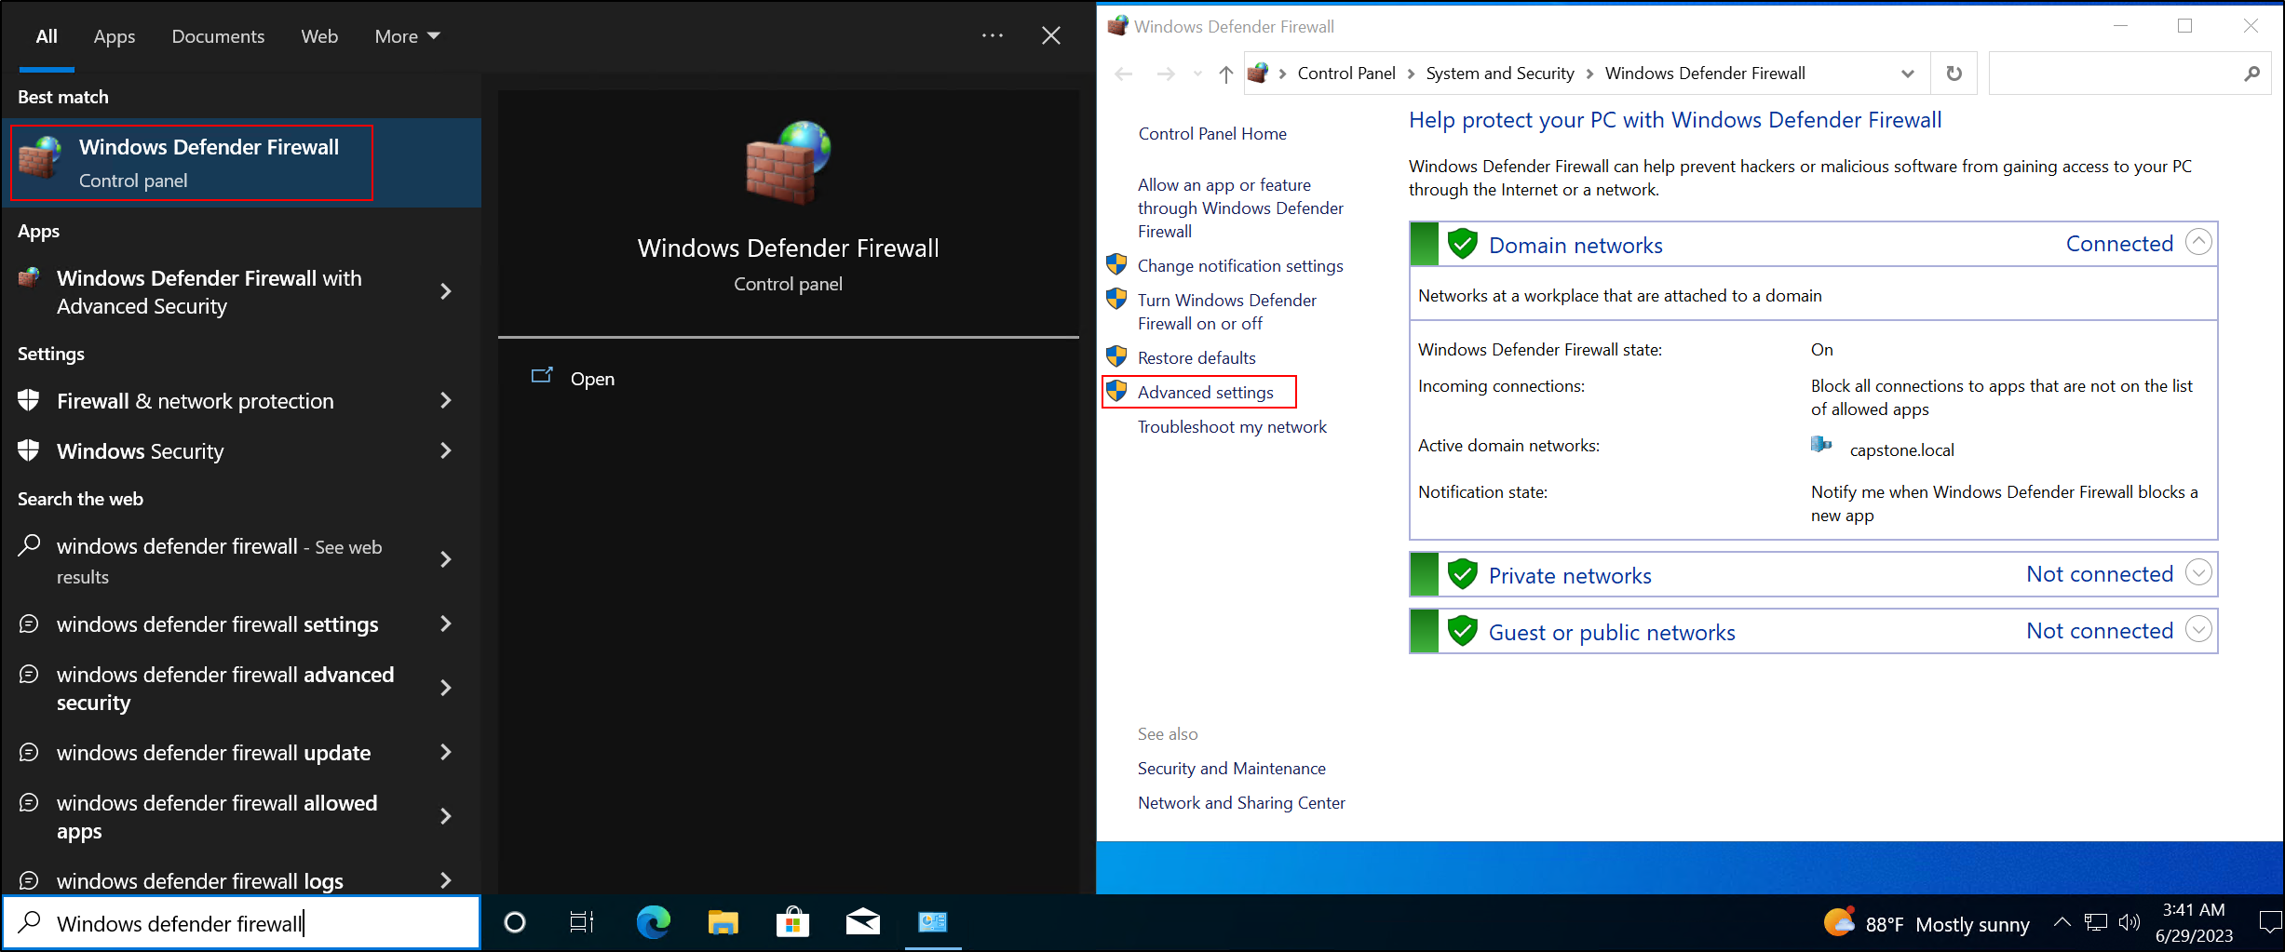

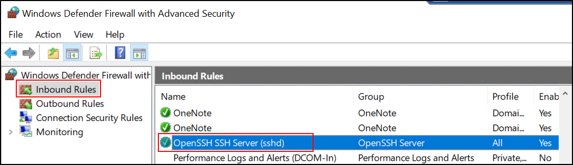

1. Testing Sconnection from the Windows Server 2019 DC to Windows 10 SSH Server:

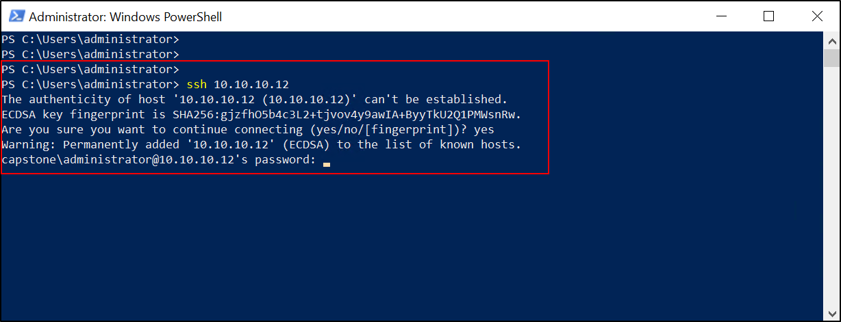

1. Finally, sign out from the capstone\administrator account, and log back into the machine with the capstone\sshadmin account.

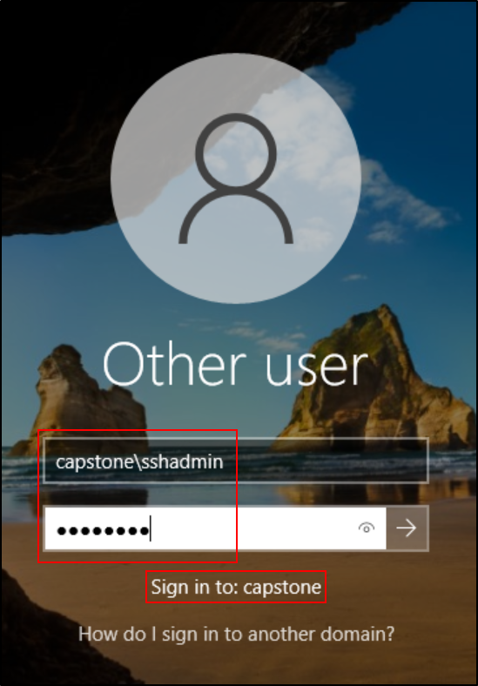

You've now installed and configured an SSH server on your Windows 10 SSH Server machine through Optional features. You can test the connection with an SSH client on another machine by connecting to the IP address of the Windows 10 SSH Server machine with the SSH protocol on port 22. Remember, you should use the capstone\sshadmin account for the SSH connection.

**Installing and Configuring SMB Server on Windows 10 SMB Server:**

It's recommended to use SMB2 and SMB3 in modern networks for improved performance and security. SMB1 is an older protocol with well-known security issues, and its use is generally discouraged.

If all your machines support SMB2 or SMB3, it's best to disable SMB1. The WannaCry ransomware, for instance, exploited a vulnerability in the implementation of SMB1 in Windows systems.

To ensure compatibility, confirm that all your devices, including network-attached storage (NAS) devices, printers, and other devices that use SMB, support SMB2 or SMB3 before disabling SMB1.

If you still have legacy systems that require SMB1, you should consider upgrading them, isolating them, or replacing them if possible.

For enabling and configuring SMB Server on your Windows 10 SMB Server machine, you can follow these steps:

1. **Open Windows Features**: To install the SMB1 protocol, you'll need to open the Windows Features window. Press Windows key + R to open the Run dialog box. Then type optionalfeatures.exe and press Enter or click OK.
2. **Navigate to SMB 1.0/CIFS File Sharing Support**: In the Windows Features window, you'll see a list of available features. Look for SMB 1.0/CIFS File Sharing Support in the list.
3. **Check SMB 1.0/CIFS File Sharing Support**: Click the checkbox next to SMB 1.0/CIFS File Sharing Support to select it.

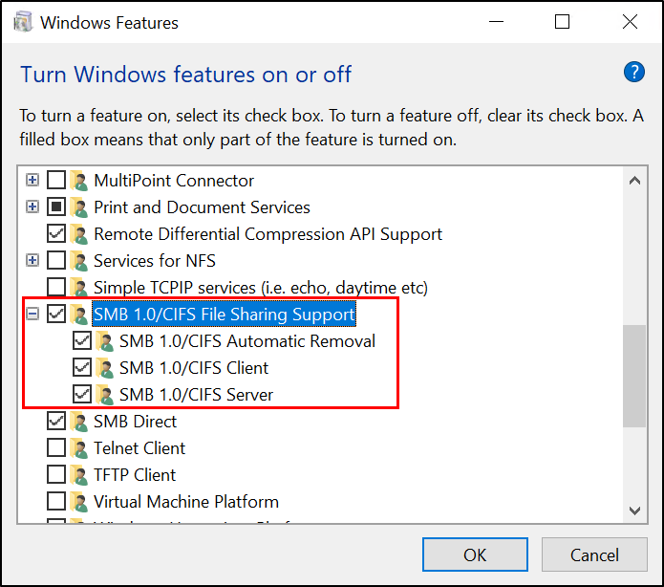

1. **Enable SMB 1.0/CIFS File Sharing Support**: With the SMB 1.0/CIFS File Sharing Support option selected, click OK. This will start the installation of the SMB1 protocol.
2. **Reboot Your Computer**: Once the installation is complete, you'll be prompted to reboot your computer. Click the Restart now button to reboot your computer and complete the installation of the SMB1 protocol.

After these steps, your Windows 10 machine should have the SMB1 protocol installed and enabled.

Once SMB1 Server is enabled, you can share a folder over the network. To do this, follow these steps:

1. Navigate to your C: drive and create a new folder named "CapstoneSMB". This is the folder that will be shared over the network.
2. Once the "CapstoneSMB" folder is created, right-click on it, select Properties, navigate to the Sharing tab, and click on Share.

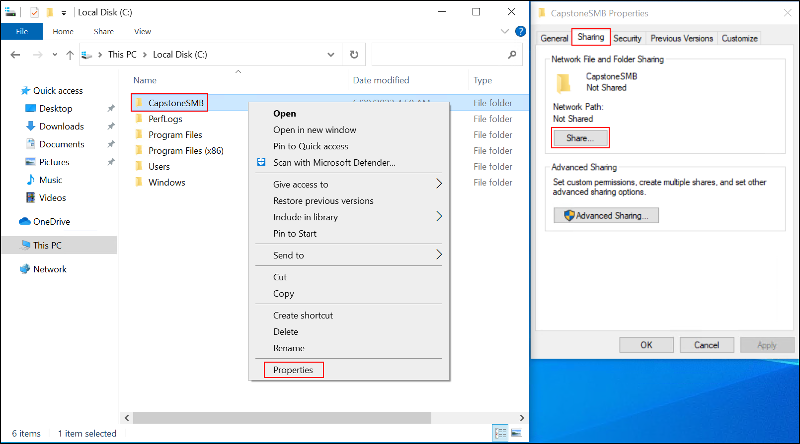

1. In the Network access window, select the "Find people" option. In the search field, click on "Advanced". In the name field, type "Domain Users" and click "Find Now". From the search results, select the "Domain Users" group and click "OK". Then, click "OK" again to grant access to the "Domain Users" group. This will allow all users in the "Domain Users" group to access the shared folder.

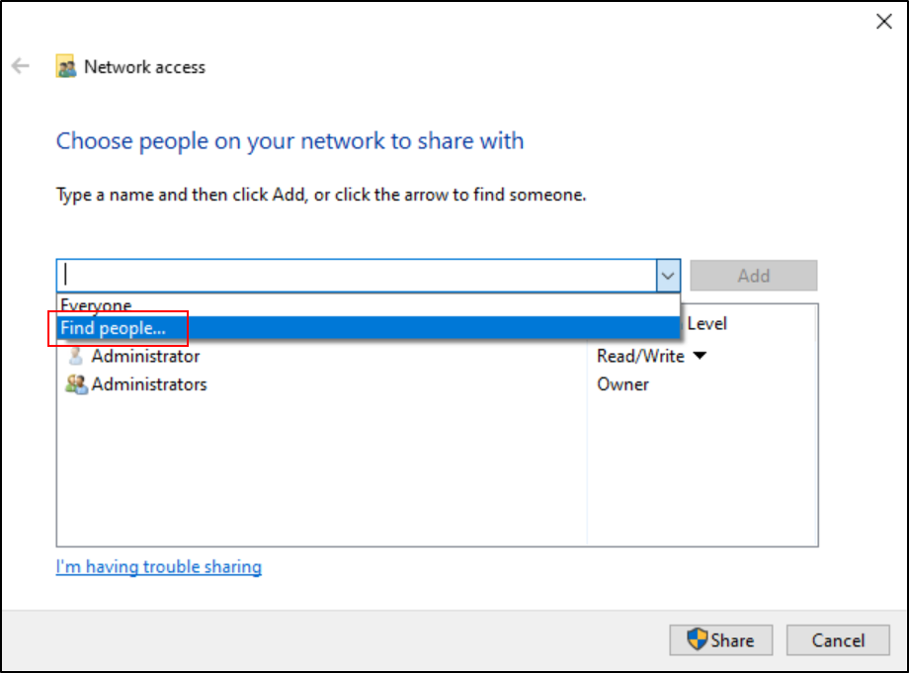

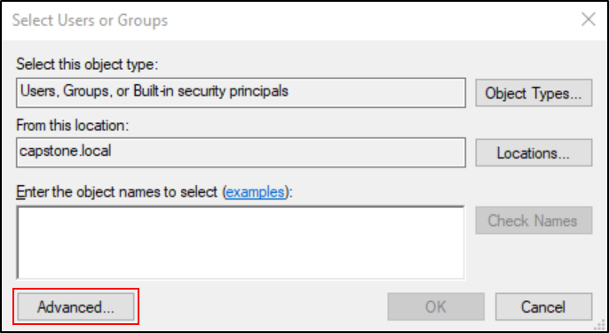 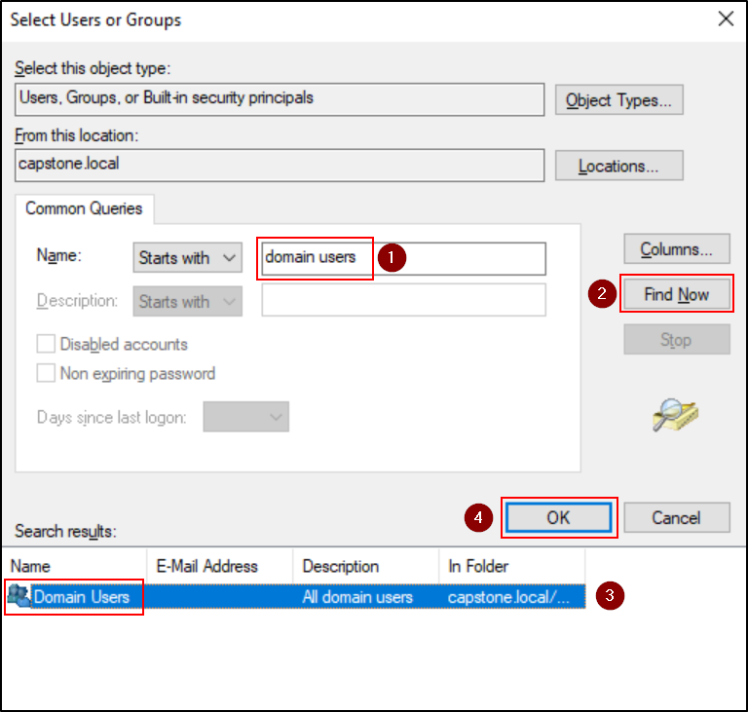

1. In the Permission Level column, for the Domain Users group, select Read/Write, then click on Share.

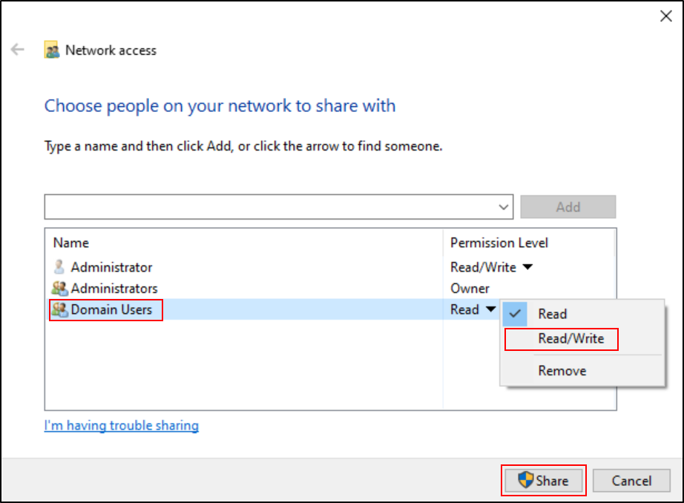

1. Write down the Network Path displayed, as you will need it to access the shared folder from other machines.
2. Click on Done, and then Close.

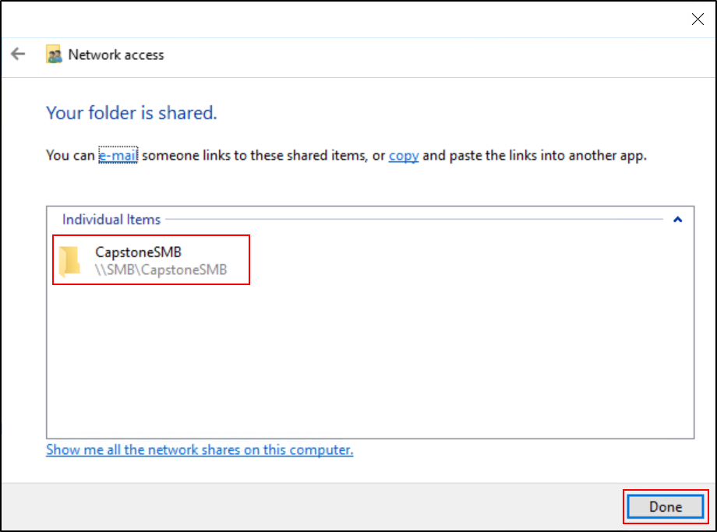

1. Now, you need to switch your account from capstone\administrator to capstone\smbadmin. Click on the Start Menu, select the user icon on the left side, then click on "Sign out". Log back into the machine using the capstone\smbadmin account in the Windows 10 SMB Server machine.
2. Once logged in as smbadmin, navigate to the CapstoneSMB folder (C:\CapstoneSMB). Right-click within the folder, select "New", then "Folder" and name it "Test".

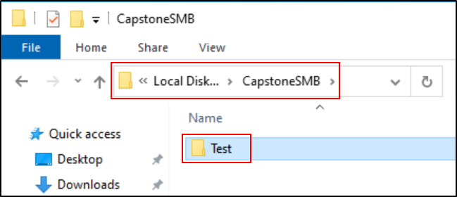

1. Testing SMB Connection from Another Machine

To test the SMB connection to the shared folder on your SMB Server from another machine, follow these steps:

1. On the remote machine (in this case we will use Windows Server 2019 DC), open the file manager or file explorer.
2. In the address bar of the file manager, enter the address of the shared folder in the following format: \\10.10.10.13\CapstoneSMB, Press Enter.
3. If prompted, enter the credentials of the capstone\smbadmin user or any other authorized Domain Users with access to the shared folder.
4. If the SMB connection is successful and the permissions are configured correctly, you should now be able to access the shared folder and its contents from the remote machine. You can perform various file operations such as creating, modifying, and deleting files within the shared folder.

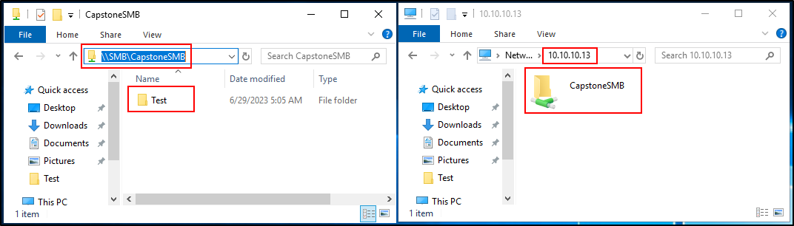

Remember to ensure that proper security measures are in place, such as using strong passwords, configuring appropriate access permissions, and regularly updating your systems to protect against any potential vulnerabilities.

After you've done these steps, the SMB2 Server should be properly configured on your Windows 10 SMB Server machine. You can access the shared folder from other machines in the network using the network path you wrote down in step 10.

## **Installing Splunk Enterprise in Windows Server 2019 Splunk:**

This involves downloading and installing Splunk Enterprise, configuring it to start at boot time, and logging into the Splunk interface.

Installing Splunk Enterprise in Windows Server 2019 Splunk:

1. Log in to your Windows Server 2019 Splunk machine using an account with administrative privileges (capstone\administrator).
2. Register an account on the Splunk website (<https://www.splunk.com/>) if you haven't already done so. This will allow you to download the Splunk Enterprise installation package and access additional resources.
3. Log in to your Splunk account using your credentials.

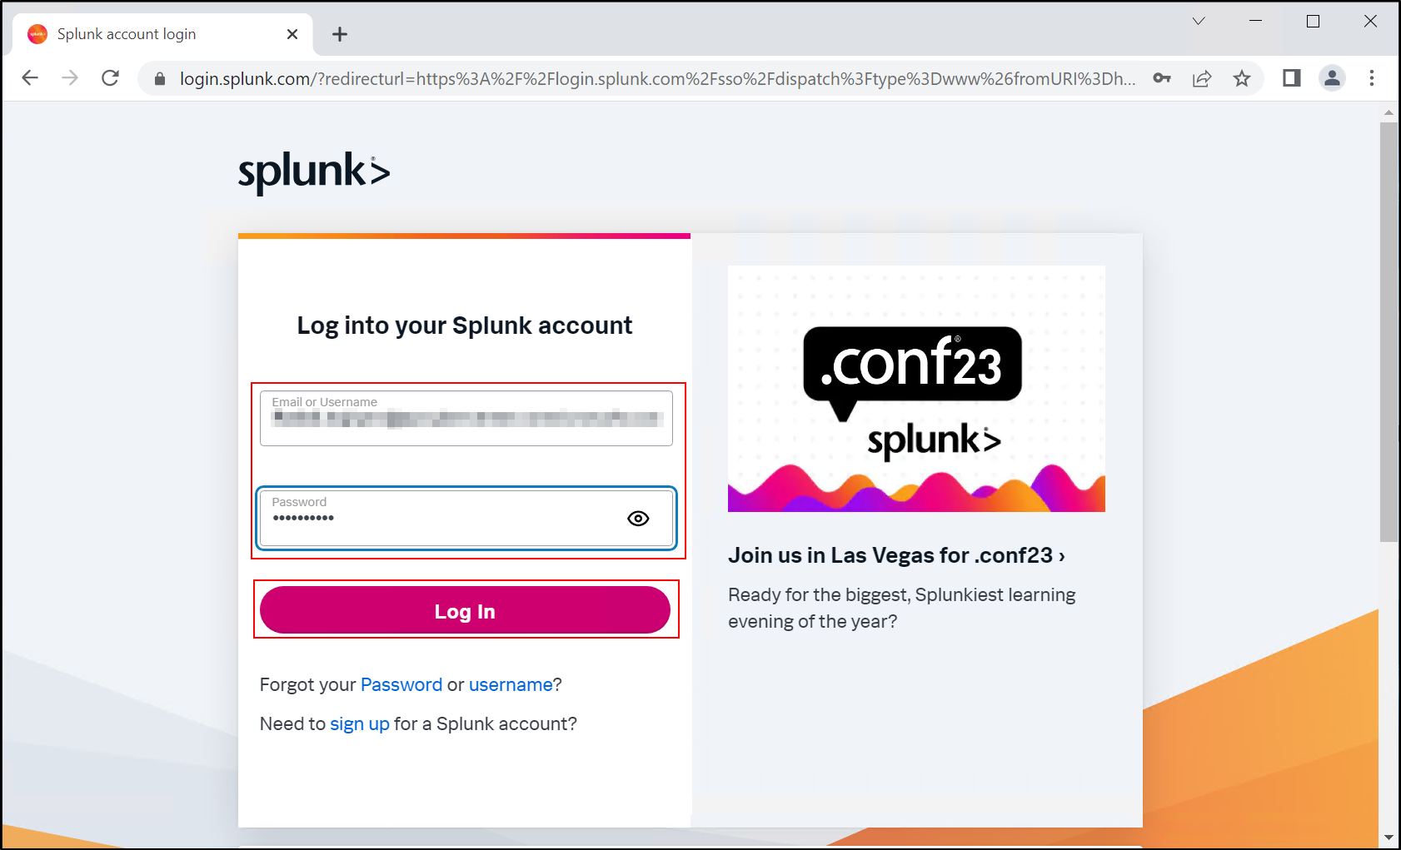

1. Navigate to the Splunk website (<https://www.splunk.com/>) and locate the download section. This is usually found in the top menu or in the main page sections.

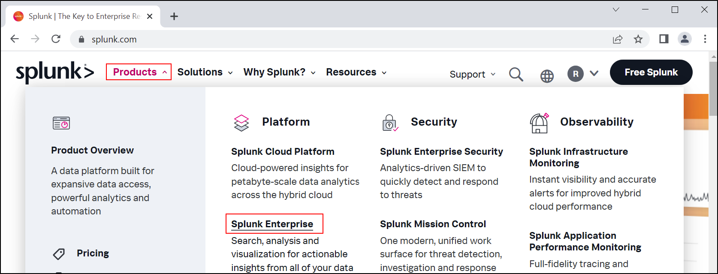



1. Choose the appropriate Splunk Enterprise installation package for Windows Server 2019. Make sure to select the version that matches your operating system and architecture (32-bit or 64-bit).
2. After selecting the appropriate Splunk Enterprise installation package for Windows Server 2019, click on the download link. The installation package will be automatically saved to the default Downloads folder on your Windows Server 2019 Splunk machine.

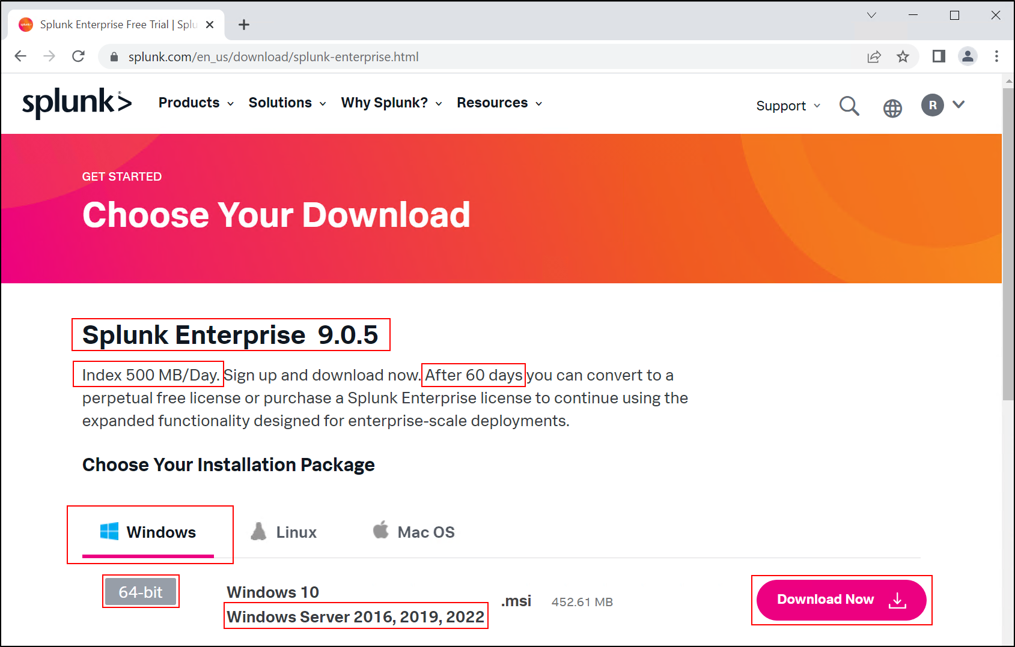

1. Once the download is complete, navigate to the Downloads folder on your Windows Server 2019 Splunk machine. Locate the downloaded Splunk Enterprise installation package and double-click on it to start the installation process. This action will launch the Splunk Enterprise installer and begin the installation procedure.
2. Follow the on-screen instructions to complete the installation. This includes accepting the license agreement, selecting the installation location, and configuring the startup behavior. Make sure to review each step carefully before proceeding.

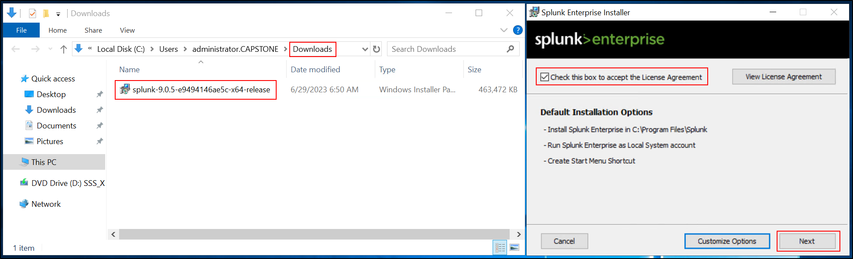

1. In the installation wizard, you will be prompted to set up an administrator username and password for Splunk Enterprise. Enter the following credentials:

* Username: splunkadmin
* Password: Pa$$word

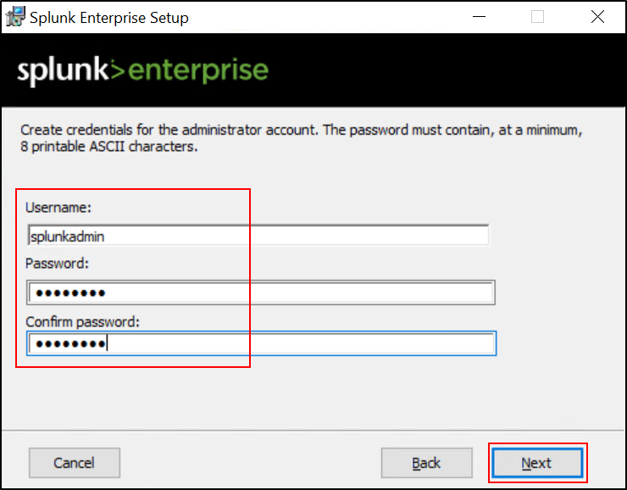 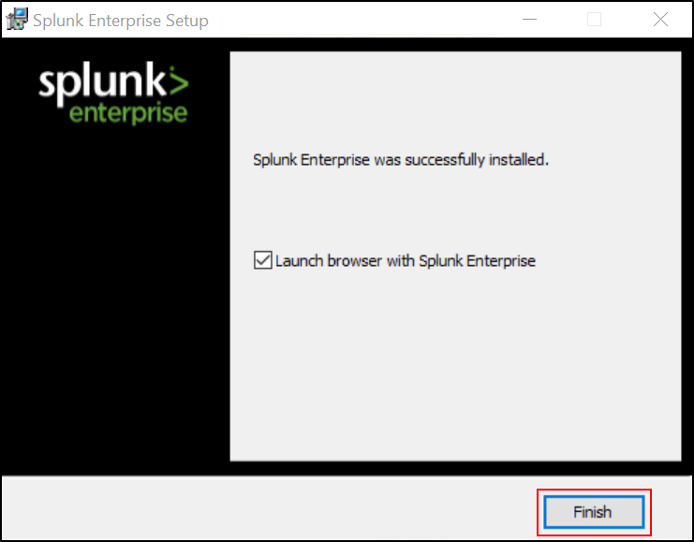

1. Once the installation is complete, open a chrome browser on the Windows Server 2019 Splunk machine.
2. In the address bar of the web browser, enter "<http://localhost:8000>" (or <http://10.10.10.20:8000>) to access the Splunk Enterprise web interface.

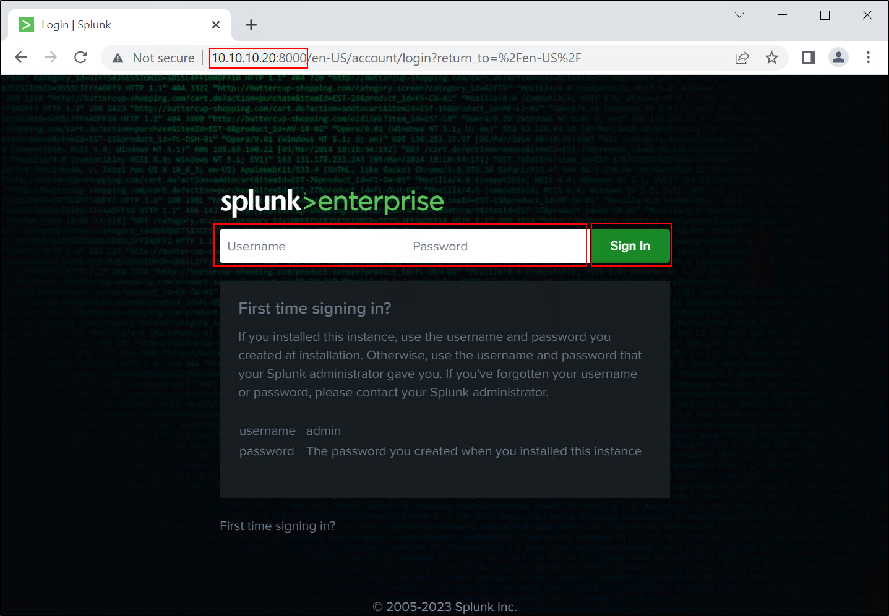

1. Enter the credentials for the administrator account you just created.

* Username: splunkadmin
* Password: Pa$$word

1. Upon successful login, you will have access to the Splunk Enterprise interface. From here, you can configure data inputs, create dashboards, and perform various data analysis tasks.

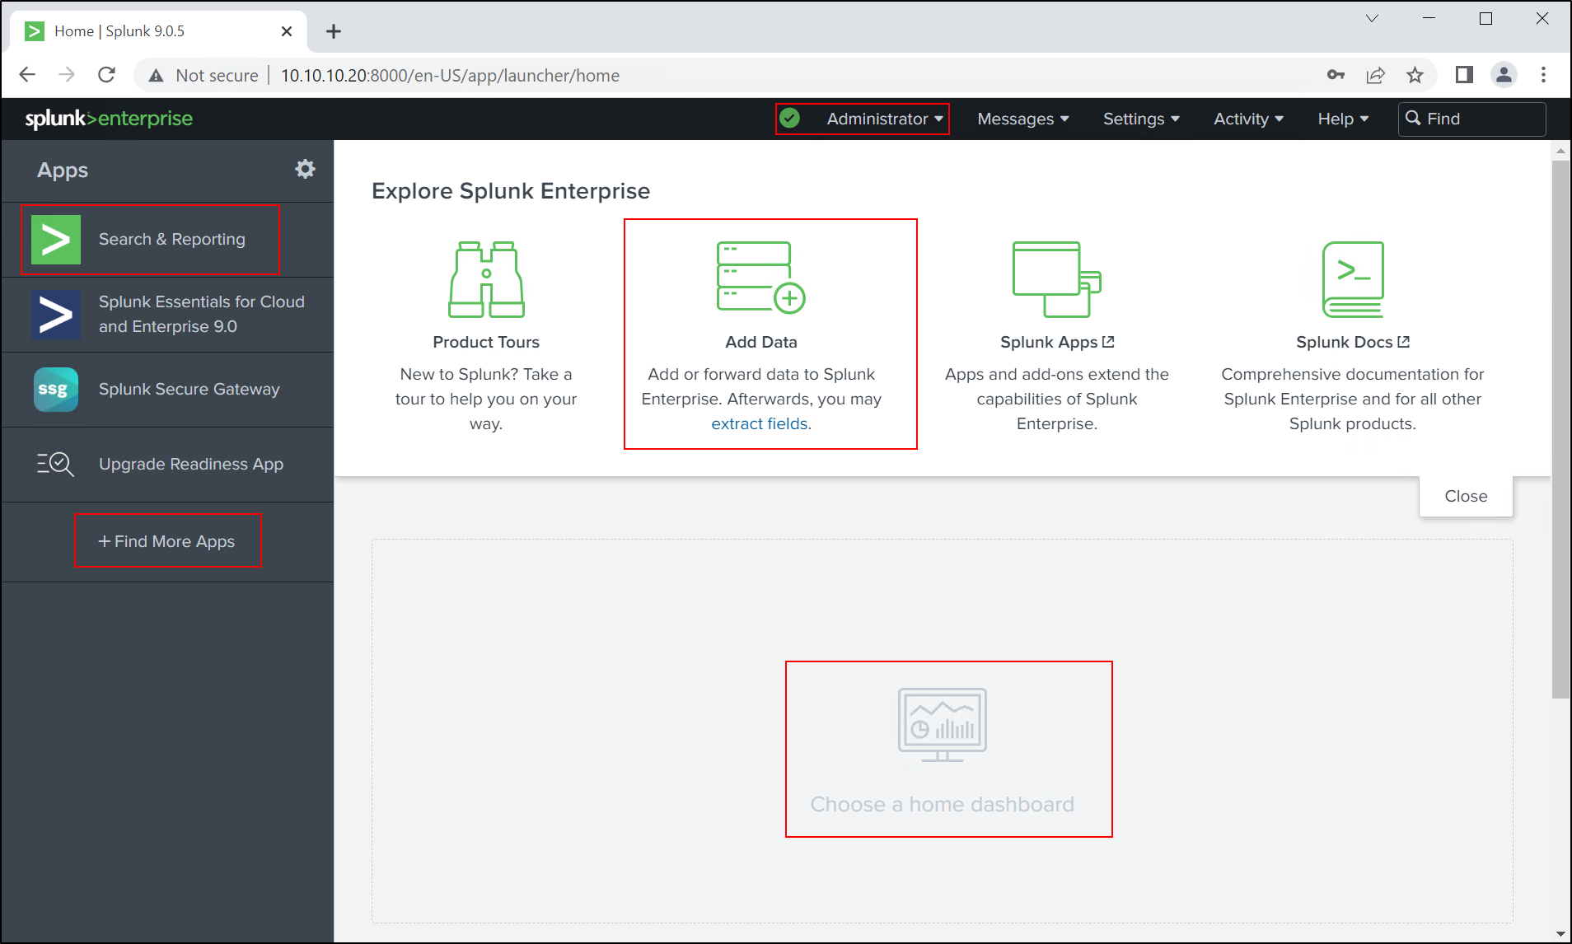

## **Configuring User Permissions and Access in Windows Server 2019 Splunk**

1. After successfull installetion log out of the Windows Server 2019 Splunk machine if you are currently logged in as "capstone\administrator".
2. On the login screen, select "Other user" and enter "capstone\splunkadmin" as the username. Provide the corresponding password for the "capstone\splunkadmin" account, Press Enter to log in with the "capstone\splunkadmin" account.

The lack of the shutdown and restart options for the SplunkAdmin account could be due to limited permissions assigned to this user account. By default, non-administrator accounts in Windows Server 2019 do not have shutdown or restart permissions to prevent accidental or unauthorized system shutdowns. However, if it's necessary for the SplunkAdmin user to have these privileges, you can grant them.

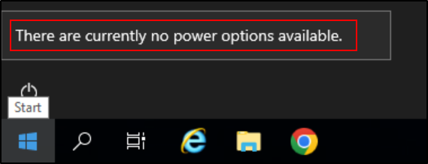

To allow the SplunkAdmin account to have the ability to shutdown or restart the system, you can modify the local security policy. Here's how to do it:

1. Login to the Windows Server 2019 Splunk with an administrator account.
2. Press Windows + R, type secpol.msc and hit Enter to open the Local Security Policy editor.
3. In the Local Security Policy editor, navigate to Security Settings > Local Policies > User Rights Assignment.

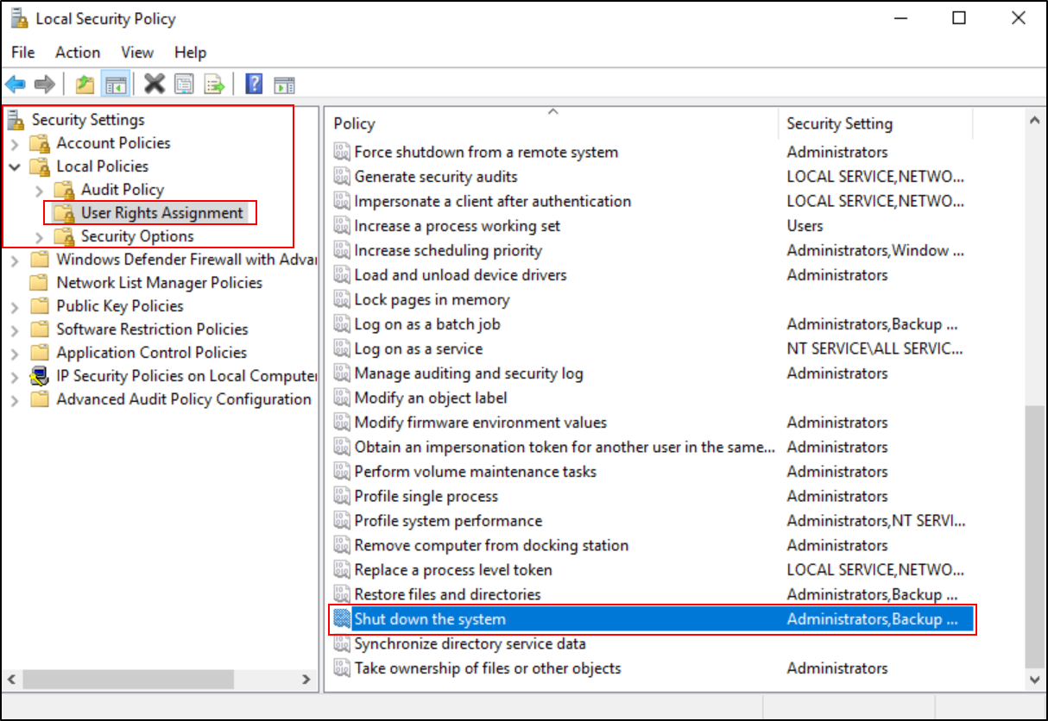

1. In the details pane, double-click Shutdown the system.
2. In the Shutdown the system Properties dialog box, click Add User or Group.

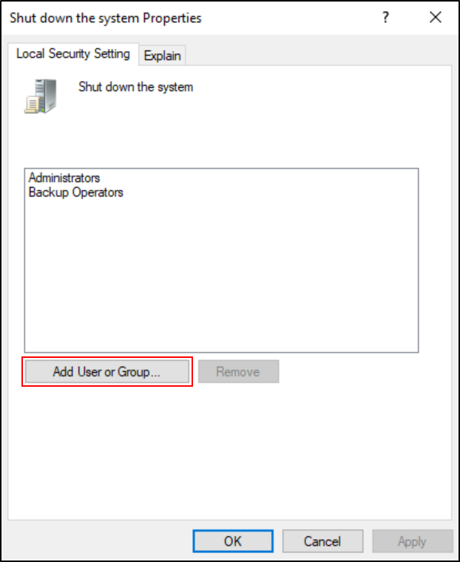

1. In the Select Users or Groups dialog box, type SplunkAdmin in the box, click Check Names, and then click OK.

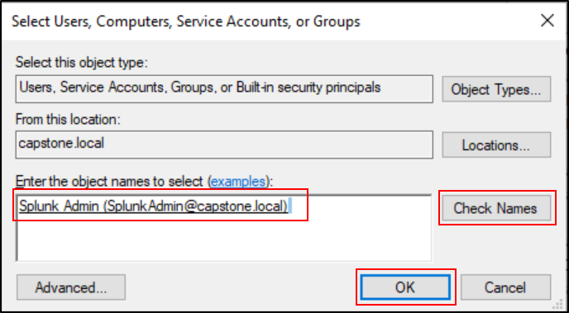

1. Click Apply and then OK.
2. Repeat steps 4-7 for the Force shutdown from a remote system if you want the user to have remote shutdown privileges too.

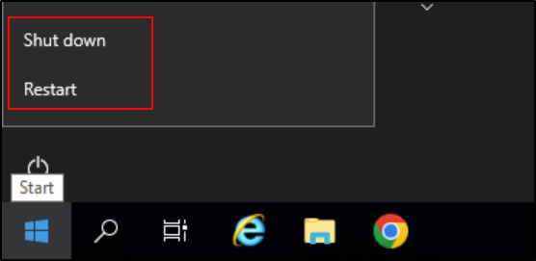

Now, SplunkAdmin should have the permissions to shutdown or restart the system.

Please note: This method gives shutdown rights to the user. It does not elevate the user to an administrative level. So, the user still follows the principle of least privilege.

## **Installing Universal Forwarder on Each Windows 10 Machine (Except Commando VM):**

Splunk's Universal Forwarder is a lightweight data collector which can be installed on the servers to gather data and send it back to the Splunk instance for indexing and analysis.

To get started with installing the Universal Forwarder on each Windows 10 machine, you'll need to follow these steps:

1. **Log in as Domain Administrator**: On your Windows 10 FTP Server machine, log in with the Domain Administrator account.
2. **Open Splunk Download Page**: Open a web browser on the Windows 10 FTP Server machine and navigate to the Universal Forwarder download page: <https://www.splunk.com/en_us/download/universal-forwarder.html>.
3. **Log into your Splunk Account**: If you're not already logged in, the website will prompt you to log into your Splunk account. If you don't have an account, you'll need to create one. Splunk requires users to have an account to download its software.
4. **Download the Universal Forwarder**: After logging in, choose the Universal Forwarder version that matches your system architecture (32-bit or 64-bit) and download it.

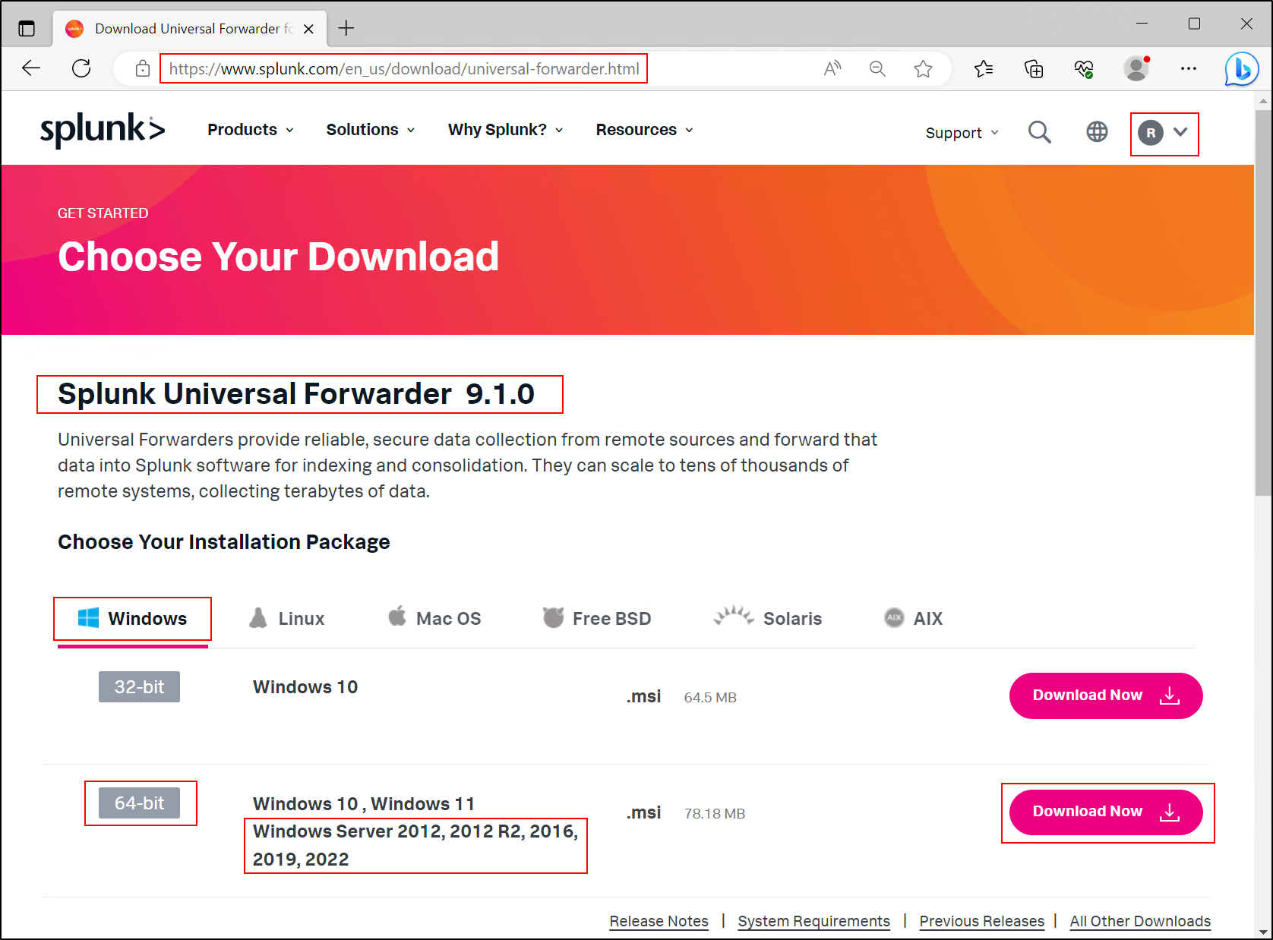

1. **Run the Installer**: After the download has completed, run the installer by double-clicking the .msi file. The Domain Administrator privileges should allow you to perform this operation.
2. **Configure the Installer**: During the installation, provide the following information:
   * **For "Destination Folder", leave the default setting unless you have a specific directory where you want to install the Universal Forwarder.**

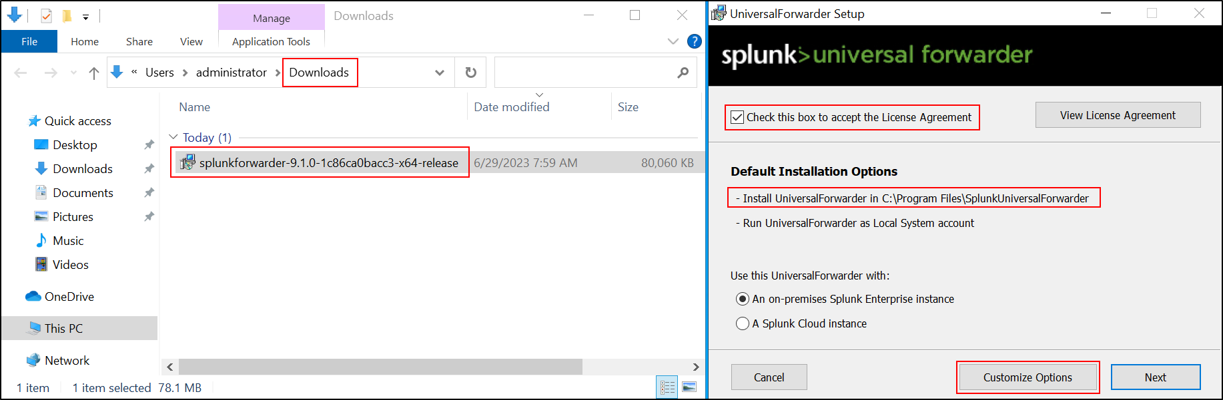

* + **In "Local System or Domain User", choose "Local System".**

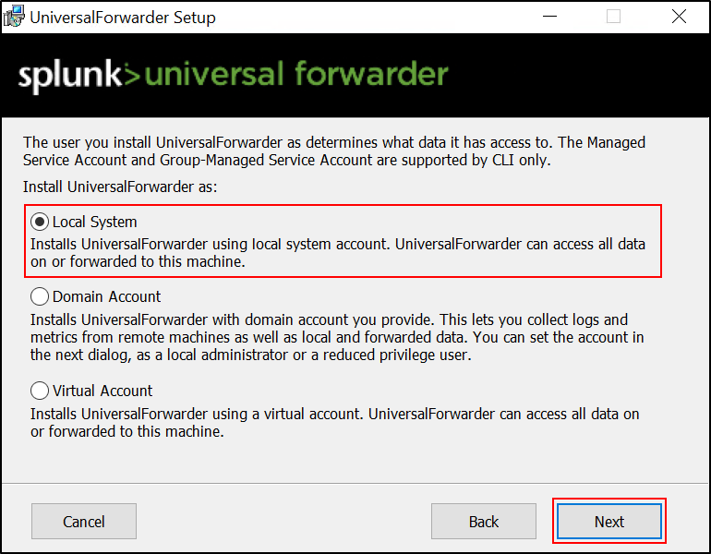

* + Don’t choose anything in this step, we will configure it later on.

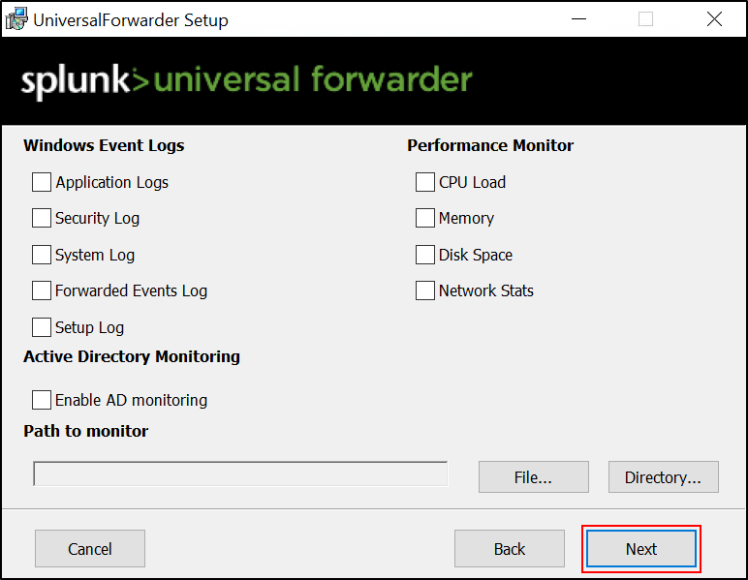

* + You will be asked credentials for the administrator account. You need to create credentials for your universal forwarder administrator account when you install it from an installer. This is different from the credentials you created for your Splunk enterprise in your domain controller. I will set the credentials like this:
    - Username: ftpsplunkadmin
    - Password: Pa$$word

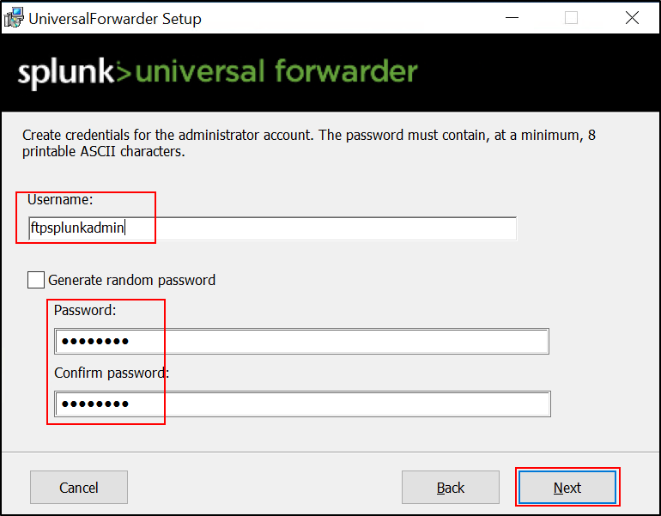

* + **Deployment Server:** Enter the IP address of your Splunk Enterprise instance (10.10.10.20) and the management port (default is 8089).

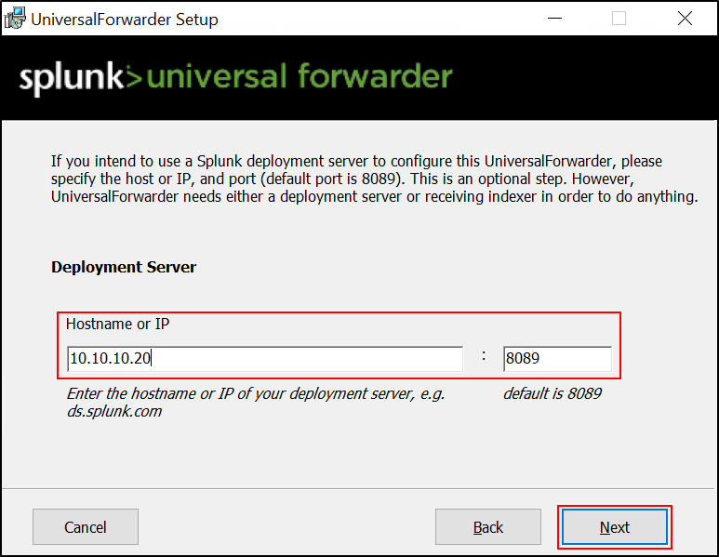

* + **Receiving Server (Indexer):** Enter the IP address of your Splunk Enterprise instance (10.10.10.20) and the receiving port (default is 9997). Note that you'll need to have enabled receiving on your Splunk Enterprise instance for this to work.

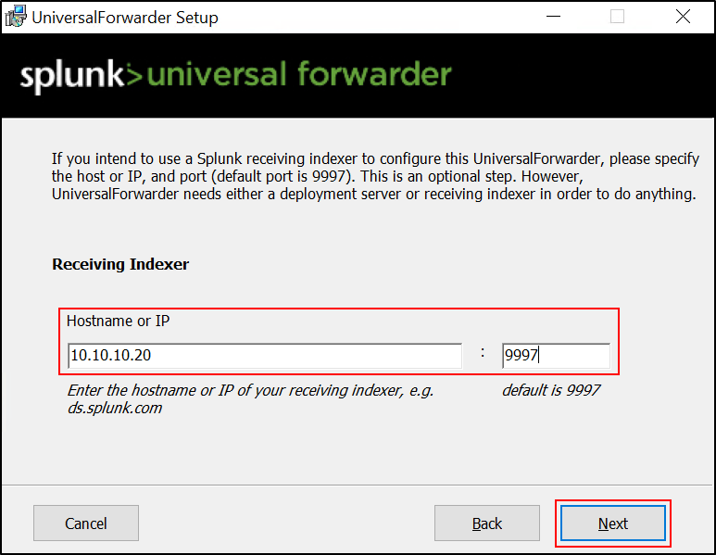

* + Click Install

1. **Complete the Installation**: Follow through the rest of the prompts to complete the installation. Once the installer finishes, the Universal Forwarder will start up automatically.

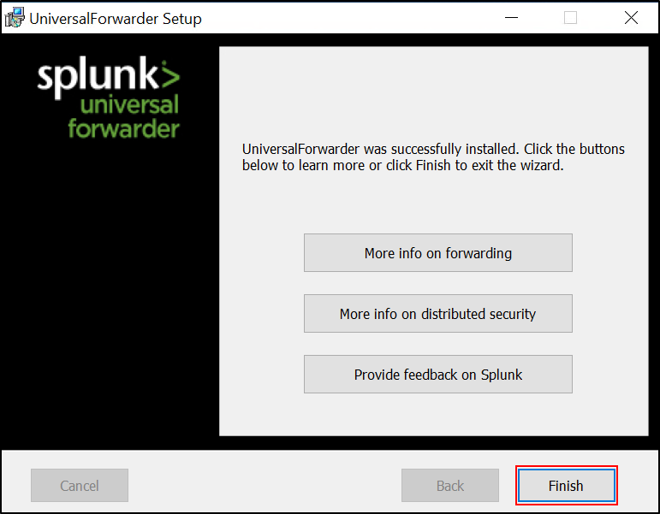

1. **Verify the Installation**: Check if the Universal Forwarder is running by opening the Windows Services manager (run "services.msc" from the Run dialog box) and look for "SplunkForwarder". The status should be "Running".

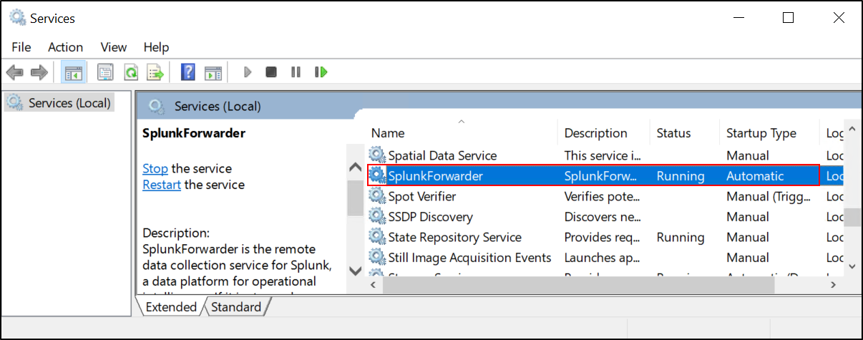

1. **Copy the Universal Forwarder Installer**: Transfer the Universal Forwarder installer that you downloaded earlier to the Windows 10 SSH Server and Windows 10 SMB Server machines (after logging in with the capstone\administrator account).
2. **Install the Universal Forwarder**: On each machine, run the Universal Forwarder installer.
3. **Specify Administrator Credentials: During the installation process on each machine, you'll be asked for the administrator credentials for the Universal Forwarder. These should be as follows:**
   * + For the Windows 10 SSH Server:

* Username: sshsplunkadmin
* Password: Pa$$word
  + - For the Windows 10 SMB Server:
* Username: smbsplunkadmin
* Password: Pa$$word

Remember to adjust your security settings and firewall to allow communication between the Universal Forwarder and your Splunk Server.

## **Setting Up Enhanced Session and Group Policy for Domain Users**

Before proceeding with the setup of the Universal Forwarder on each Windows 10 machine, you'll need to enable the enhanced session in Hyper-V and configure the necessary group policy settings to allow domain users to access the enhanced session. Follow these steps:

1. Open the Server Manager on the Windows Server 2019 DC and go to Tools > Active Directory User and Computers.
2. Expand the capstone.local domain and locate the Computers folder.
3. Press the Right Clikck on the capstone.local domain and Create a new OU (Domain Computers) (during the creation process uncheck “Protect container from accidental deletion”) and move the relevant computers (SPLUNK, FTP, SSH, SMB) from the Computers folder to the newly created OU using drag and drop.

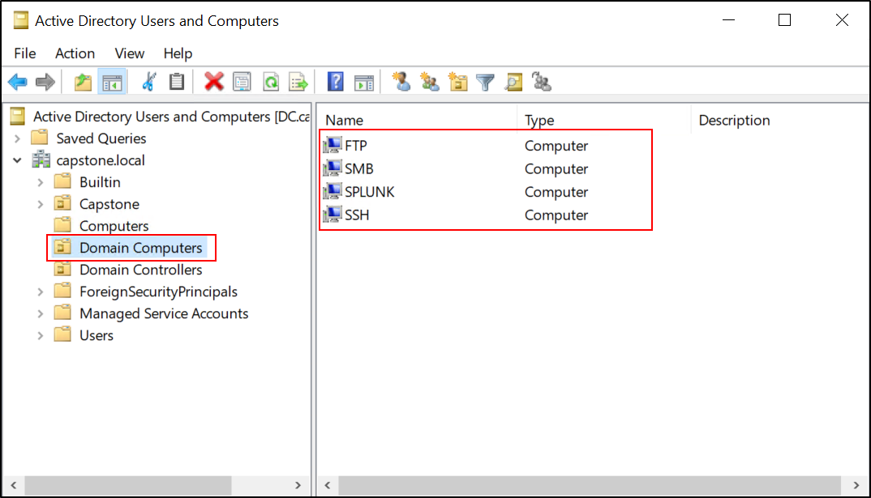

1. Navigate to the Builtin folder and locate the "Remote Desktop Users" Built-in group.
2. Right-click on the "Remote Desktop Users" group, select Properties.
3. In the Members tab, click Add, type "Domain Users" in the field, click Check Names, and then click OK.

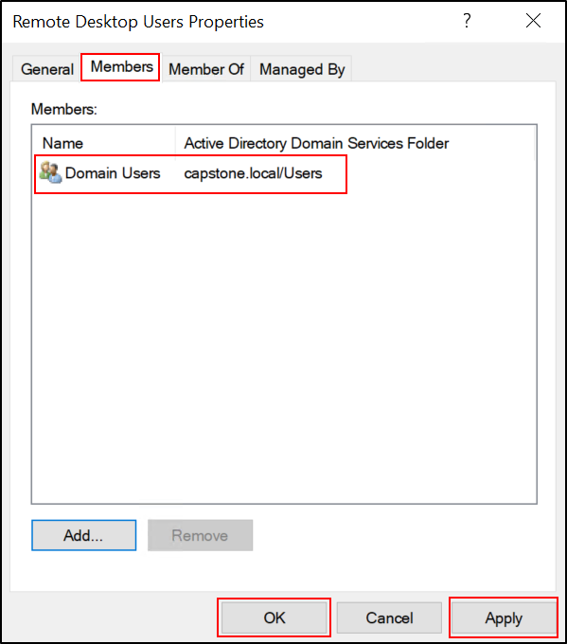

1. Now, we need to create a group policy for the computers.
2. Open the Server Manager, go to Tools, and click on "Group Policy Management".
3. Expand your domain (capstone.local) and click on Group Policy Objects.
4. Right-click and select New to create a new group policy.
5. Name the group policy "Remote Desktop Users Policy" and click OK.

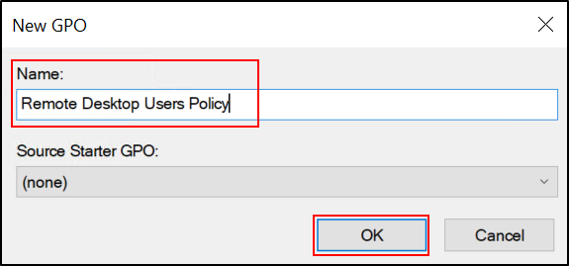

1. Right-click the created group policy and select Edit.
2. In the group policy editor, configure the following settings:
   * Enable "Allow users to connect remotely by using RDS" under Computer Configuration > Policies > Administrative Templates > Windows Components > Remote Desktop Services > Remote Desktop Session Host > Connections.

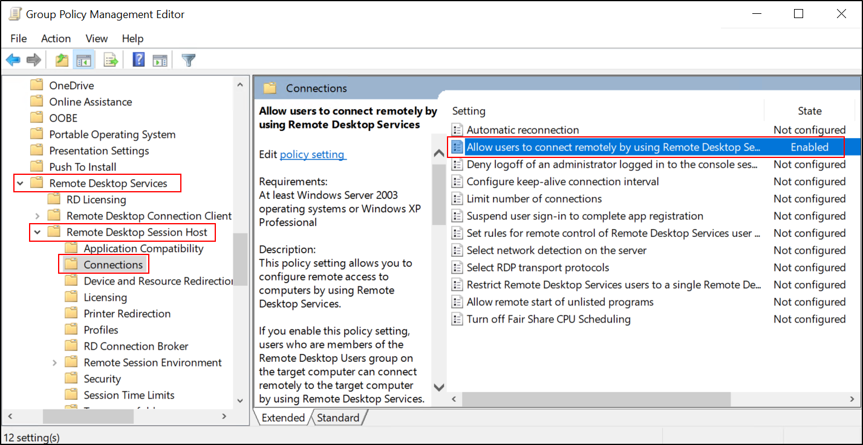

* + Enable "Require user authentication for remote connections by using Network Level Authentication" under Computer Configuration > Policies > Administrative Templates > Windows Components > Remote Desktop Services > Remote Desktop Session Host > Security.

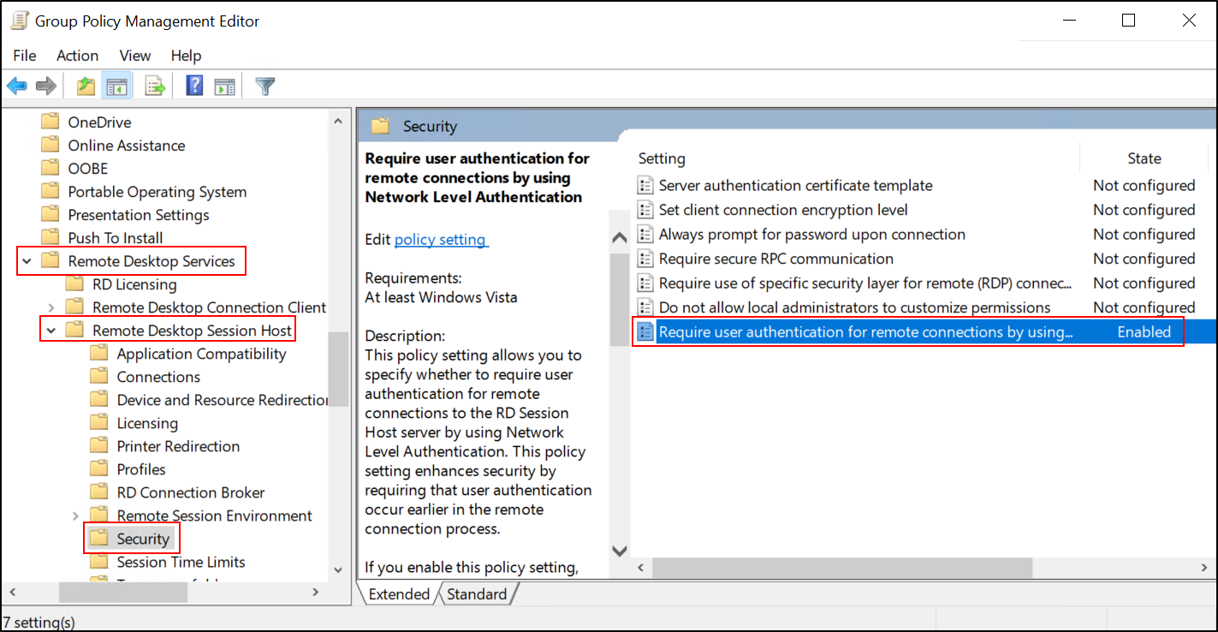

* + Configure the "Remote Desktop Users (built-in)" group under Computer Configuration > Control Panel Settings > Local users and groups. Add the "Domain Users" group to the Remote Desktop Users group.

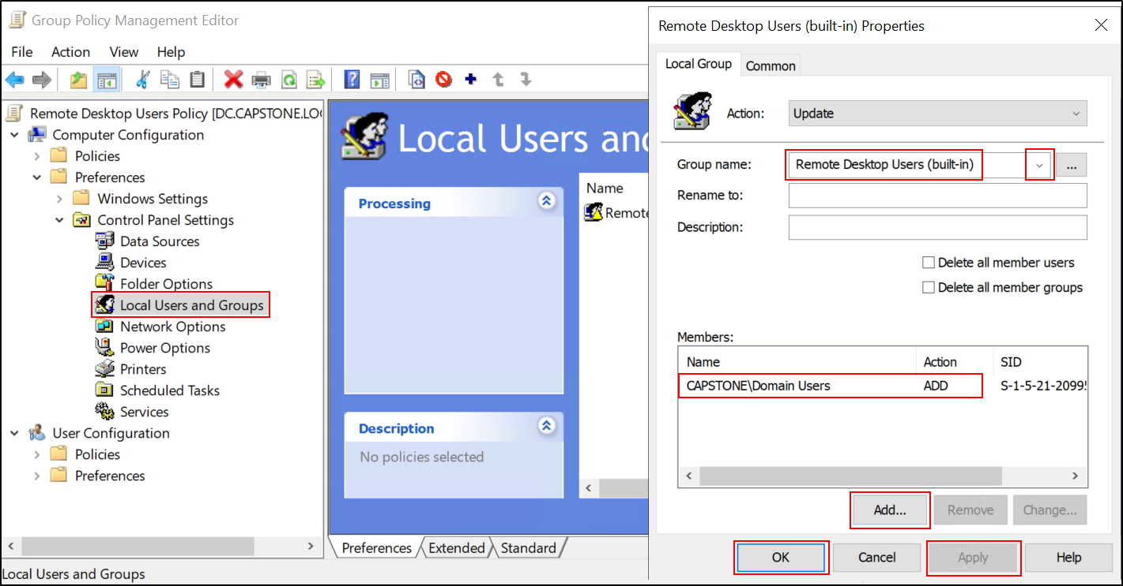

1. Once the group policy settings are configured, link the "Remote Desktop Users Policy" group policy to the "Domain Computers" and “Capstone” OUs by right-clicking on the OU, selecting "Link an Existing GPO...", and choosing the "Remote Desktop Users Policy" group policy.

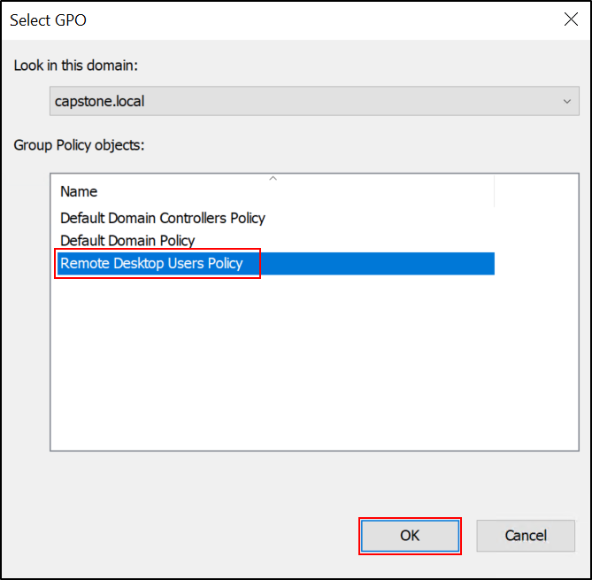

1. Open PowerShell with administrative privileges and run the command "gpupdate /force" to force the group policy update.

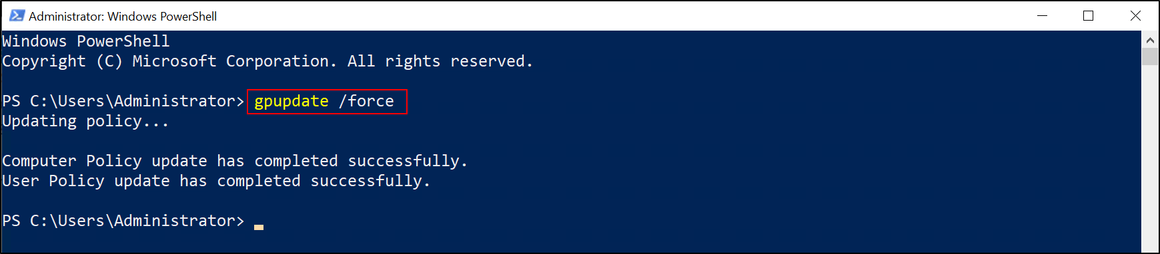

1. Restart the client PCs to apply the group policy settings to the users.

By following these steps, you have enabled the enhanced session in Hyper-V and configured the necessary group policy settings to allow domain users to access the enhanced session. This will allow you to log in to the "capstone\splunkadmin," "capstone\ftpadmin," "capstone\sshadmin," and "capstone\smbadmin" accounts in the enhanced session.

Please note that these steps provide a general guideline for enabling the enhanced session and configuring group policy settings. It's always recommended to refer to the official documentation for detailed instructions specific to your environment and requirements.

## Change the time zone of machines to Coordinated Universal Time (UTC), follow these steps:

**For Windows 10 Pro:**

1. Open the Control Panel.
2. Click on Clock and Region.
3. Click on Date and Time.
4. Click on Change the time zone.
5. In the dropdown, select (UTC) Coordinated Universal Time and then click OK.

**For Windows Server 2019:**

1. Open Server Manager.
2. In the upper right corner, click on Local Server.
3. In the main panel, find the TIME ZONE section. Click on the link that shows the current timezone.
4. This will open the Date and Time dialog box. Click on Change time zone....
5. In the dropdown, select (UTC) Coordinated Universal Time and then click OK.

Changing the system's timezone will affect all software and services running on the server. In particular, for your FTP server on IIS, the timestamps in the logs are recorded in UTC by default. Therefore, if you change the system timezone to UTC, the log timestamps will match your system time.

Note that you may need to restart your machines or at least certain services on them for the timezone change to fully take effect.

## **Setting Up Universal Forwarder in Each Windows 10 Machine:**

After installation, you need to set up and configure each Universal Forwarder to ensure it is collecting and forwarding the right data to your Splunk instance.

Before proceeding with the configuration of the Universal Forwarder, ensure that you are logged in to the system with the domain administrator account (capstone\administrator).

**Part 1**: Initial Configuration in Splunk Enterprise

1. Log in to Splunk Enterprise on the Windows Server 2019 Splunk machine using a web browser.
2. Navigate to the Settings menu and select Forwarding and Receiving.

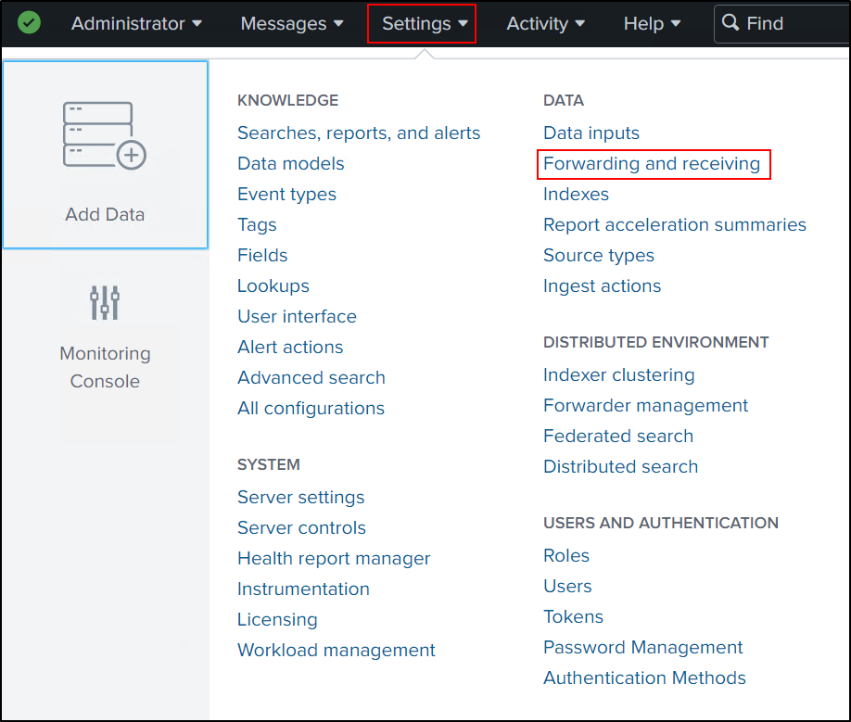

1. In the Forwarding and Receiving settings, set the desired port for the forwarder to communicate with Splunk Enterprise (e.g., 9997).

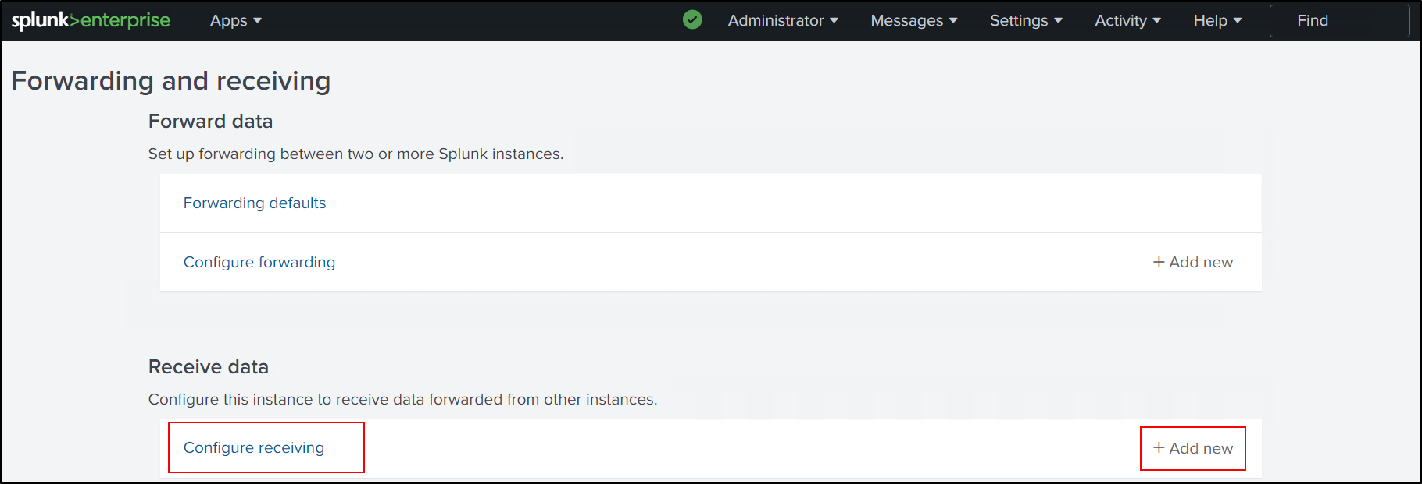

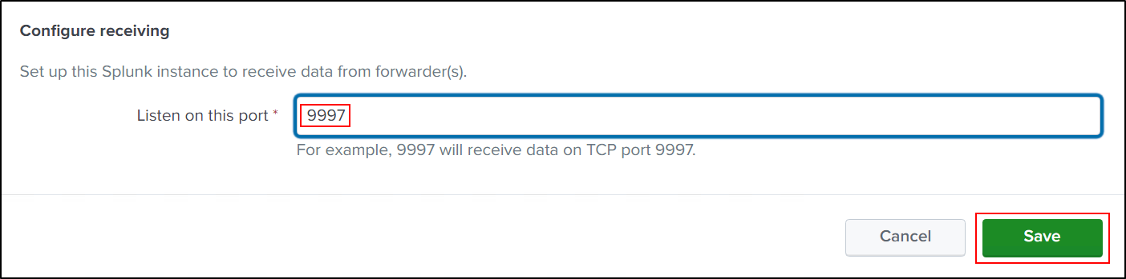

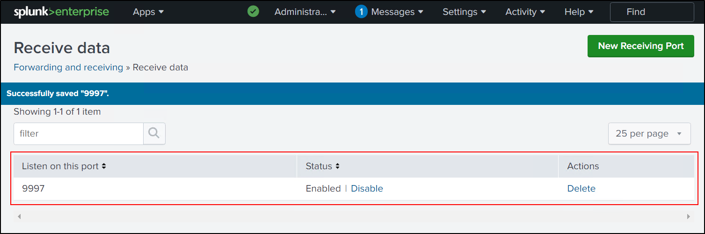

1. Navigate to the Settings menu and select Indexes.

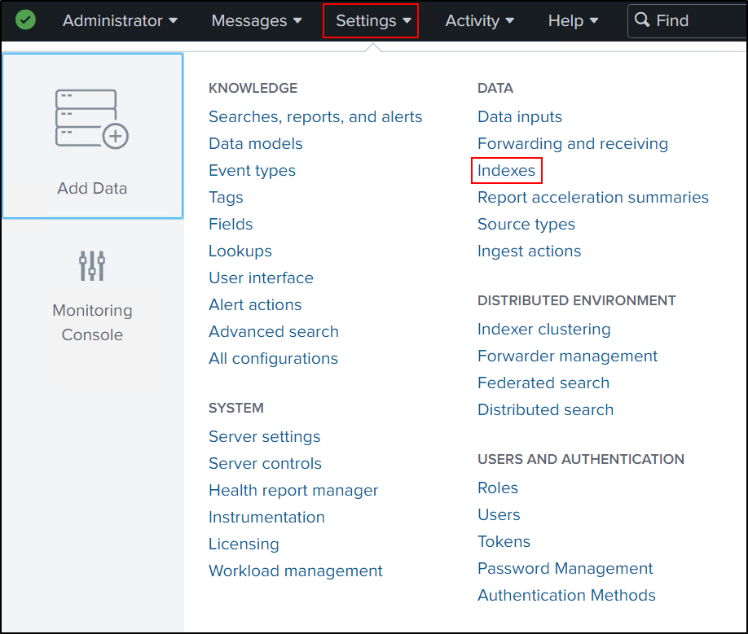

1. Click on the "New Index" button to create a new index.

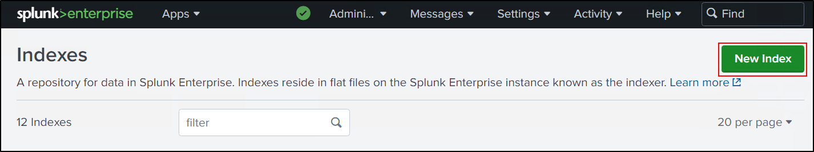

1. In the "Index Name" field, enter a name for the index (ftplogs).
2. Click on the "Save" button to create the index. Repeat this process to create indexes for SSH and SMB as well, using the respective names (sshlogs and smblogs).

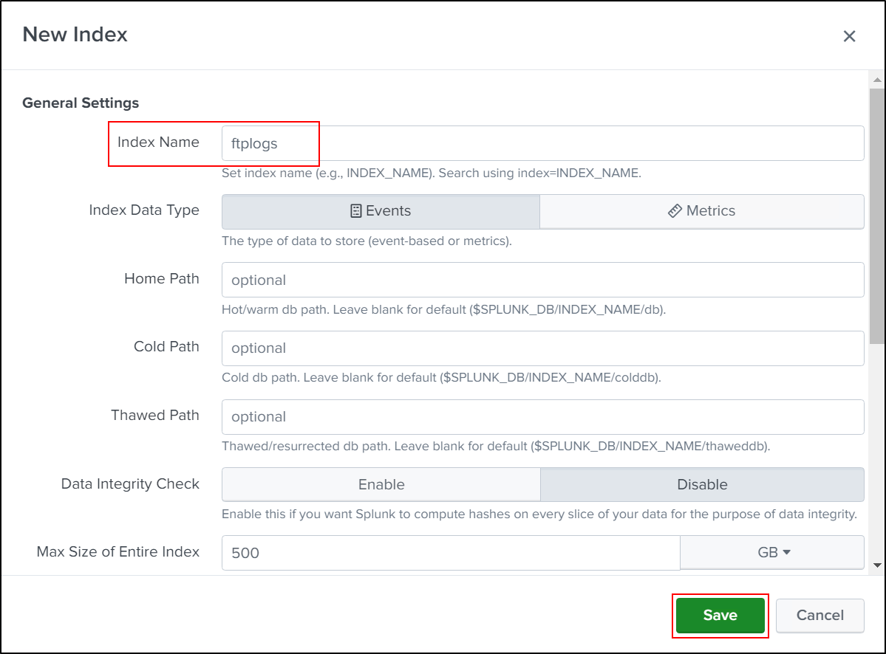

1. After creating the indexes, verify that they appear in the Indexes list with the correct configurations.

**Part 2:** confirm that your Windows 10 machines (FTP, SSH, SMB) are connected to Splunk Enterprise

1. Navigate to the Settings menu and select "Forwarder Management."

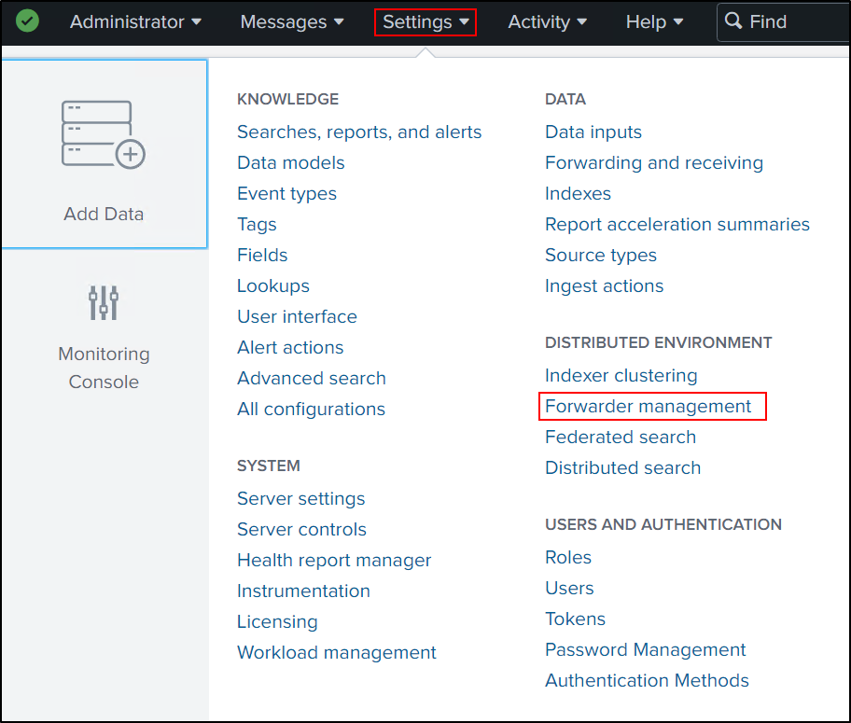

1. In the Forwarder Management window, you should see a list of connected forwarders.
2. Look for the entries corresponding to your Windows 10 machines (FTP, SSH, SMB). These entries should display the machine names or IP addresses.

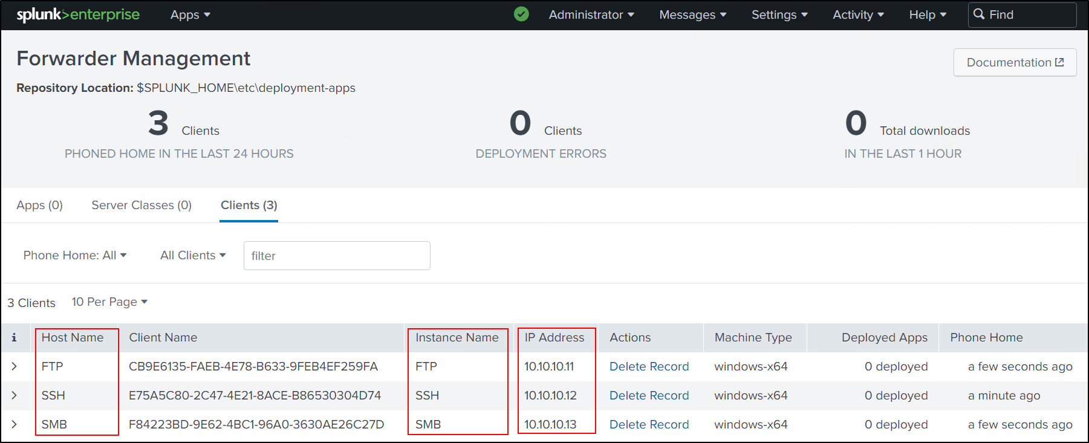

1. Wait for a few minutes if you don't immediately see your machines listed. It may take some time for the forwarders to establish a connection and appear in the Forwarder Management window.

The Forwarder Management window provides an overview of the connected forwarders and their status. It allows you to monitor the health and connectivity of the forwarders in your Splunk environment. By confirming the presence of your Windows 10 machines in this window, you can ensure that the forwarders are successfully sending data to Splunk Enterprise for further processing and analysis.

**Part 3:** Configuration for Windows 10 FTP Server

to configure FTP logging in IIS manager on your Windows 10 FTP Server machine:

1. **Log in as Domain Administrator**: On your Windows 10 FTP Server machine, log in with the Domain Administrator account.
2. Type IIS manager in the Start Menu and press Enter to launch the IIS Manager console.
3. In the left panel, navigate to the FTP site where your application (Capstone) is located and click on it. If you have multiple sites, they will be listed under the Sites folder.
4. In the middle panel, double click FTP Logging. This will open the FTP Logging settings.
5. Click on Select W3C Fields.... This will open a dialog box where you can choose which fields to log.
6. Enable the Service Name, Server Name, Host, and Client Port fields by checking the boxes next to them. Click OK to close the dialog box.

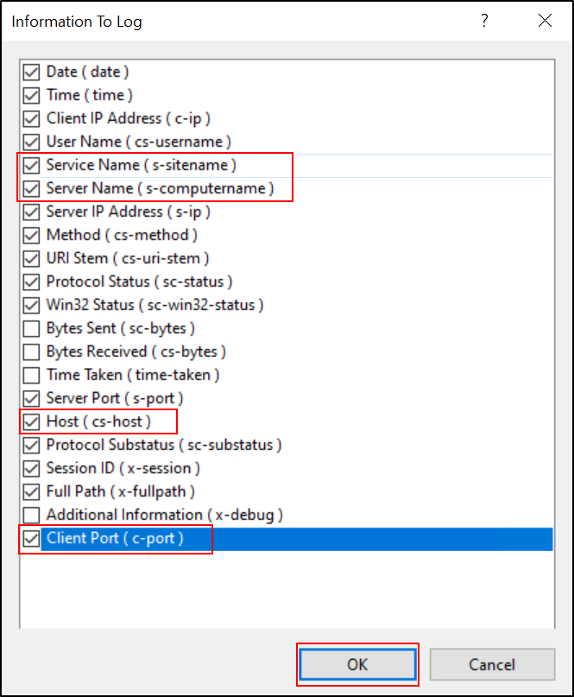

1. In the right panel (the Actions pane), click Apply. This will save your changes.
2. Now, you need to restart IIS for the changes to take effect. Type cmd in the Start Menu and press Enter to open the Command Prompt.
3. In the Command Prompt, type iisreset /restart and press Enter. This command will stop and then restart all IIS services.

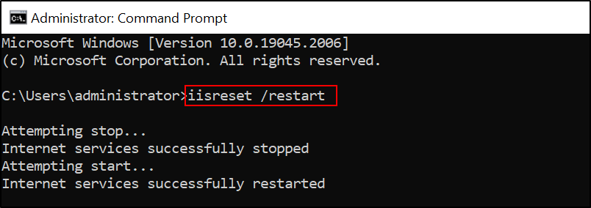

After doing these steps, your IIS FTP server will start logging the specified fields for each FTP request. The log files will be saved in the directory you specified in the FTP Logging settings (or the default directory, if you didn't specify one).

Then, you can proceed with the Splunk configuration to forward these logs as per the steps provided in the previous response.

Configure Splunk Forwarder to monitor and forward FTP logs from your Windows 10 FTP Server.

1. **Log in to Both Machines:** Log in as a domain administrator to both your Windows Server 2019 Splunk and your Windows 10 FTP Server.
2. **Verify FTP Server Log Directory:** Check the FTP Server log directory in your Windows 10 machine to ensure it's properly set up. The directory path should be C:\inetpub\logs\LogFiles\FTPSVC2\.

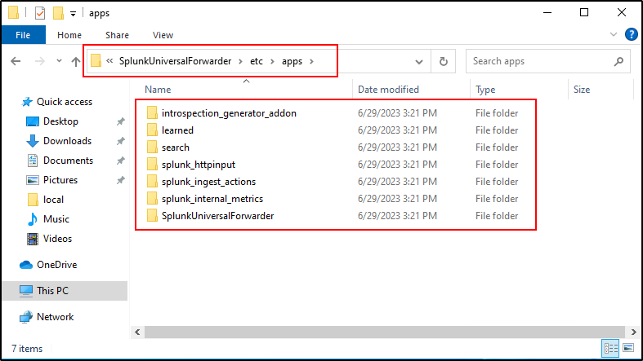

1. **Access Splunk Enterprise:** Open Splunk Enterprise on your Windows Server 2019 and log in with your admin account.
2. **Navigate to Data Inputs:** On the Splunk dashboard, click on 'Settings' in the upper-right corner, then select 'Data inputs' from the drop-down menu.

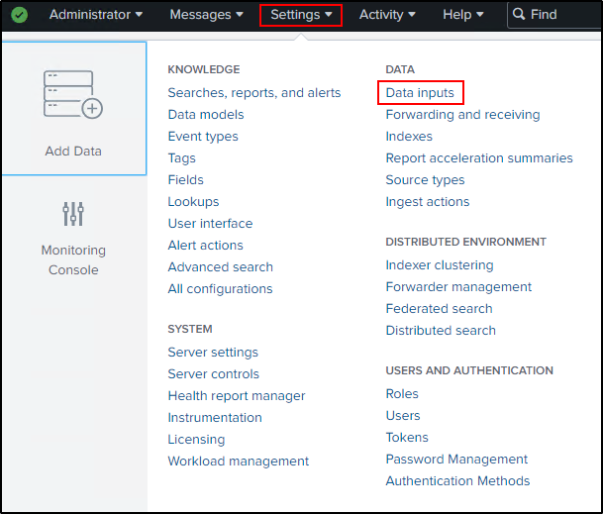

1. **Go to Forwarder Inputs:** In the 'Data Inputs' page, scroll down to 'Forwarder inputs' and click on 'Files & Directories'.

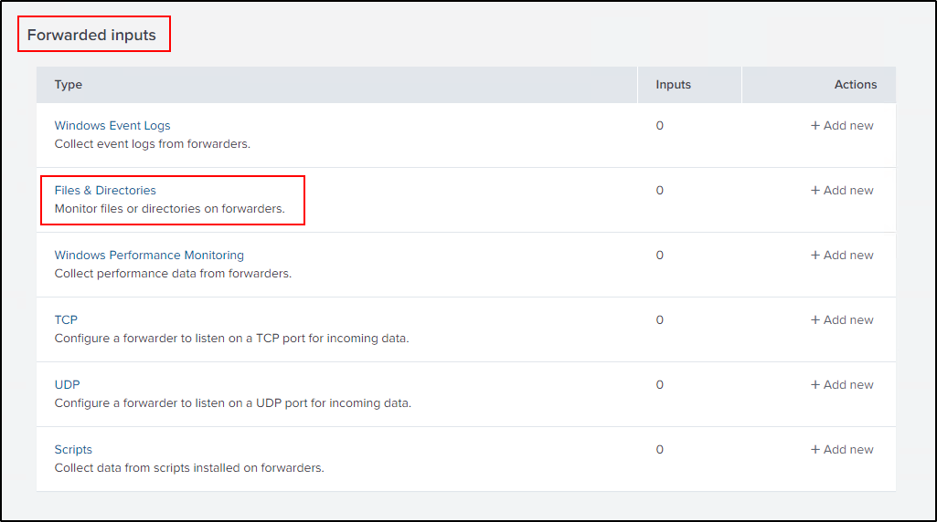

1. **Create New Remote File & Directory:** On the next screen, click 'New Remote File & Directory'.

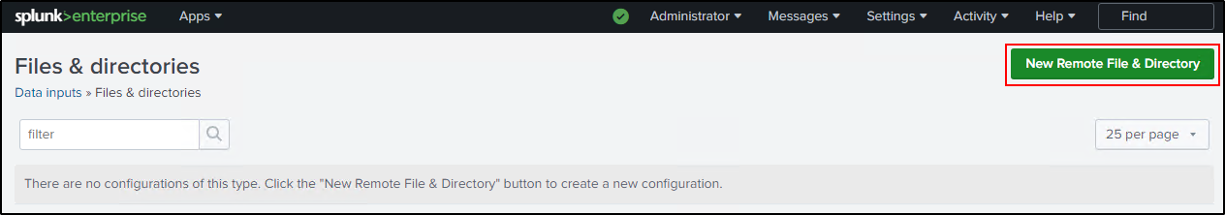

1. **Select FTP Server:** Under 'Available host(s)', select your FTP server machine. Provide a 'New Server Class Name – for instance, "FTP_Server".

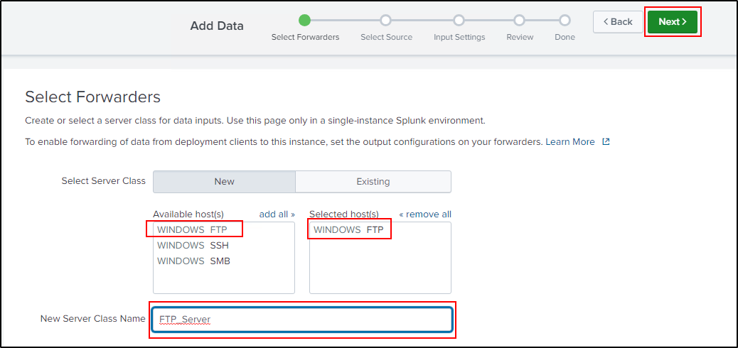

1. **Specify FTP Server Log Path:** Type the path to the FTP Server logs, C:\inetpub\logs\LogFiles\FTPSVC2\*.log, into the input box. This path is on the Windows 10 FTP Server machine. The "*.log" at the end means all log files in the directory will be ingested.

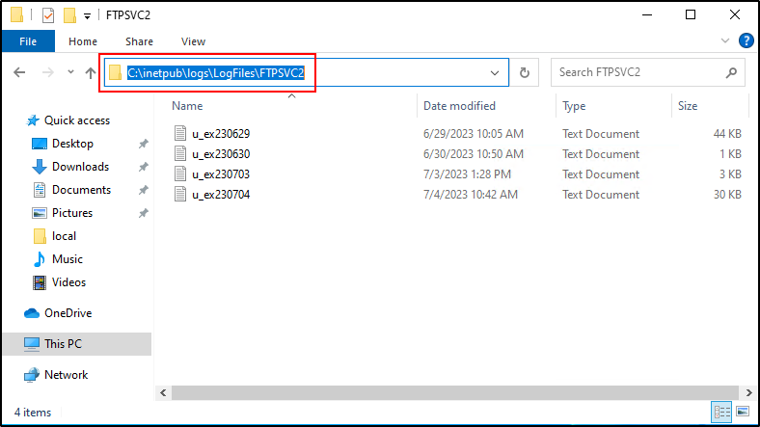

1. **Select the 'ftplogs' Index:** From the 'indexes' drop-down menu, select the 'ftplogs' index that you previously created, then click 'Review'.

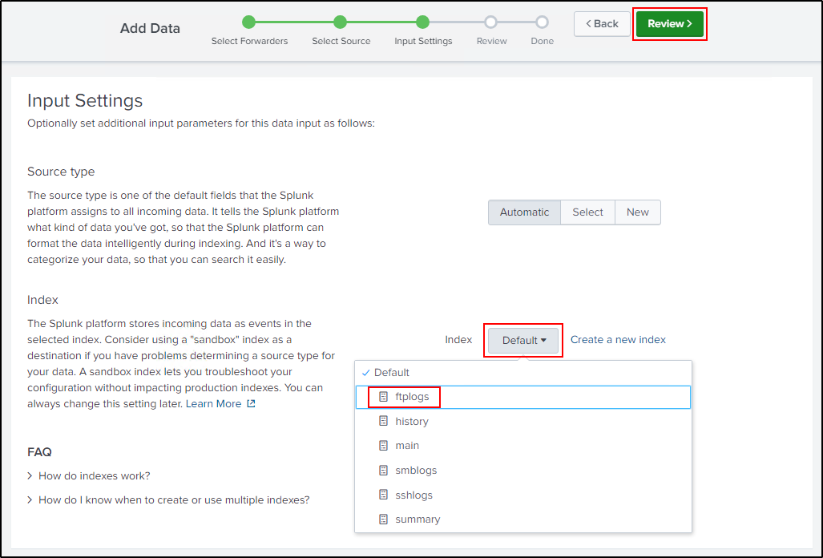

1. **Submit and Deploy:** Confirm all the information is correct, then click 'Submit'.

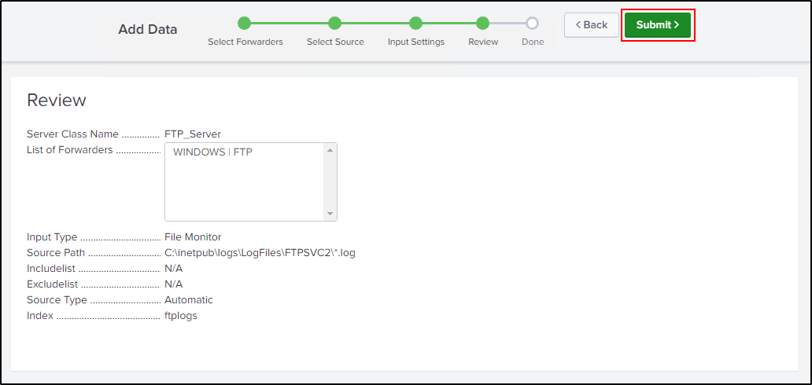

1. **Wait for Deployment:** Wait approximately 5 minutes for the deployment process to complete. No system restart is required.

After completing these steps, your Splunk Forwarder should be configured to monitor and forward FTP logs from your Windows 10 FTP Server to your Splunk Enterprise system.

1. Now we can check if the logs are correctly being forwarded to your Splunk Enterprise instance. As a domain administrator, log into your Windows Server 2019 machine where Splunk is installed.
2. Open a web browser (Chrome) and navigate to the Splunk web interface at <http://10.10.10.20:8000>.
3. Log into the Splunk web interface using your admin account credentials.
4. In the left pane, select "Search & Reporting".
5. In the Search field at the top, enter index=ftplogs and press Enter or click on the magnifying glass button to start the search.
6. You should now see a list of events from your OpenSSH logs. Each event corresponds to a line in the log files and displays the various fields extracted from the logs.

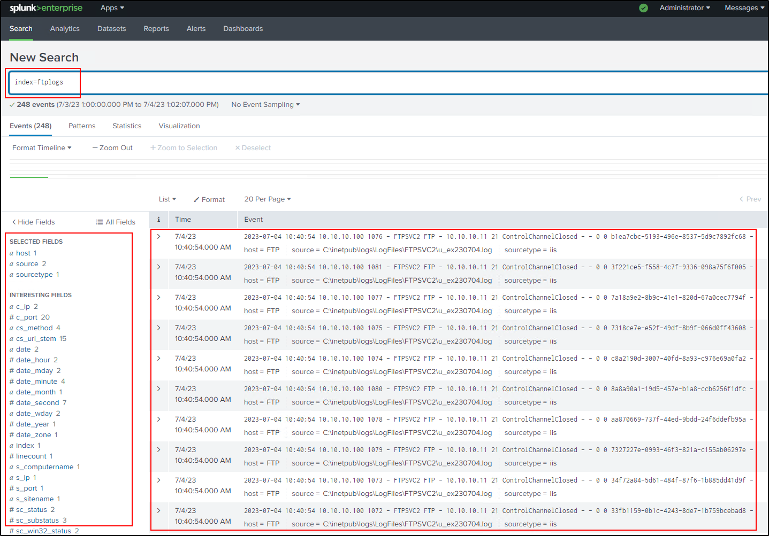

**Part 4:** Configuration for Windows 10 SSH Server

Step by Step Guide to Configuring OpenSSH Log in Splunk Forwarder:

1. Log into your Windows 10 SSH Server as a domain administrator.
2. Open the File Explorer and navigate to the C:\Program Files\SplunkUniversalForwarder\etc\apps\SplunkUniversalForwarder\default directory.
3. Here, locate the inputs.conf file.
4. Copy the inputs.conf file.
5. Now navigate to C:\Program Files\SplunkUniversalForwarder\etc\system\local.
6. Paste the copied inputs.conf file into this directory.
7. Open the newly copied inputs.conf file with a text editor like Notepad.
8. Add the following configuration to the inputs.conf file:

[WinEventLog://OpenSSH/Admin]

disabled = 0

index = sshlogs

sourcetype = OpenSSH

checkpointInterval = 10

[WinEventLog://OpenSSH/Operational]

disabled = 0

index = sshlogs

sourcetype = OpenSSH

checkpointInterval = 10

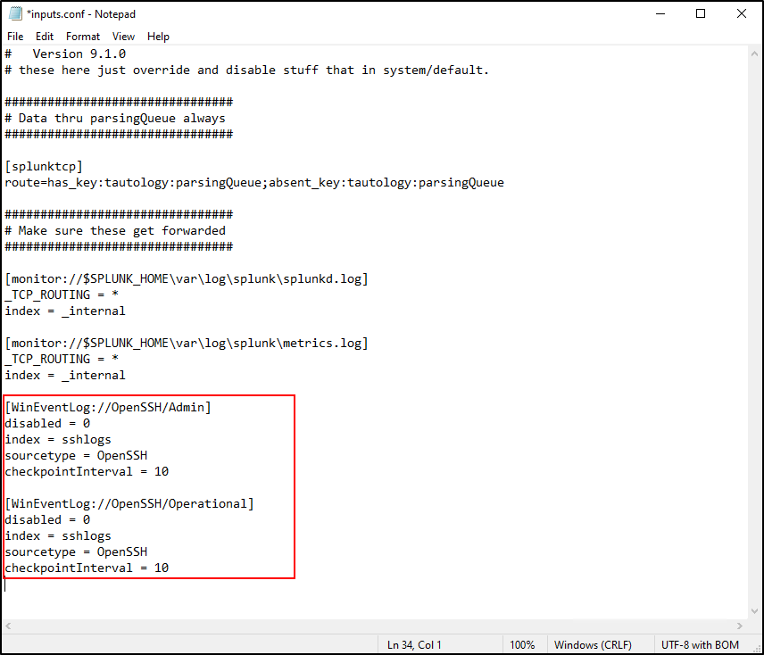

1. Save the changes to the inputs.conf file and close the text editor.
2. Next, we need to restart the Splunk Forwarder service for these changes to take effect. Open PowerShell as an administrator.
3. Change directory to the Splunk Forwarder bin directory by entering:

cd 'C:\Program Files\SplunkUniversalForwarder\bin'

1. Restart the Splunk Forwarder service by entering:

.\splunk.exe restart

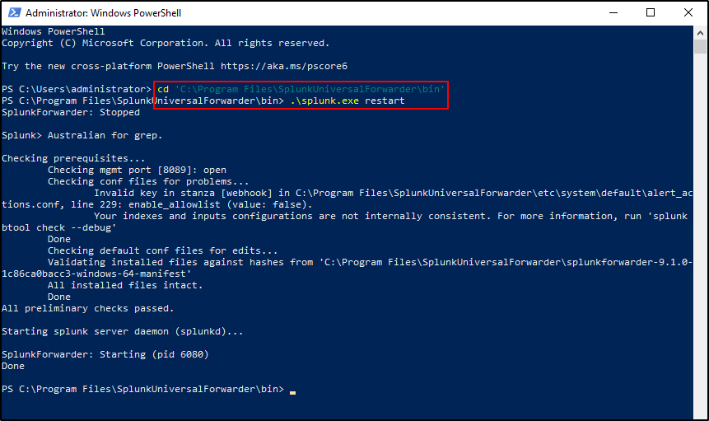

1. Now we can check if the logs are correctly being forwarded to your Splunk Enterprise instance. As a domain administrator, log into your Windows Server 2019 machine where Splunk is installed.
2. Open a web browser (like Chrome) and navigate to the Splunk web interface at <http://10.10.10.20:8000>.
3. Log into the Splunk web interface using your admin account credentials.
4. In the left pane, select "Search & Reporting".
5. In the Search field at the top, enter index=sshlogs and press Enter or click on the magnifying glass button to start the search.
6. You should now see a list of events from your OpenSSH logs. Each event corresponds to a line in the log files and displays the various fields extracted from the logs.

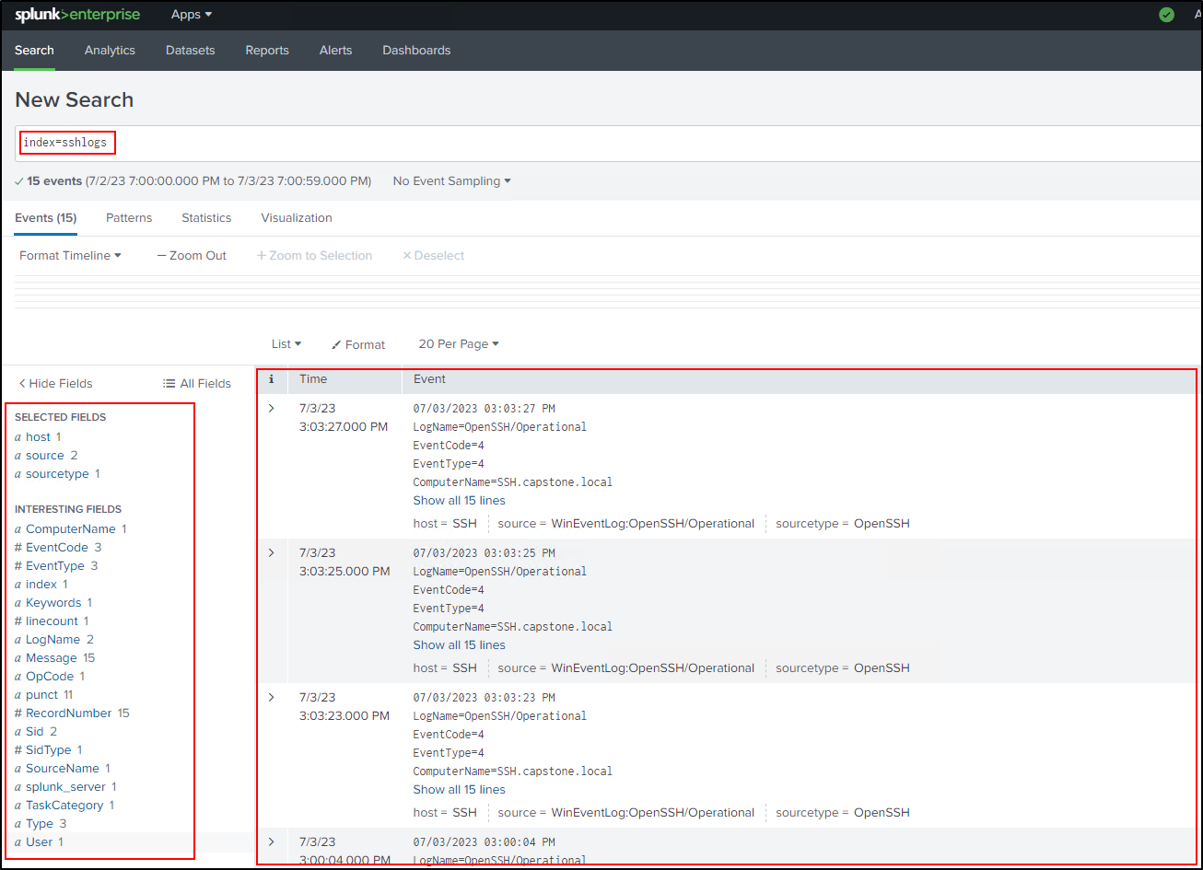

**Part 5: Configuration for Windows 10 SMB Server**

Step by step guidance for setting up SMB Server log collection in Splunk using Sysmon:

**Part 2: Splunk Forwarder Configuration**

1. Login to your Windows 10 SMB Server machine as a domain administrator.
2. Navigate to the C:\Program Files\SplunkUniversalForwarder\etc\apps\SplunkUniversalForwarder\default directory.
3. Locate the inputs.conf file.
4. Copy the inputs.conf file to your desired directory, which is C:\Program Files\SplunkUniversalForwarder\etc\system\local.
5. Now navigate to C:\Program Files\SplunkUniversalForwarder\etc\system\local, and open the inputs.conf file with a text editor like Notepad.
6. Add the following configuration to the inputs.conf file:

[WinEventLog://Microsoft-Windows-SMBServer/Security]

disabled = 0

index = smblogs

sourcetype = smb

checkpointInterval = 10

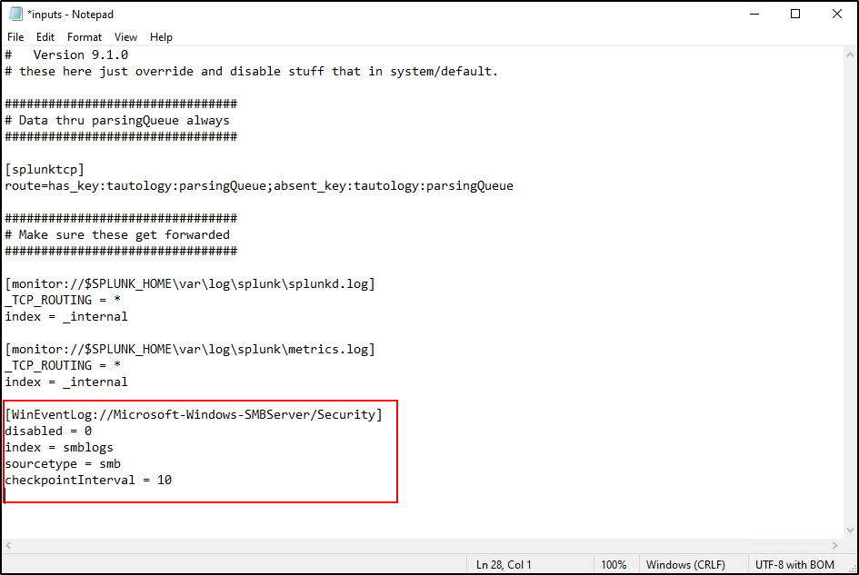

1. Save the inputs.conf file.
2. Finally, you need to restart the Splunk Forwarder service to apply these changes. Open PowerShell as an administrator and type the following commands:

cd '..\..\Program Files\SplunkUniversalForwarder\bin'

.\splunk.exe restart

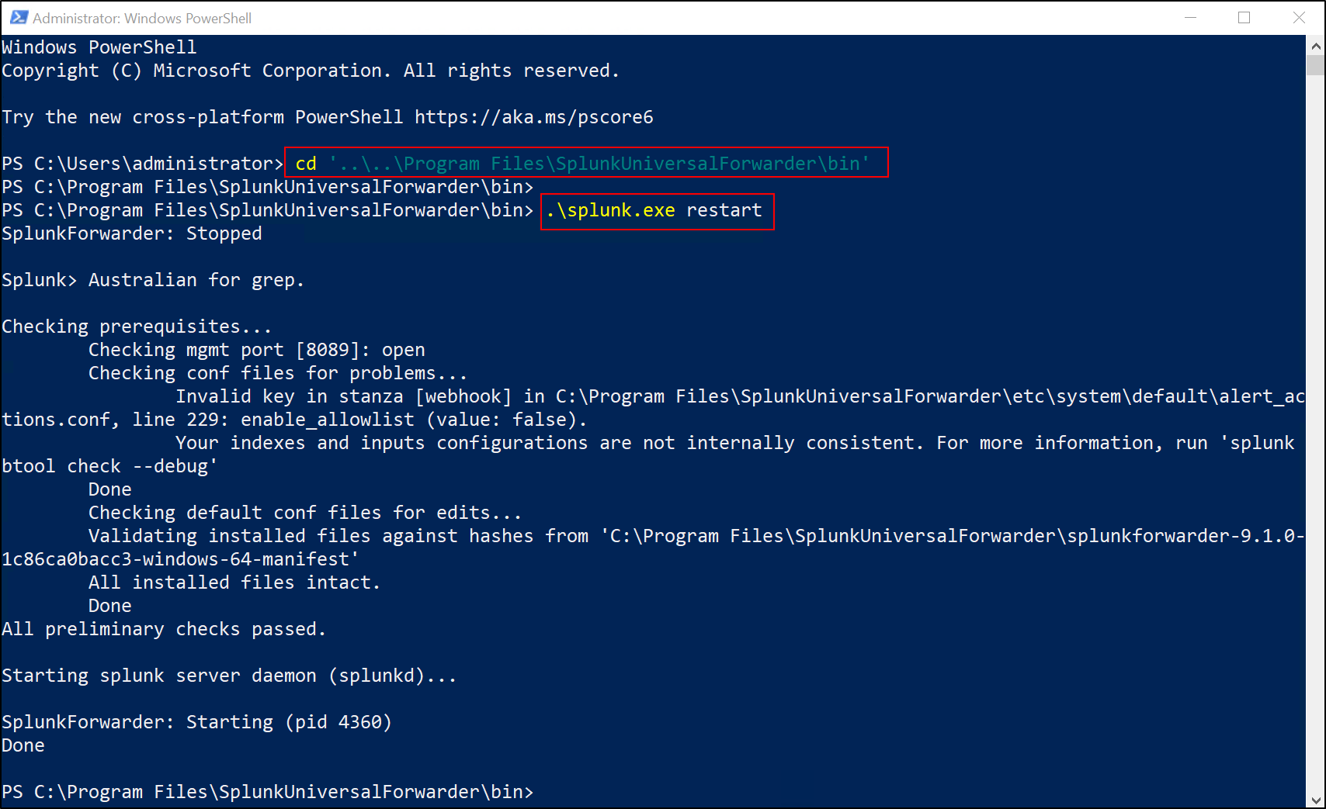

**Part 3: Verifying on Splunk Enterprise**

1. As a domain administrator, log into your Windows Server 2019 machine that has Splunk installed.
2. Open a web browser (Chrome) and navigate to the Splunk web interface at http://10.10.10.20:8000.
3. Log into the Splunk web interface using your admin account credentials.
4. In the left pane, select Search & Reporting.
5. In the Search field, enter index=smblogs and click on the Search button.
6. You should now see a list of events from your SMB logs. Each event will correspond to a line in the log files and will display the various fields from the logs.

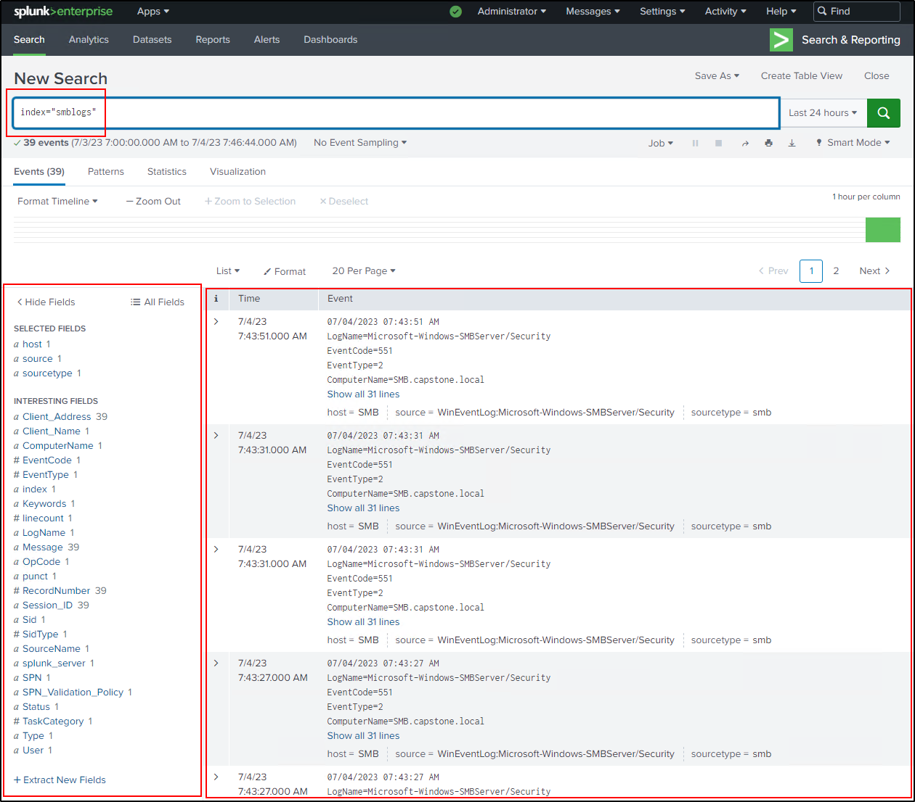

These steps should enable you to successfully set up and verify the collection of SMB server logs in Splunk using Sysmon.

Once the Universal Forwarder configurations are in place, the logs from the respective Windows 10 servers (FTP, SSH, SMB) will be forwarded to the corresponding indexes in Splunk Enterprise.

Please note that the above steps provide a general guideline for setting up the Universal Forwarder and configuring inputs.conf. It's essential to refer to the official Splunk documentation for detailed instructions and best practices specific to your Splunk version and deployment requirements.

## Installing Commando VM in the Windows 10 21H1 Commando VM machine.

1. **Windows Configuration**

* **Turn off tamper protection:** To turn off tamper protection on Windows 10, you can follow these steps:
  + Open Windows Security (type Windows Security in the search box)
  + Virus & threat protection > Virus & threat protection settings > Manage settings
  + Switch Tamper Protection to Off

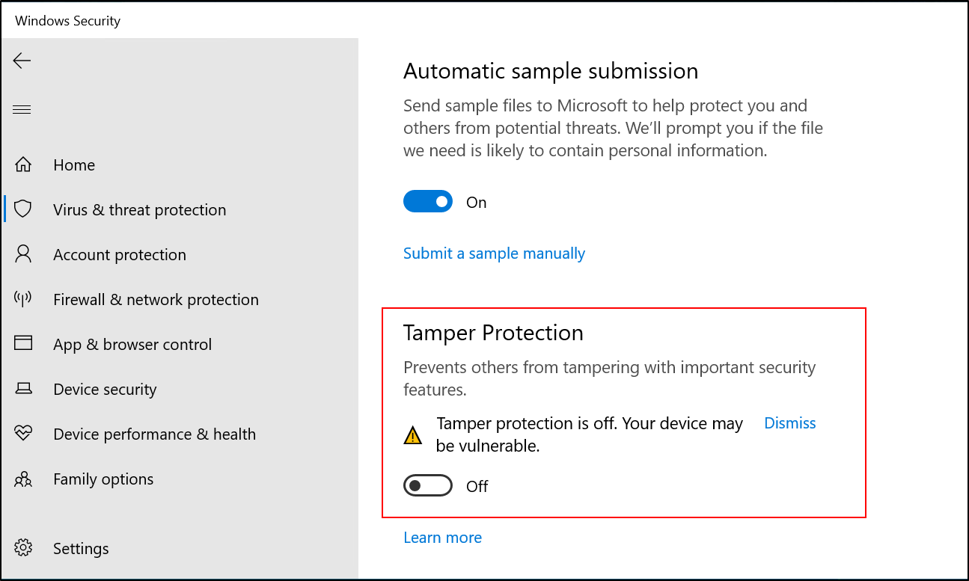

**It is not necessary to change any other setting (Real Time Protection, etc.)**

**Important.** Tamper Protection must be disabled before changing Group Policy settings.

* **To permanently disable Real Time Protection:** 
  + Open Local Group Policy Editor (type gpedit in the search box)
  + Computer Configuration > Administrative Templates > Windows Components > Microsoft Defender Antivirus > Real-time Protection
  + Enable Turn off real-time protection

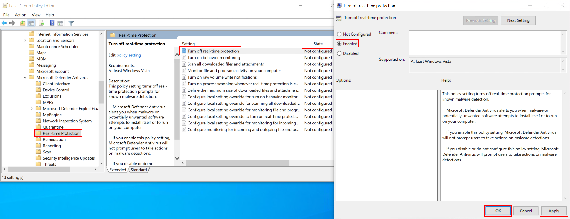

* + Reboot

Make sure to **reboot** before making the next change

* **To permanently disable Microsoft Defender**:
  + Open Local Group Policy Editor (type gpedit in the search box)
  + Computer Configuration > Administrative Templates > Windows Components > Microsoft Defender Antivirus
  + Enable Turn off Microsoft Defender Antivirus

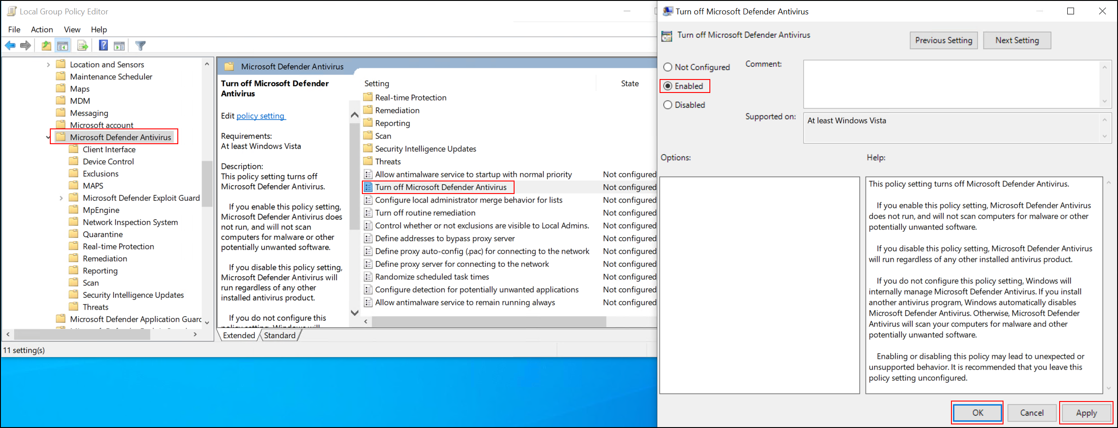

* + Reboot

1. **PowerShell Configuration**

* **Enable PowerShell script execution:** Open PowerShell as an administrator and run: Set-ExecutionPolicy Unrestricted -f. This allows PowerShell to run scripts, which is necessary for the Commando VM installation.

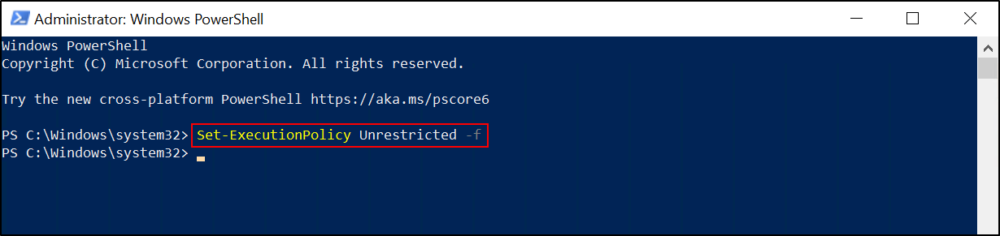

**Preparing the Commando VM Installation File**

* **Open a PowerShell terminal with administrative privileges**: This can be done by right-clicking the PowerShell icon and selecting "Run as Administrator".
* **Navigate to the Commando VM directory**: Use the cd command to change to the directory where you've downloaded Commando VM:

cd "C:\Users\Commando-VM\Downloads\commando-vm-main"

* **Unblock the install file**: Run the following command to unblock the installation script:

Unblock-File .\install.ps1

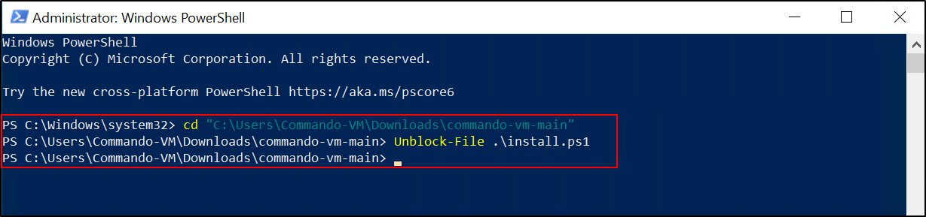

1. **Installing Commando VM**

* **Execute the installation script:** Run the following command to start the install process, include your password as an argument:

.\install.ps1 -password ‘Pa$$word’

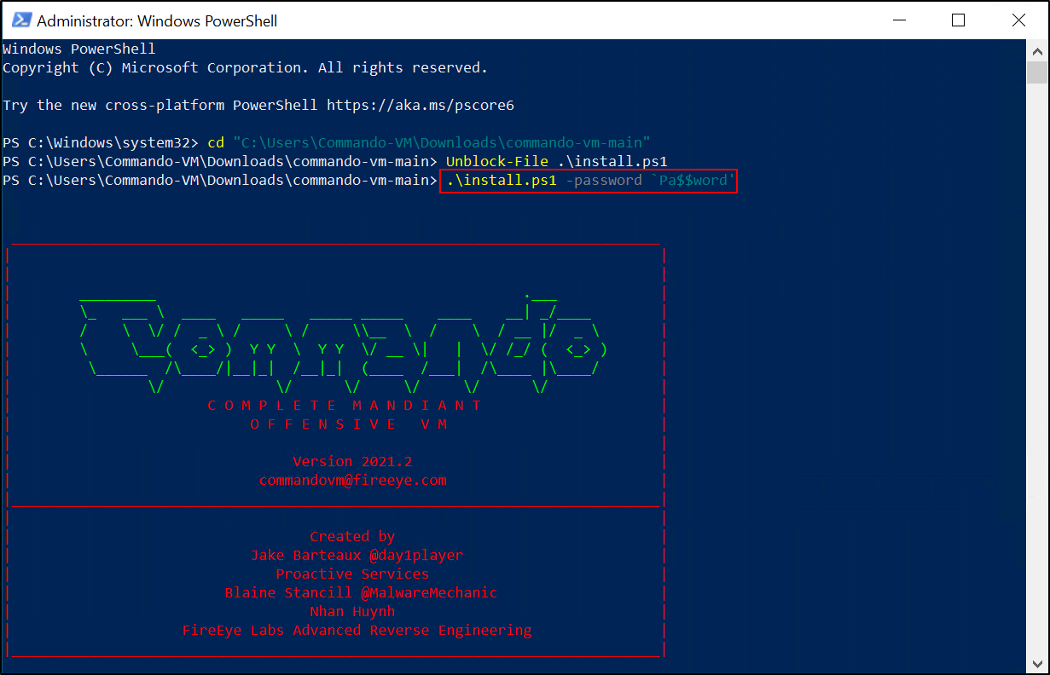

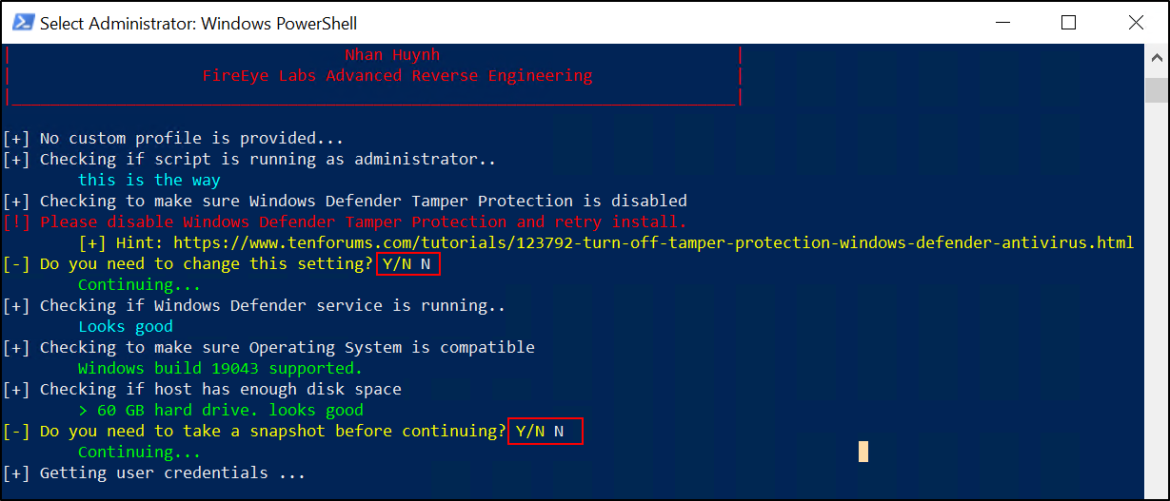

The script may require you to reboot your machine several times during the process. Make sure to log back in as the same user after each reboot.

1. **Post-Installation**

Before proceeding with the installation of optional tools and Hydra, you must first configure the network settings of your Commando VM:

1. Open Hyper-V Manager on your host machine.
2. In the 'Virtual Machines' section, right-click on your Commando VM and select 'Settings...'.
3. In the settings window, select 'Network Adapter' in the 'Hardware' list.
4. On the right side, under 'Network', select 'Capstone' from the dropdown menu.

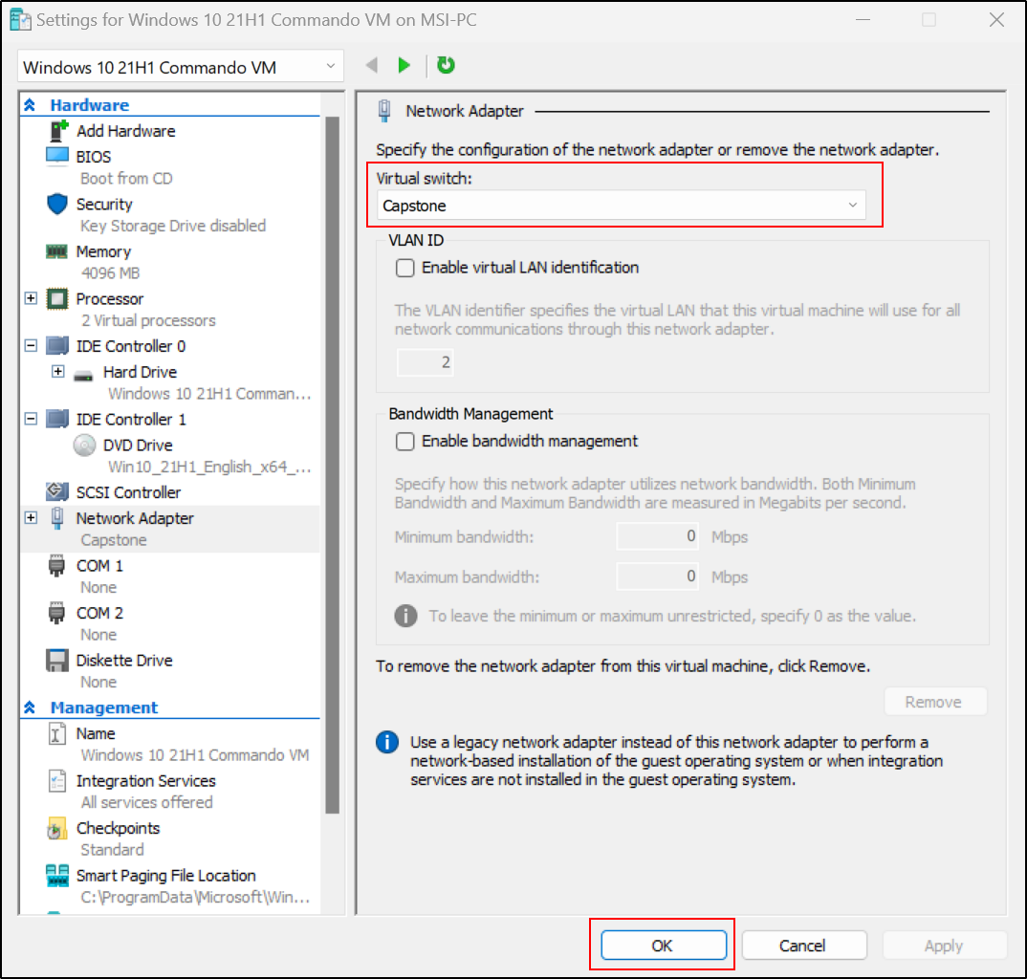

1. Click 'OK' to save your changes and close the settings window.

Once the network is set to 'Capstone', you should now configure the static IP within the Commando VM:

1. Inside your Commando VM, open the Network and Sharing Center by right-clicking on the network icon in the system tray and selecting 'Open Network & Internet settings'. Then click on 'Network and Sharing Center'.
2. In the Network and Sharing Center, click on 'Change adapter settings'.
3. Right-click on the network adapter that is currently connected to the internet (this should be the adapter associated with 'Capstone') and select 'Properties'.
4. Select 'Internet Protocol Version 4 (TCP/IPv4)' and click on 'Properties'.
5. In the 'Properties' window, select 'Use the following IP address' and enter the following details:
   * IP address: 10.10.10.100
   * Subnet mask: 255.255.255.0
   * Default gateway: 10.10.10.1
6. Then, select 'Use the following DNS server addresses' and enter '8.8.8.8' as the Preferred DNS server. Leave the Alternate DNS server blank.

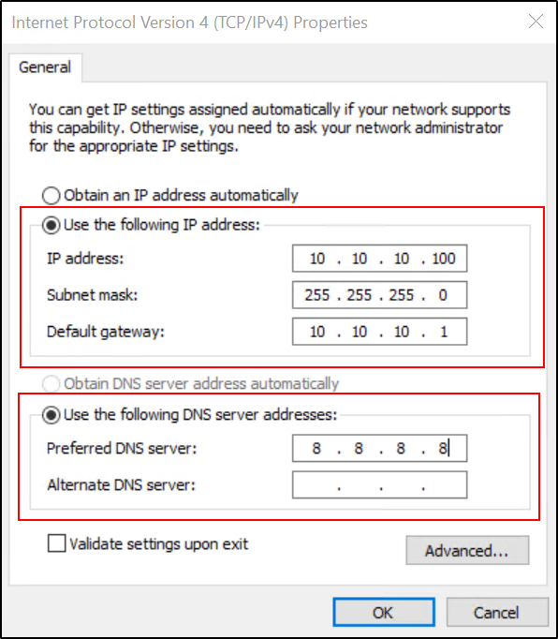

1. Click 'OK' to save the changes and close the 'Properties' window. Click 'Close' to close the adapter's properties window.

Now that your Commando VM's network is properly configured, you can continue with the rest of the post-installation configuration as described in the previous guidance. This includes installing optional tools, downloading Hydra, setting up your username and password lists, and using Hydra to simulate brute force attacks against your test systems.

Next, download Hydra for attacking your FTP, SSH, SMB Services:

* Open a web browser and navigate to <https://github.com/maaaaz/thc-hydra-windows>

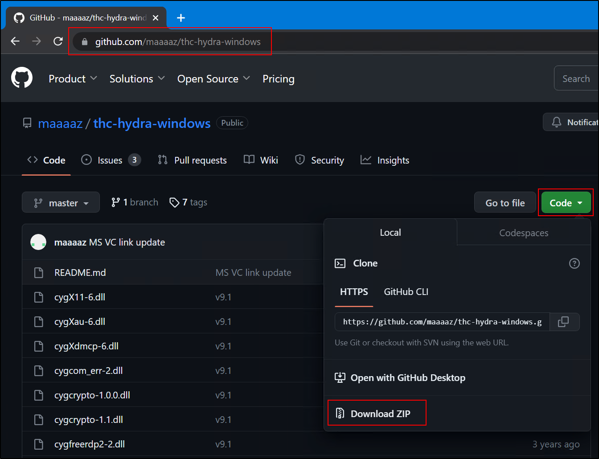

* Download the project as a zip file and extract it on the Desktop. The extracted folder will be "thc-hydra-windows-master".

Next, create Usernames.txt and Passwords.txt for Hydra:

* On your Desktop, create a new file called Usernames.txt.
* Populate Usernames.txt with randomly created names. Be sure to include "sshadmin" as one of the usernames.
* On your Desktop, create a new file called Passwords.txt.
* Populate Passwords.txt with randomly created passwords. Be sure to include "Pa$$word" as one of the passwords.

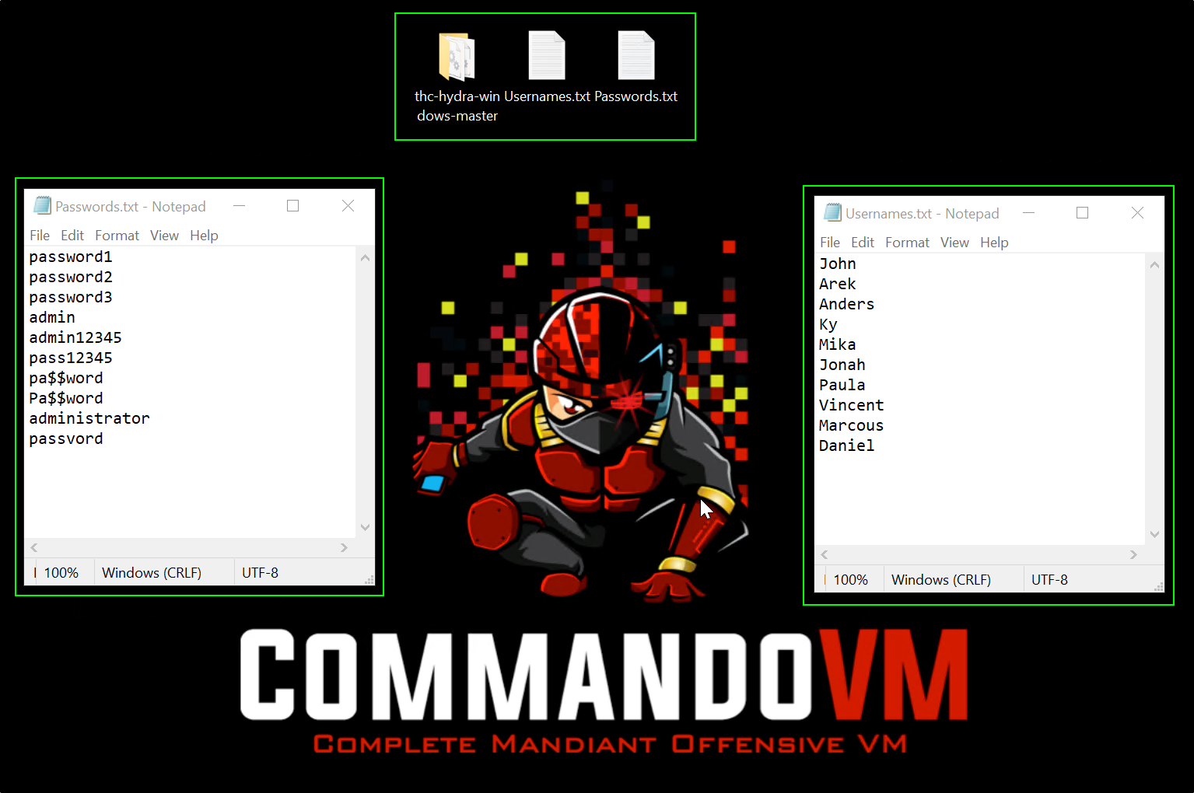

Now, you can use Hydra to launch brute force attacks against your test systems:

* Open PowerShell and navigate to the Hydra folder: cd .\Desktop\thc-hydra-windows-master
* For the FTP server, use the following command: .\hydra.exe -L ..\Usernames.txt -P ..\password.txt ftp://10.10.10.11
* For the SSH server, use the following command: .\hydra.exe -L ..\Usernames.txt -P ..\password.txt ssh://10.10.10.12
* For the SMB server, use the following command: .\hydra.exe -L ..\Usernames.txt -P ..\password.txt smb://10.10.10.13

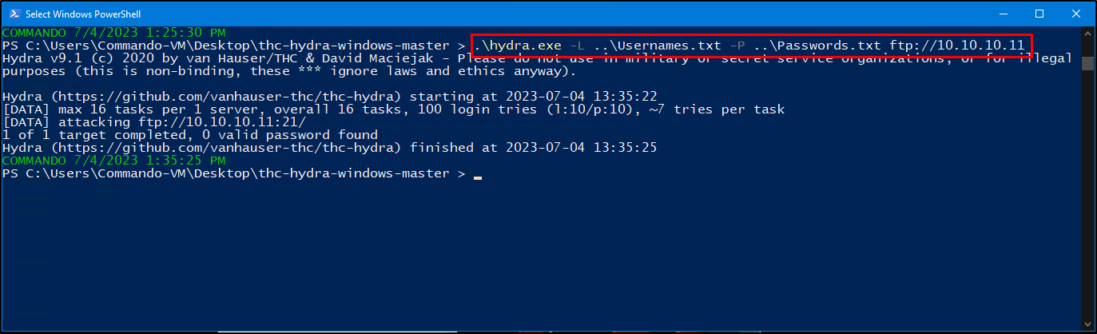

Remember to replace the IP addresses in the commands above with the IP addresses of your test systems. Also, always have permission before testing any systems, and do not use it for any illegal activities.

Remember, Commando VM is a powerful tool that should be used responsibly, and only for ethical hacking purposes such as penetration testing or red teaming exercises where you have permission.

The specific instructions may change over time as the Commando VM GitHub repository gets updated. Always refer to the repository for the most up-to-date instructions.

## **Creating Appropriate Query for Detecting Brute Force Attack:**

Splunk's powerful search functionality can be used to create queries that can help detect brute force attacks in your network data.

here is a step by step breakdown for each one of your queries:

**For FTP Server Brute Force Detection:**

1. index=ftplogs ftp_command=USER: This command tells Splunk to search for all events in the 'ftplogs' index where the FTP command is 'USER', which is used when someone is attempting to login to an FTP server.
2. | bin _time span=1m: The pipe symbol | is used to chain commands in Splunk. Here, it's followed by the bin command, which is used to group events based on the _time field in one-minute (1m) intervals.
3. | stats count as Attempts by _time: This command uses the stats function to count the number of 'USER' commands for each one-minute interval. This count is saved as a new field called 'Attempts'.
4. | table _time, Attempts: This command creates a table with two columns: _time (the one-minute intervals) and 'Attempts' (the number of 'USER' commands in each interval).

index=ftplogs cs_method=USER

| bin _time span=1m

| stats count as Attempts by _time

| table _time, Attempts

**For SSH Server Brute Force Detection:**

1. index="sshlogs" sourcetype="OpenSSH": This command tells Splunk to search for all events in the 'sshlogs' index where the sourcetype is 'OpenSSH'.
2. The next three steps are identical to the steps above for the FTP server.

index="sshlogs" sourcetype="OpenSSH" "Message"="*Failed password*"

| bin _time span=1m

| stats count as Attempts by _time

| table _time, Attempts

**For SMB Server Brute Force Detection:**

1. index="smblogs" source="WinEventLog:Microsoft-Windows-SMBServer/Security": This command tells Splunk to search for all events in the 'smblogs' index where the source is 'WinEventLog:Microsoft-Windows-SMBServer/Security'.
2. The next three steps are identical to the steps above for the FTP server.

index="smblogs" source="WinEventLog:Microsoft-Windows-SMBServer/Security"

| bin _time span=1m

| stats count as Attempts by _time

| table _time, Attempts

After running these queries, you can review the tables produced to identify possible brute force attempts. If you see a high number of 'Attempts' within a short period of time, this could suggest a brute force attack is taking place.

**Creating an Alert Based on These Query:** Once you've crafted a suitable query, you can set up alerts in Splunk that will notify you when the conditions of your brute force detection query are met.

let's integrate the queries into the step-by-step guide for clarity.

1. ****Login to Splunk**:** Log into the Splunk instance on your Windows Server 2019 as a domain administrator.
2. ****Navigate to Search & Reporting:** From the Splunk home page, move to the "Search & Reporting" page.**
3. ****Enter the Query:** In the search bar, enter the query for the service you're setting up the alert for. We'll start with the FTP Brute Force Detection query:**

index=ftplogs cs_method=USER

| bin _time span=1m

| stats count as Attempts by _time

1. ****Execute the Query:** Click on the "Search" icon to execute the query and review the results.**
2. ****Save Query as Alert:** Click on the "Save As" button at the top right of the page, then select "Alert" from the dropdown.**

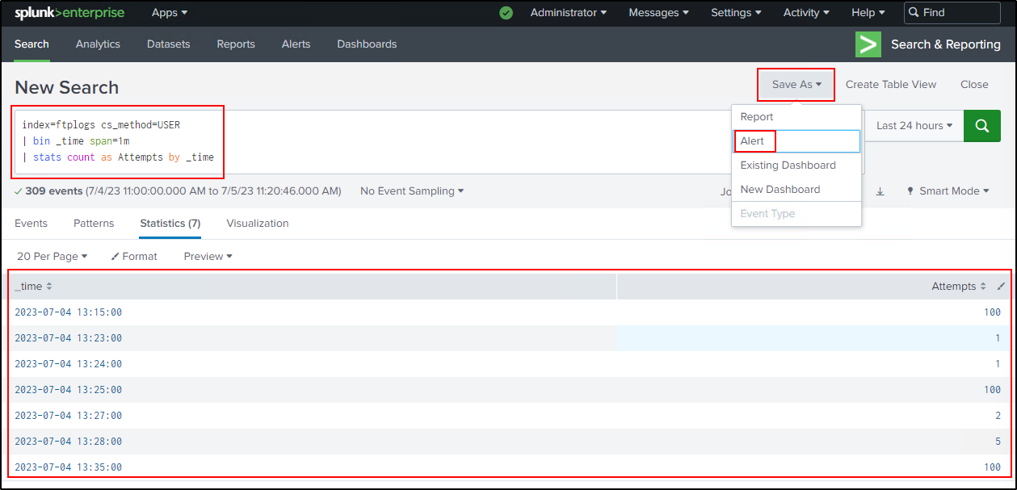

1. ****Name the Alert:** In the "Title" field, provide a descriptive name such as   
   "FTP Brute Force Detection".**
2. ****Set Alert Type:** Change the "Alert type" to "Real-time".**
3. ****Enable Throttling:** Check the "Throttle" checkbox. Throttling helps to prevent the alert from triggering too frequently.**
4. ****Configure Throttling:** After enabling Throttling, set a condition using the "Suppress resultscontaining field value" field. Enter "where Attempts > 10" to suppress alerts when there are more than 10 attempts within the time span.**
5. ****Set Throttling Duration:** Change the "Suppress triggering for" field from the default 60 seconds to 10 second.**
6. ****Add Actions to the Alert:** Click on the "+ Add Actions" button, and then select "Add to Triggered Alerts" from the dropdown.**
7. ****Set Severity Level:** Set the Severity level of the alert to "Critical".**

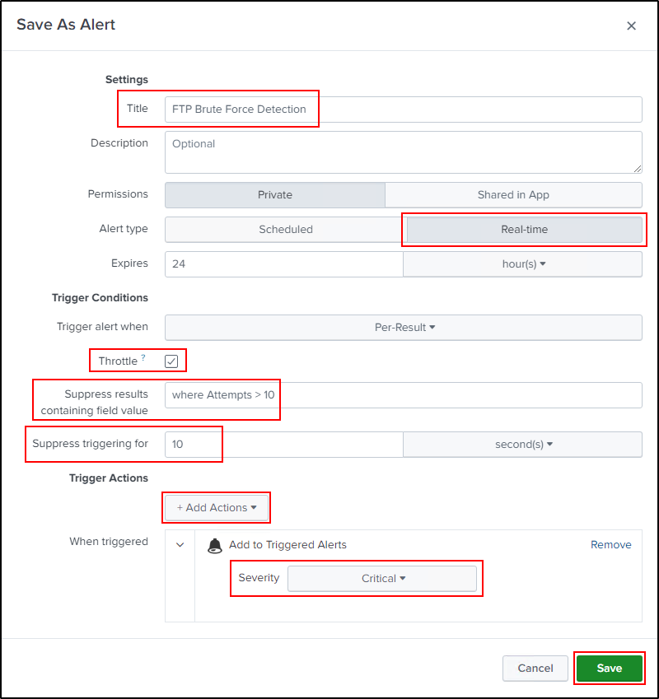

1. ****Save the Alert:** Click on "Save".**
2. ****Repeat for Other Server Types:** Follow the same steps for creating alerts for SSH and SMB brute force detection. Use these queries respectively:**

****SSH Brute Force Detection Query****

index="sshlogs" sourcetype=OpenSSH Message="*Failed password*"

| bin _time span=1m

| stats count as Attempts by _time

****SMB Brute Force Detection Query****

index="smblogs" sourcetype=smb

| bin _time span=1m

| stats count as Attempts by _time

Remember to give the alerts appropriate titles: "SSH Brute Force Detection" and "SMB Brute Force Detection".

1. ****Review Created Alerts:** Navigate to the "Settings" tab and click on "Searches, reports, and alerts". Ensure the alerts you created are listed and the "App" section reads: "Search & Reporting (search)".**

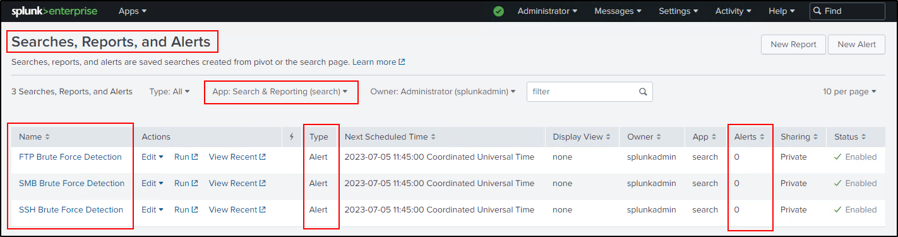

1. ****Initiate Test Attacks:** To test whether your newly created alerts are working, you need to simulate brute force attacks. On your Commando VM, open the PowerShell and navigate to the Hydra folder. Once there, execute the following commands one by one:**

For FTP server:

.\hydra.exe -L ..\Usernames.txt -P ..\password.txt <ftp://10.10.10.11>

For SSH server:

.\hydra.exe -L ..\Usernames.txt -P ..\password.txt ssh://10.10.10.12

For SMB server:

.\hydra.exe -L ..\Usernames.txt -P ..\password.txt smb://10.10.10.13

These commands use Hydra to simulate brute force attacks on your FTP, SSH, and SMB servers.

1. ****Check Triggered Alerts:** Now, navigate back to your Splunk instance on your Windows Server 2019 machine. In the Splunk Enterprise interface, click on the "Activity" tab, followed by the "Triggered Alerts" link. In the "Triggered Alerts" section, you should see the alerts that have been activated by the simulated attacks. This indicates that your alerts are set up correctly and are able to detect actual brute force attacks on your servers.**

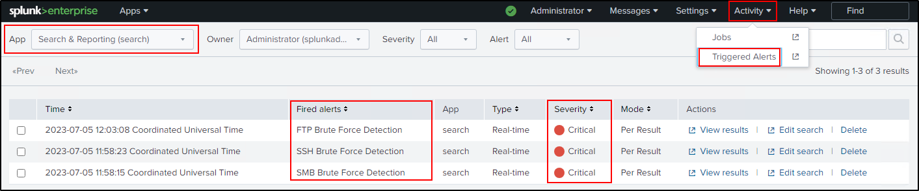

Remember, conducting such tests is important to ensure that your system's security measures are functioning as expected. Always make sure to perform these tests in a controlled environment to prevent any unintentional harm to your network or systems.

## **Creating Visual Dashboard for Monitoring in Splunk Enterprise:**

Finally, this section will guide you on how to create a dashboard in Splunk that can visually display the important data and alerts you need to monitor.

In this section, we'll walk you through the process of creating a comprehensive dashboard in Splunk Enterprise to monitor potential brute force attacks on our Windows Server 2019. We'll provide step-by-step instructions on configuring the dashboard and adding relevant queries to it.

**Step 1: Create a New Dashboard**

1. Open Splunk Enterprise in your Windows Server 2019 Splunk.
2. Click on 'Search & Reporting'.
3. Select the 'Dashboard' tab at the top.

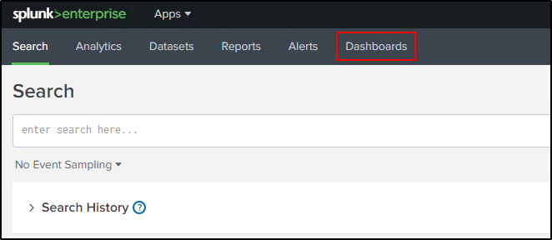

1. Click on 'Create New Dashboard':

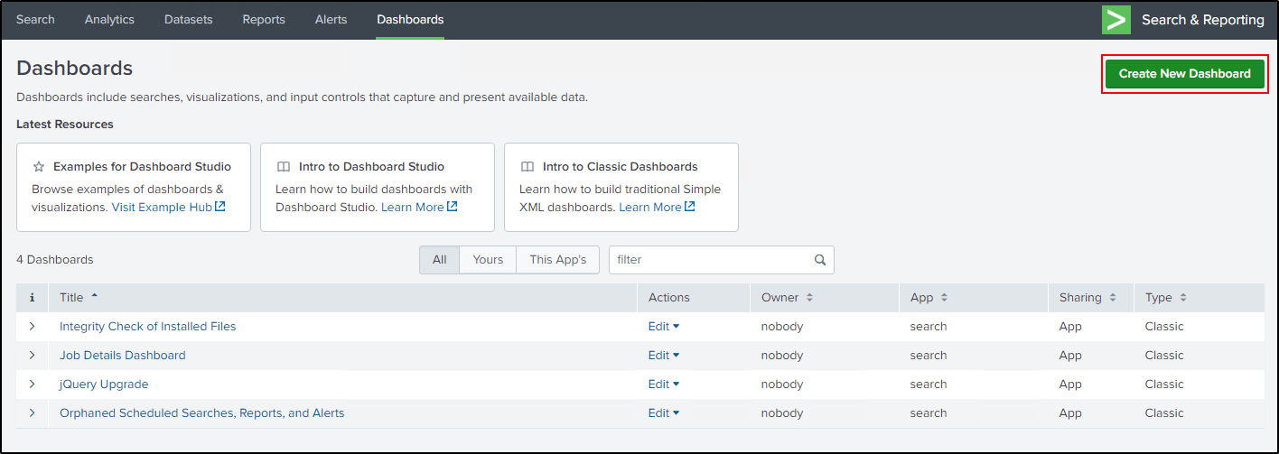

* + Set the 'Dashboard Title' as 'Brute Force Detection Dashboard'.
  + Enter 'Last 1 hour results' in the 'Description' field.
  + When asked 'How do you want to build your dashboard?', select 'Dashboard Studio'.
  + For 'Select layout mode', select 'Absolute'.
  + Click on 'Create'.

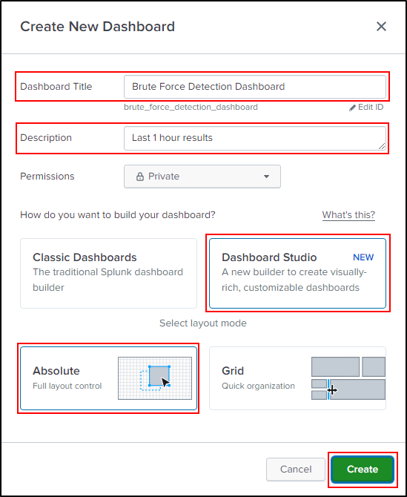

You should now see an empty dashboard that's ready to be customized.

**Step 2: Customize Your Dashboard**

1. Change the dashboard to 'Dark' mode using the toggle at the top of the page.
2. In the right pane, change the 'Display Mode' to 'Actual Size'.
3. Adjust the 'Canvas Width' and 'Canvas Height' according to your preferences.

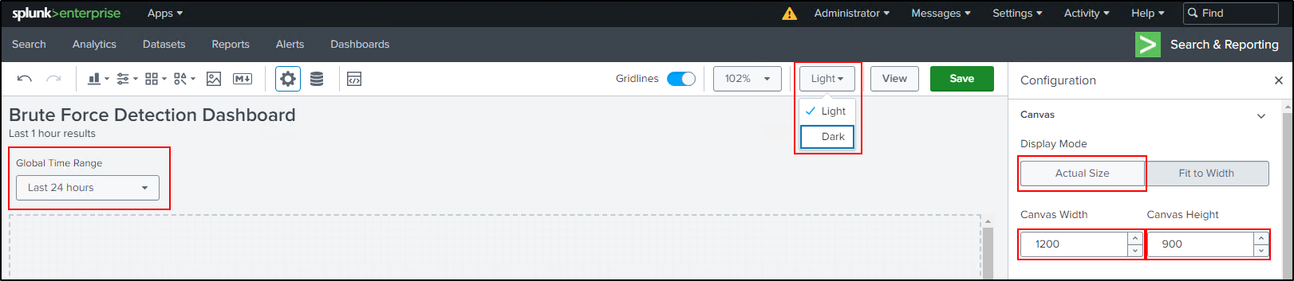

1. Click on the 'Global Time Range' at the top left corner and select 'Remove'.

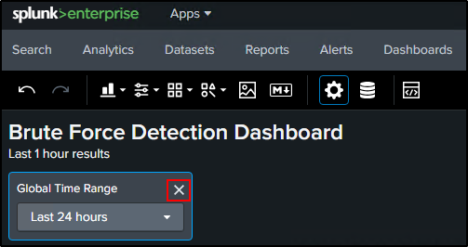

1. Click 'Save' to apply these changes.

**Step 3: Add Queries to Your Dashboard**

Before starting, ensure that you have the latest results from the past hour by repeating the 'Test Attack' scenario. Each type of brute force attack (FTP, SSH, SMB) will be represented by a Column Chart, while all three attack types will be collectively displayed in a Pie Chart. We'll also include tables for alerts from the last hour and detailed information about the attack.

**Please follow these steps for each of the queries provided:**

Column Chart for FTP, SSH, and SMB Brute Force Attacks

Here, we illustrate the process using the FTP Brute Force Attack query. The steps for SSH and SMB are identical. Simply substitute the relevant query and panel title.

1. Go to the main page of Splunk Enterprise and click on 'Search & Reporting'.
2. Enter the following query to search for FTP Brute Force Attack:

index=ftplogs cs_method=USER earliest=-1h

| timechart span=1m count as Attempts

1. Switch to the 'Visualization' tab and then click on 'Format'.

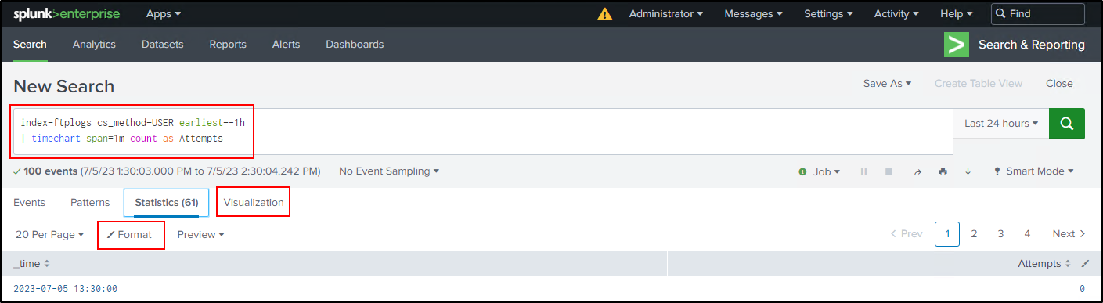

1. In the 'General' tab, set 'Show Data Values' to 'On'.

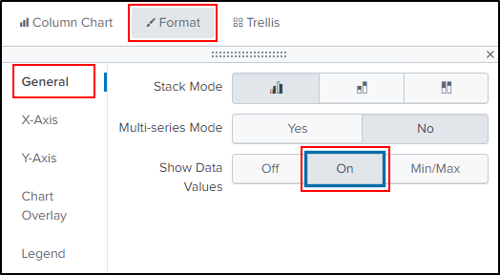

1. In the 'Legend' tab, set 'Legend Position' to 'Bottom'.

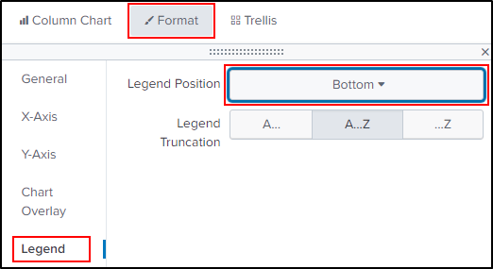

1. Click on 'Save As...', select 'Existing Dashboard', and choose 'Brute Force Detection Dashboard' from the dropdown.

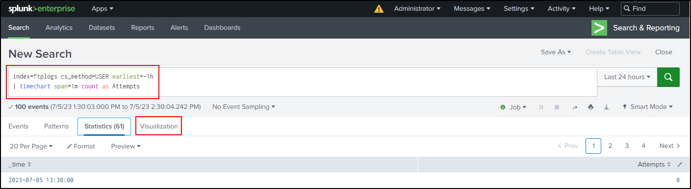

1. Set the 'Panel Title' as 'FTP Brute Force Attack'.

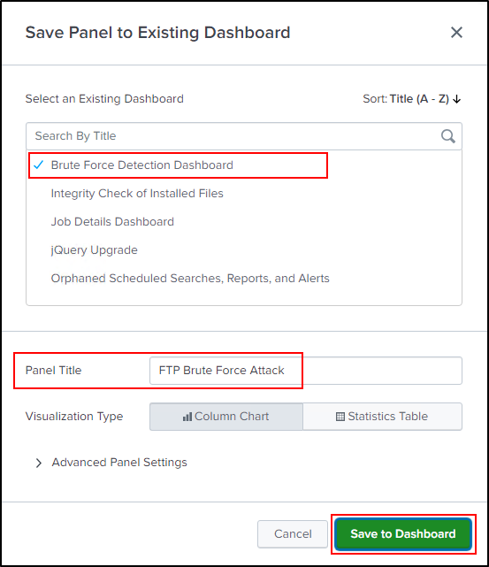

1. Click on 'Save to Dashboard'.

For SSH and SMB Brute Force Attack queries, replace the 'Panel Title' with 'SSH Brute Force Attack' and 'SMB Brute Force Attack' respectively.

* Use the following query to search for SSH Brute Force Attack:

index=ftplogs cs_method=USER earliest=-1h

| timechart span=1m count as Attempts

* Use the following query to search for SMB Brute Force Attack:

index="smblogs" source="WinEventLog:Microsoft-Windows-SMBServer/Security" earliest=-1h

| timechart span=1m count as Attempts

Pie Chart for All Attack Types

Follow these steps to create a pie chart that visualizes all three attack types collectively:

1. Go to the main page in Splunk Enterprise and click on 'Search & Reporting'.
2. Enter the following query:

index=ftplogs cs_method=USER earliest=-1h | eval source="FTP"

| append [search index="sshlogs" sourcetype="OpenSSH" "Message"="*Failed password*" earliest=-1h | eval source="SSH"]

| append [search index="smblogs" source="WinEventLog:Microsoft-Windows-SMBServer/Security" earliest=-1h | eval source="SMB"]

| stats count as Attempts by source

1. Switch to the 'Visualization' tab and change the format from 'Column Chart' to 'Pie Chart'.

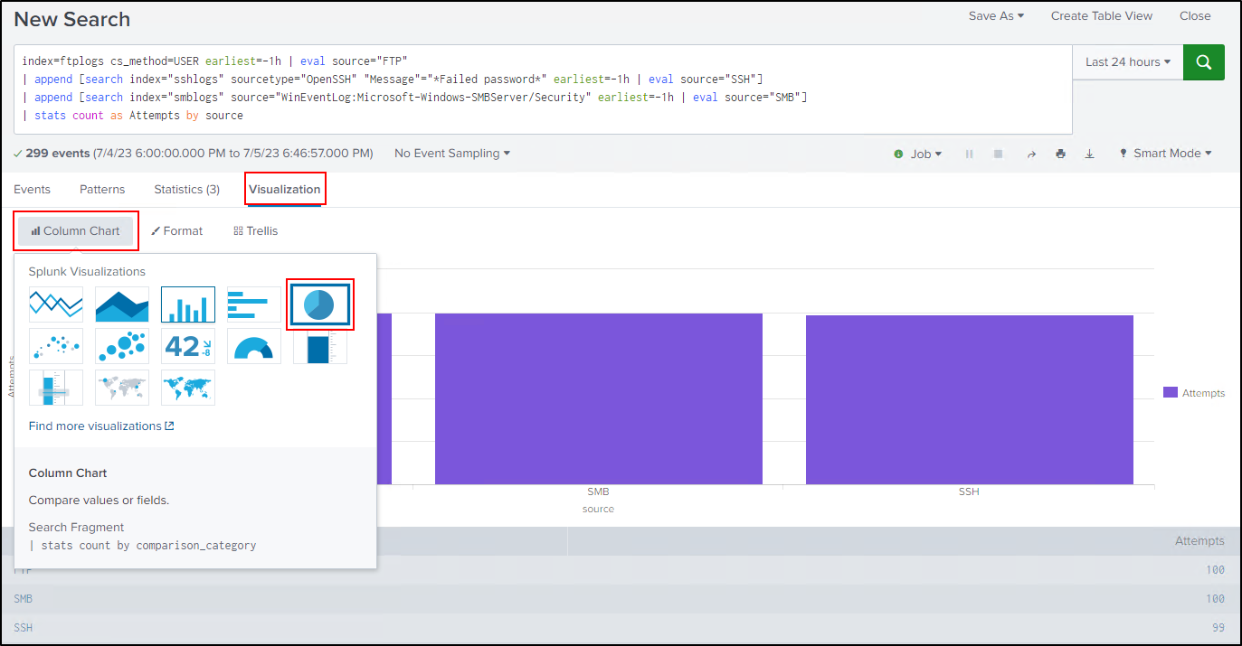

1. Click on 'Save As...', select 'Existing Dashboard', and choose 'Brute Force Detection Dashboard' from the dropdown.
2. Leave the 'Panel Title' blank.
3. Click on 'Save to Dashboard'.

Table for Last One Hour Alerts

Create a table that lists all alerts from the past hour:

1. Go to the main page in Splunk Enterprise and click on 'Search & Reporting'.
2. Enter the following query:

index=_audit action="alert_fired" earliest=-1h

| rename ss_name AS Alert_Name, triggered_alerts AS Triggered_Alerts, severity AS Severity

| stats sum(Triggered_Alerts) as Total_Triggered, values(Severity) as Severity by Alert_Name

| eval Severity=if(Severity==5, "Critical", Severity)

| table Alert_Name, Total_Triggered, Severity

1. Click on 'Save As...', select 'Existing Dashboard', and choose 'Brute Force Detection Dashboard' from the dropdown.
2. Set the 'Panel Title' as 'Alerts'.
3. Click on 'Save to Dashboard'.

Table for Detailed Attack Information

Create a table that provides detailed information about the attack:

1. Go to the main page in Splunk Enterprise and click on 'Search & Reporting'.
2. Enter the following query:

index=ftplogs cs_method=USER earliest=-1h

| eval Attack_Type="FTP Brute Force", Attacker_IP=c_ip

| append [

search index="sshlogs" sourcetype="OpenSSH" "Message"="*Failed password*" earliest=-1h

| rex field=Message "Failed password for invalid user (?<user>.*) from (?<Attacker_IP>.*) port"

| eval Attack_Type="SSH Brute Force"

]

| append [

search index="smblogs" source="WinEventLog:Microsoft-Windows-SMBServer/Security" earliest=-1h

| rex field=Client_Address "(?<Attacker_IP>[^:]+)"

| eval Attack_Type="SMB Brute Force"

]

| stats count as Attempts by Attack_Type, Attacker_IP

1. Click on 'Save As...', select 'Existing Dashboard', and choose 'Brute Force Detection Dashboard' from the dropdown.
2. Set the 'Panel Title' as 'Detailed Information'.
3. Click on 'Save to Dashboard'.

After adding all these queries to the Dashboard, out dashboard look like in the below:

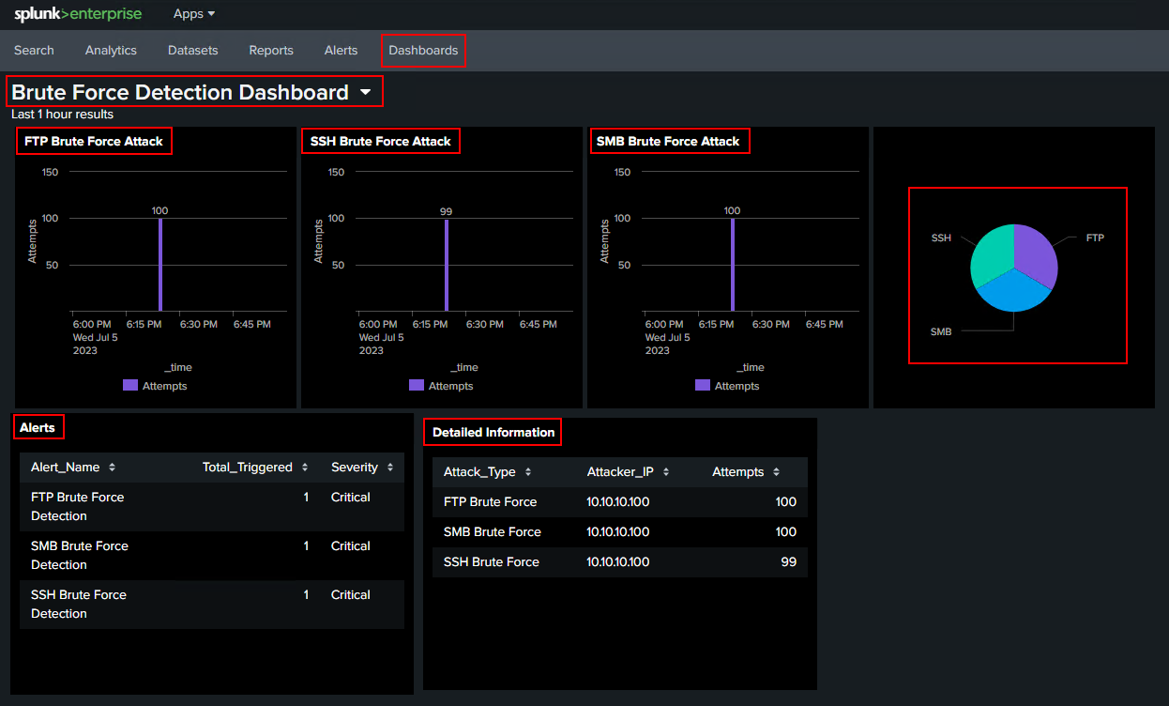

Now, we have successfully added all necessary queries to your 'Brute Force Detection Dashboard'. In the next steps, you can continue to customize and enhance our dashboard as needed.

## Step-by-step guide on how to customize and enhance your Splunk dashboard:

1. **Prepare for Customization**: Before you begin customizing, ensure you have the most recent results by repeating the 'Test Attack' scenario.
2. **Access Dashboard**: Navigate to the main page of your dashboard.
3. **Enter Edit Mode**: Click on the 'Edit' button located at the top right corner of the page. This puts your dashboard in 'Edit' mode and allows you to modify its settings.

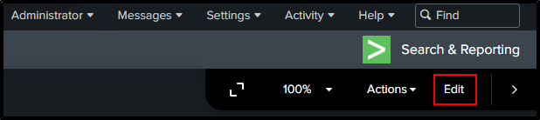

1. **Customize the Dashboard**: In this mode, you can perform a variety of customizations. This includes changing the background color, adjusting visualization positions, modifying chart settings, and more. Your final view will depend on your specific requirements and preferences.

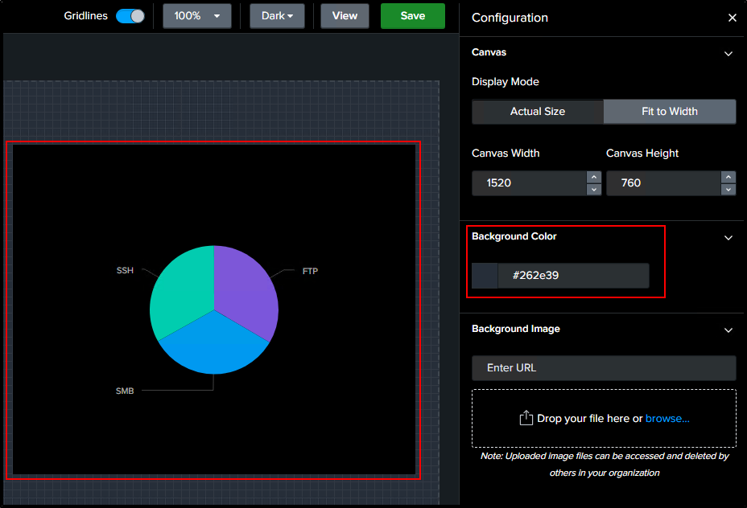

1. **Access Source Code**: To make important configurations beyond visual customization, click on the 'Source' button located at the top of the page. This will reveal the source code of your dashboard, showing all the underlying information related to it.

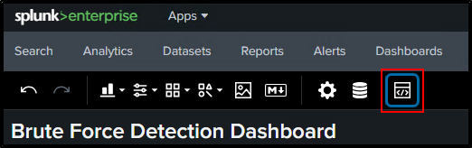

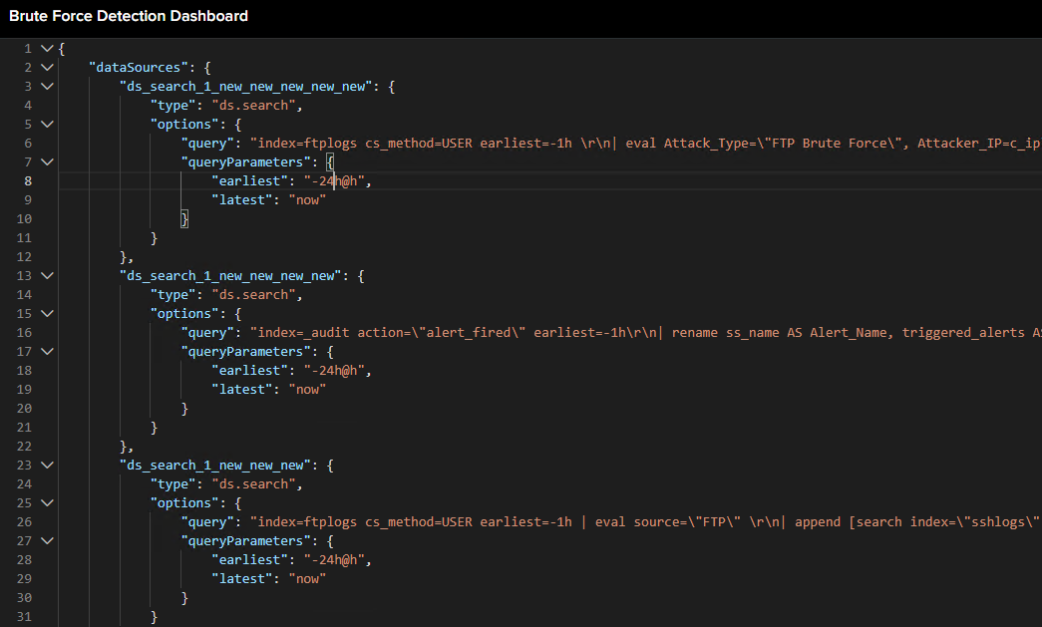

1. **Modify Query Options**: Within the source code, you can view the options for each of your six queries. For instance, you might want to adjust the time range for the data being visualized. To do this, change "earliest": "-24h@h" to "earliest": "-60m@m". This alteration ensures that your queries only display results from the last 60 minutes.
2. **Set Auto-Refresh**: In order to keep the dashboard data updated, set an automatic refresh interval for your queries. Add "refresh": 60 to the "options" field. Be cautious with punctuation and commas while making these changes. This modification needs to be repeated for the rest of the five queries.

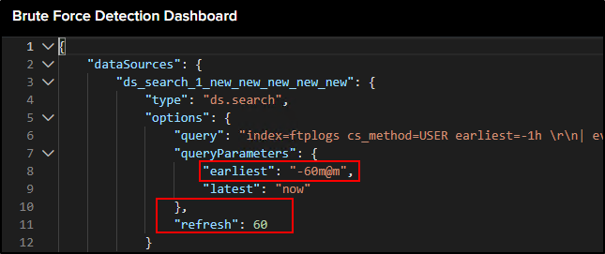

1. **Finalize and Save**: After you've customized your dashboard's appearance and configured its settings according to your needs, your final dashboard will take shape. Make sure you're satisfied with your changes, then click 'Save' to preserve your edits.

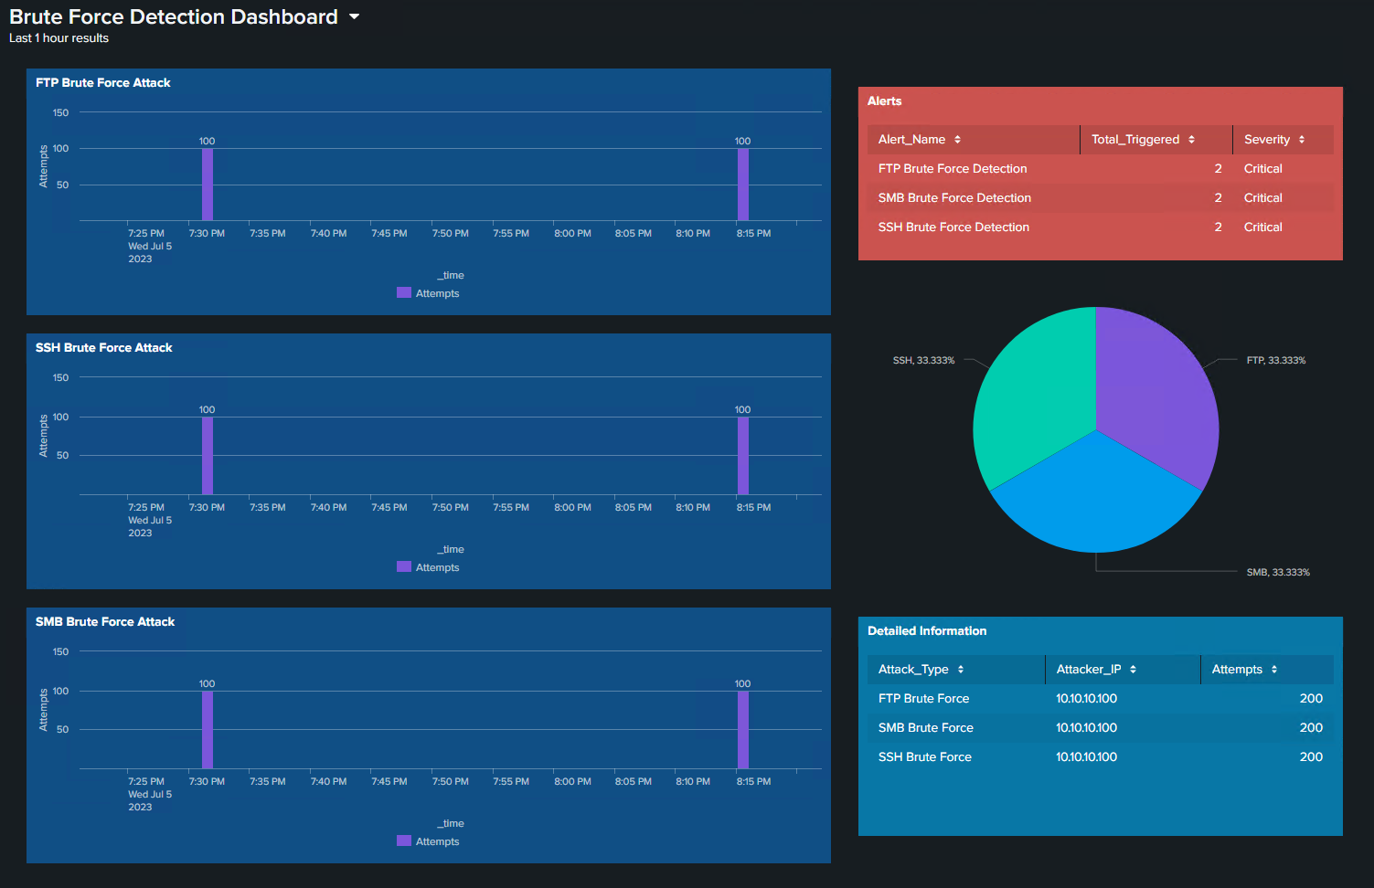

1. **Choose Home Dashboard**:
   * Return to the Splunk Enterprise main page by clicking "Splunk Enterprise" in the top left.
   * Choose your home dashboard by clicking the "Choose a home dashboard" button.

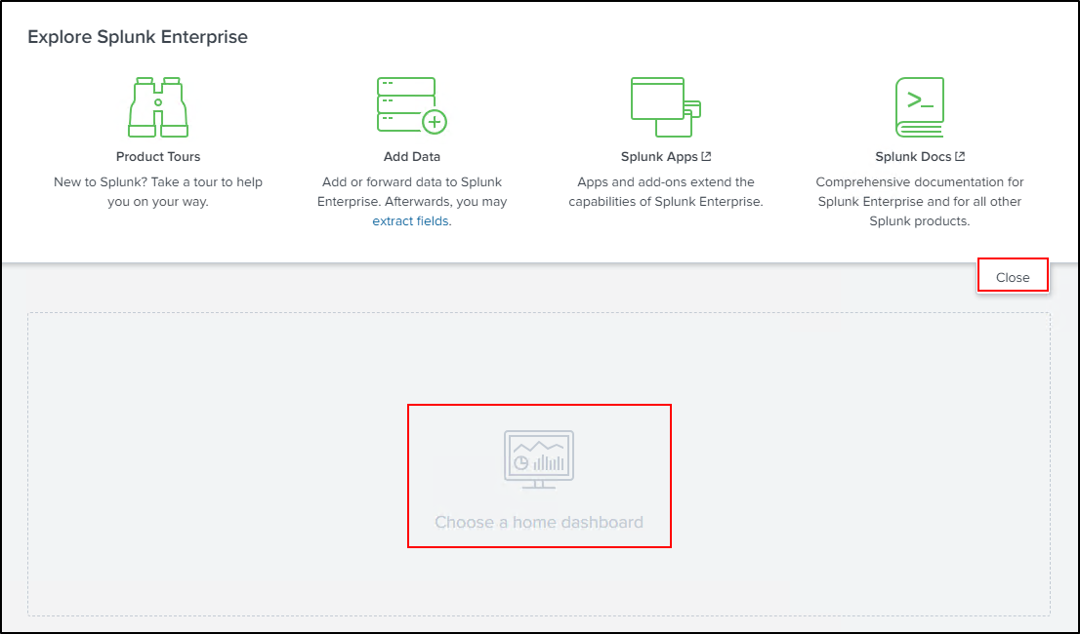

* In the dialog box that appears, select "Brute Force Detection Dashboard" and click on "Save".After completing these steps, your main page in Splunk Enterprise will be set to your custom "Brute Force Detection Dashboard".

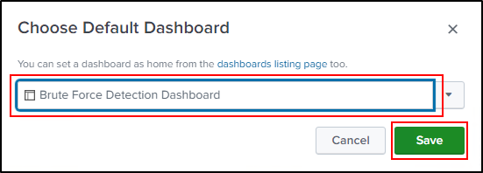

1. **Finalize and View**: After you have finished customizing and configuring your dashboard, your final dashboard should look something like the image below:

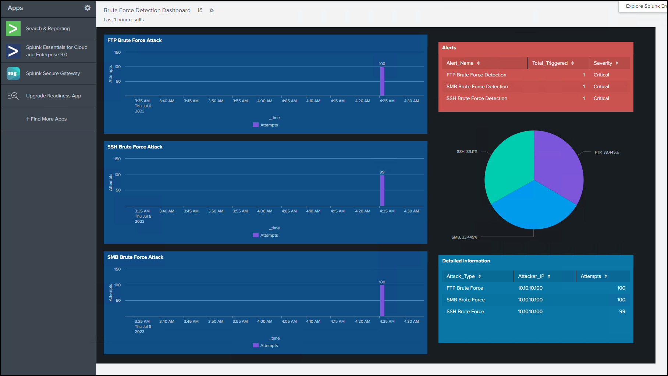

Remember, the goal of these steps is to enhance the usability and relevancy of your dashboard, so feel free to make further adjustments that suit your needs.

# Chapter 5: Executing and Monitoring a Brute Force Attack

## Launching Brute Force Attack Using Commando VM

1. Preparing for the Attack Scenario: Ensure you log out from domain administrator accounts on your three Windows machines and one Windows Server 2019 machine (Windows 10 FTP Server, Windows 10 SSH Server, Windows 10 SMB Server and Windows Server 2019 Splunk). Log in using the appropriate accounts which we created earlier in our capstone.local domain (capstone\ftpadmin, casptone\sshadmin, casptone\smbadmin, capstone\splunkadmin).
2. Launching the Brute Force Attack Using Commando VM:
   * Navigate to the Commando VM machine.
   * Open PowerShell as an administrator and navigate to the Hydra folder via the command line.
   * Before starting, ensure that you have the latest results from the past hour by repeating the 'Test Attack' scenario. Please repeat this step at least five times within 10 minutes to ensure meaningful results.
   * Use the following commands to execute the brute force attack simulations on your FTP, SSH, and SMB servers using Hydra:

For the FTP server: .\hydra.exe -L ..\Usernames.txt -P ..\password.txt ftp://10.10.10.11

For the SSH server: .\hydra.exe -L ..\Usernames.txt -P ..\password.txt ssh://10.10.10.12

For the SMB server: .\hydra.exe -L ..\Usernames.txt -P ..\password.txt smb://10.10.10.13

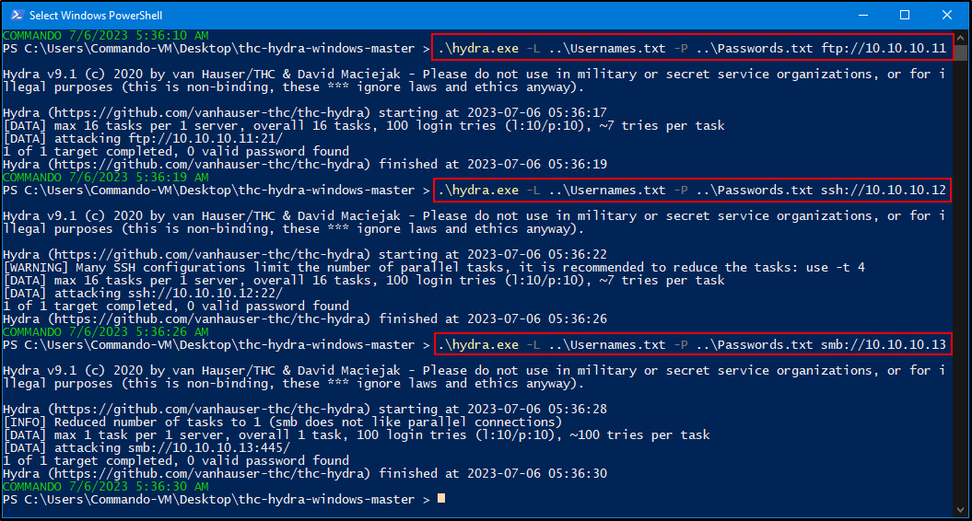

## Monitoring the Results in the Splunk Enterprise Dashboard:

* + After executing the attacks, navigate to the "Brute Force Detection Dashboard" in the Splunk Enterprise to monitor the results.

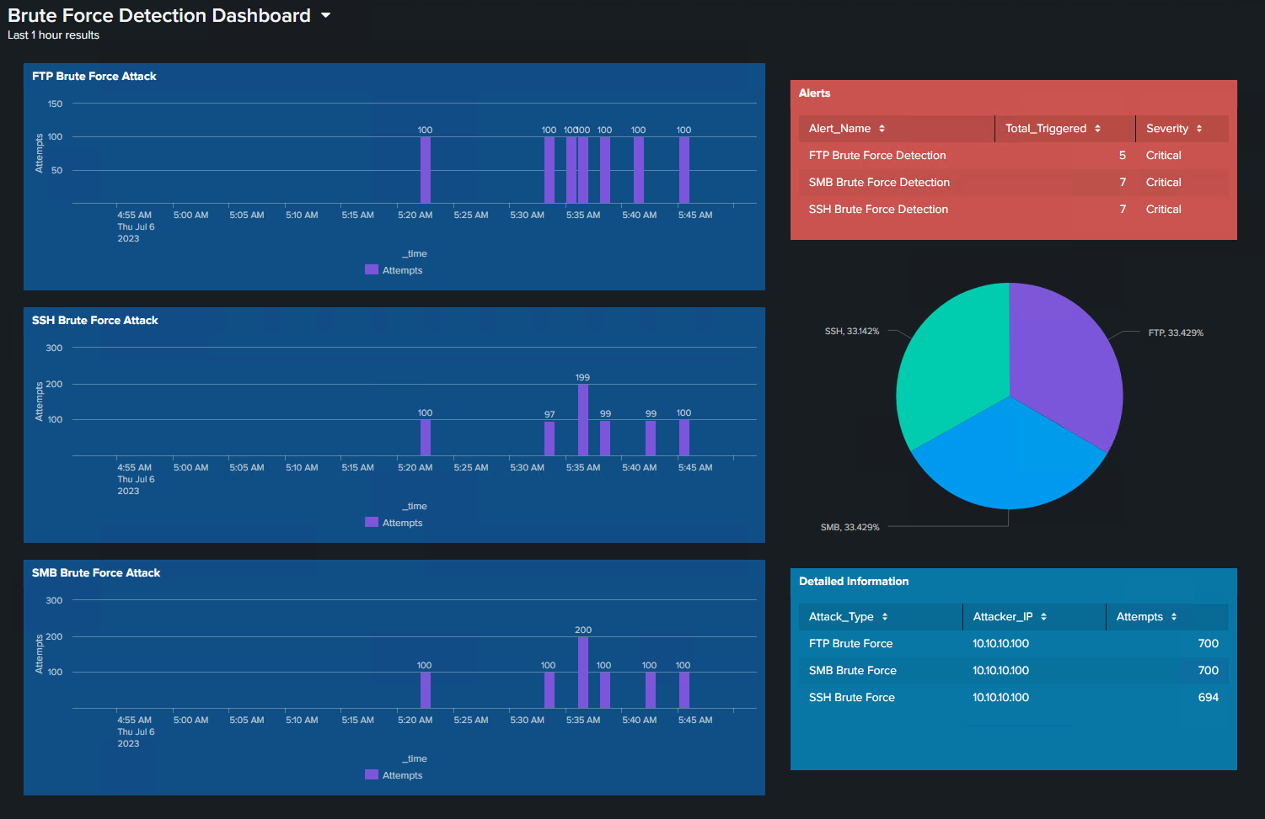

**Conclusion**

Congratulations on completing the "Brute Force Detection in Splunk Enterprise" lab! You have now gained practical experience in setting up a realistic environment for monitoring and detecting brute force attacks using Splunk Enterprise. This hands-on experience will undoubtedly serve you well in understanding cybersecurity threats and developing appropriate detection mechanisms.

Always remember, the key to a strong security posture is not only preventing attacks but also having robust monitoring and detection systems in place. Continue exploring more about cybersecurity, threat detection, and how you can leverage Splunk in various scenarios.

# Chapter 6: Mitigation

## Mitigating brute force attacks on a Splunk

To effectively mitigate brute force attacks, it is essential to identify weaknesses and vulnerabilities within the AD DS environment. This involves conducting a thorough analysis of password policies, user account configurations, and network security measures. By understanding these weaknesses, effective mitigation strategies can be developed.

* **Analyzing Password Policies:** Evaluate the existing password policies in place within the AD DS environment. Assess factors such as password complexity requirements, password length, and password expiration policies. Identify any weaknesses or gaps that could be exploited by brute force attacks, such as weak or easily guessable passwords.
* **User Account Configurations:** Examine the user account configurations within AD DS. Evaluate factors such as account lockout thresholds, failed login attempt tracking, and user access levels. Identify any misconfigurations or vulnerabilities that could make user accounts susceptible to brute force attacks.
* **Network Security Measures:** Assess the network security measures implemented within the AD DS environment. Evaluate factors such as firewall rules, network segmentation, and intrusion detection systems. Identify any weaknesses in these security measures that could be exploited by brute force attacks.

By conducting a comprehensive analysis of these areas, organizations can gain a clear understanding of the weaknesses and vulnerabilities present within their AD DS environment. This knowledge forms the foundation for developing effective mitigation strategies.

## Implementing Strong Password Policies:

Implementing strong password policies is crucial in mitigating the risk of brute force attacks. A robust password policy makes it significantly harder for attackers to guess or crack passwords. The key components of a strong password policy include:

* **Password Complexity Requirements:** Enforce the use of complex passwords that include a combination of uppercase and lowercase letters, numbers, and special characters. Set a minimum password length to ensure passwords are sufficiently long and resistant to brute force attacks.
* **Password Expiration:** Implement a password expiration policy that requires users to change their passwords periodically. This ensures that compromised passwords become invalid after a certain period, reducing the risk of unauthorized access.
* **Account Lockout Thresholds:** Set account lockout thresholds to automatically lock user accounts after a specified number of failed login attempts. This prevents brute force attacks by limiting the number of password guesses an attacker can make.

Educate users about the importance of adhering to strong password policies and provide guidance on creating secure passwords. Regularly communicate password policy reminders to reinforce good password practices.

## Enforcing Multi-Factor Authentication (MFA):

Multi-factor authentication (MFA) adds an additional layer of security to protect user accounts, even if passwords are compromised. Implementing MFA significantly reduces the risk of successful brute force attacks. Examples of MFA methods include:

* **SMS Verification Codes:** Require users to enter a one-time verification code sent to their registered mobile phone number.
* **Authenticator Apps:** Utilize authenticator apps, such as Google Authenticator or Microsoft Authenticator, to generate time-based verification codes that users must enter during login.
* **Biometric Authentication:** Implement biometric authentication methods, such as fingerprint or facial recognition, to further validate user identities.

By implementing MFA, organizations can effectively mitigate the risk of brute force attacks by adding an extra layer of protection beyond passwords.

## Implementing Account Lockout Policies:

Implementing account lockout policies is an effective measure to prevent brute force attacks. By setting thresholds for failed login attempts, user accounts can be automatically locked, rendering brute force attacks futile. Consider the following factors when implementing account lockout policies:

* **Setting Appropriate Lockout Durations:** Determine the duration for which locked accounts remain inaccessible. Strike a balance between security and usability by setting lockout durations that provide adequate protection while minimizing inconvenience for legitimate users.
* **Providing Mechanisms for Unlocking Locked Accounts**: Establish procedures or mechanisms to allow users to unlock their accounts if they become locked due to erroneous login attempts. This ensures that legitimate users can regain access to their accounts in a timely manner and reduces the risk of account lockouts caused by genuine mistakes.

Consider user feedback and usability when defining lockout thresholds. Set thresholds that are stringent enough to deter brute force attacks but lenient enough to accommodate user errors or forgotten passwords.

By implementing account lockout policies, organizations can effectively deter brute force attacks by preventing repeated failed login attempts and protecting user accounts.

## Monitoring and Alerting:

Continuous monitoring and alerting are crucial for early detection and response to brute force attacks. By utilizing SIEM platforms like Splunk, organizations can monitor login activities, track abnormal patterns, and generate real-time alerts for suspicious activities. Key considerations for monitoring and alerting include:

* **Log Analysis:** Utilize Splunk's log collection and analysis capabilities to monitor login events, detect anomalous patterns, and identify potential brute force attack attempts. Develop custom alert rules that trigger notifications when predefined conditions indicative of a brute force attack are met.
* **Real-time Alerts:** Configure Splunk to generate real-time alerts when suspicious login activities occur, such as multiple failed login attempts from a single IP address or a sudden increase in login activity. These alerts enable timely response and mitigation of potential brute force attacks.
* **Dashboard Creation:** Create customized dashboards in Splunk to visualize and monitor login activities, account lockouts, and other relevant security metrics. Dashboards provide a holistic view of the AD DS environment's security posture and facilitate proactive monitoring for potential brute force attacks.
* **Proactive Monitoring:** Establish regular monitoring routines to ensure continuous visibility into login activities and identify potential brute force attack patterns. Regularly review and analyze logs to identify trends, anomalies, and potential indicators of compromise.

By implementing robust monitoring and alerting practices, organizations can detect and respond to brute force attacks promptly, minimizing their impact and protecting sensitive information.

## Regular Patching and Updates:

Regular patching and updates play a critical role in mitigating vulnerabilities that could be exploited by brute force attacks. It is essential to stay current with security patches for operating systems, applications, and network devices. Key considerations for patch management include:

* **Patch Management Process:** Establish a robust patch management process to ensure timely application of security updates. This includes identifying relevant patches, testing them in a controlled environment, and deploying them promptly to production systems.
* **Vendor Notifications and Advisories:** Stay informed about vendor notifications and advisories regarding security vulnerabilities and patches. Subscribe to vendor mailing lists or security alert services to receive timely updates and prioritize patching efforts based on the severity of the vulnerabilities.
* **Automated Patching Tools:** Utilize automated patching tools or update management solutions to streamline the patch deployment process. These tools can help automate patch discovery, testing, and deployment, reducing the risk of delays in patching critical vulnerabilities.

By prioritizing regular patching and updates, organizations can significantly reduce the attack surface for brute force attacks and protect their systems from known vulnerabilities.

## Employee Education and Awareness:

Employee education and awareness are key elements in mitigating brute force attacks. By training employees on best practices for password security, recognizing phishing attempts, and reporting suspicious activities, organizations can create a security-conscious culture. Key considerations for employee education and awareness include:

* **Password Security Training:** Conduct regular training sessions to educate employees about the importance of strong passwords, password hygiene, and the risks associated with weak or compromised passwords. Provide practical guidance on creating secure passwords and emphasize the importance of not reusing passwords across different accounts.
* **Phishing Awareness:** Train employees to recognize and report phishing attempts, which are often used to gather credentials for brute force attacks. Teach employees to scrutinize suspicious emails, avoid clicking on suspicious links, and verify the legitimacy of requests for sensitive information.
* **Reporting Mechanisms:** Establish clear reporting mechanisms for employees to report suspicious activities or potential security incidents. Encourage a culture of reporting and ensure that employees are aware of the appropriate channels for reporting security concerns to the IT or security teams.
* **Regular Security Awareness Campaigns:** Conduct regular security awareness campaigns to reinforce good security practices and educate employees about evolving threats, including brute force attacks. Use various communication channels, such as emails, posters, or internal newsletters, to disseminate security-related information and reminders.

By prioritizing employee education and awareness, organizations can empower their workforce to actively contribute to the mitigation of brute force attacks and reinforce the overall security posture of the AD DS environment.

By addressing these mitigation strategies, organizations can showcase their proactive approach to mitigating the risk of brute force attacks in the AD DS environment. These strategies demonstrate a comprehensive understanding of the vulnerabilities and weaknesses that attackers may exploit, as well as the practical steps taken to prevent and respond to brute force attacks.

# Chapter 7: Personal Growth, Technical Insights, and Future Recommendations

## Literature Review and References

In this section, the research performed to support the project's objectives and outcomes is presented, highlighting the significance of understanding existing knowledge and practices related to brute force attack detection and mitigation in AD DS environments.

**Overview of Research:** To develop an effective detection mechanism for brute force attacks in AD DS environments, extensive research was conducted to explore the existing knowledge and practices in the field. This research aimed to gain insights into the latest techniques, tools, and strategies used to detect and mitigate brute force attacks. Understanding the current landscape of brute force attack detection is crucial to developing a robust and proactive defense mechanism.

**Sources Used:** A variety of sources were utilized to gather information and insights for the literature review. These sources include articles from reputable journals, books, online resources, course materials, and relevant industry reports. The information obtained from these sources formed the foundation of the literature review, providing a comprehensive understanding of the subject matter.

**Existing Knowledge and Practices:** The literature review revealed a wealth of existing knowledge and practices related to brute force attack detection and mitigation in AD DS environments. Analysis of established frameworks, industry standards, and best practices recommended by experts and organizations provided valuable insights into the common approaches, tools, and techniques used in the field.

Frameworks and standards such as the NIST Cybersecurity Framework, CIS Controls, and OWASP Top 10 outlined the recommended security measures and controls to mitigate the risk of brute force attacks. Scholarly articles and industry reports discussed various detection techniques, including anomaly detection, pattern recognition, and behavior-based analysis, to identify indicators of compromise associated with brute force attacks.

Additionally, the literature review explored the role of SIEM platforms like Splunk in detecting and responding to brute force attacks. It highlighted the importance of log analysis, real-time monitoring, and custom alerting to promptly detect and mitigate such attacks. Best practices for configuring and fine-tuning SIEM systems in AD DS environments were also discussed.

## Project Plan Reflection

**Lessons Learned:**

Throughout the project, several valuable lessons were learned:

1. **Time Management:** Effective time management played a crucial role in the project's success. Initially, there were challenges in adhering to project timelines due to competing priorities and unexpected delays. To overcome these challenges, we implemented strategies such as creating a detailed project schedule, breaking down tasks into manageable chunks, and regularly reassessing priorities. This helped us stay on track and allocate resources efficiently.
2. **Technical Complexities:** Configuring the AD DS environment and fine-tuning the detection mechanism in Splunk posed significant technical complexities. To address these challenges, we conducted extensive research, collaborated closely with team members, and sought guidance from external experts. Almost the whole day we spent hours and hours just to research. This allowed us to gain a deeper understanding of the technologies involved and identify effective solutions to overcome technical hurdles.
3. **Unforeseen Obstacles:** During the project, unforeseen obstacles such as system compatibility issues and data inconsistencies emerged. Especially we had a problem with Virtual Box and VMware. To tackle these challenges, we adopted a problem-solving approach that involved effective communication, adaptability, and resourcefulness. We used Hyper-V instead. Additionally, we remained adaptable to changing circumstances and leveraged alternative data sources when faced with data inconsistencies.

**Evaluation of Project Plan**

The initial project plan proved to be effective in achieving the project objectives. However, some adjustments were made along the way to ensure optimal outcomes:

1. **Alignment with Objectives:** The project plan aligned well with the project objectives and scope. Defined milestones, deliverables, and tasks were closely aligned with the intended goals.
2. **Adaptability and Flexibility:** The project plan demonstrated sufficient flexibility to accommodate unforeseen challenges and changes in requirements. Regular checkpoints and team discussions allowed us to assess the progress, identify potential risks, and adjust the plan accordingly. The team's adaptability and proactive problem-solving mindset ensured that project objectives were met, even in the face of evolving circumstances.

**Personal Reflection:**

The project contributed significantly to personal growth and development, fostering technical skills, knowledge expansion, and professional growth:

1. **Technical Skills Enhancement:** The project provided an opportunity to deepen technical skills, particularly in configuring AD DS environments and working with Splunk. Through hands-on experience and extensive research, proficiency was gained in deploying and fine-tuning the detection mechanism. These skills are valuable for future projects and contribute to a well-rounded understanding of cybersecurity practices.
2. **Knowledge Expansion:** The project expanded knowledge in various areas, including brute force attack detection and mitigation, SIEM platforms, and industry best practices. The research conducted and insights gained broadened the understanding of the subject matter and its practical application in real-world scenarios. This knowledge is transferable and can be applied to future projects, enabling a more comprehensive approach to security and attack detection.
3. **Professional Growth**: The project contributed to professional growth by developing project management skills, improving communication and collaboration abilities, and gaining experience in cybersecurity practices. Managing the project from start to finish enhanced project management capabilities, including planning and coordination. Collaboration with team members improved communication and teamwork skills, vital for successful project execution.
4. **Areas of Improvement:** Reflecting on the project, areas of improvement were identified for future projects. These include deepening knowledge in specific areas of cybersecurity, such as emerging threats and advanced detection techniques. Further refining technical skills, such as exploring more complex configurations in AD DS environments or advanced analysis in Splunk, would also enhance capabilities. Additionally, ongoing development of project management skills, such as risk assessment and mitigation, would contribute to more effective project execution.

## Personal Learnings and Experiences

During the project, several technical issues were encountered, and creative problem-solving skills were applied to overcome them:

**Technical Issue**: One specific technical issue encountered was the difficulty in configuring log collection from endpoints within the AD DS environment. The challenge stemmed from various factors such as firewall restrictions, agent deployment issues, and differing log formats across different endpoints.

**Solution and Insights:** To address this issue, a collaborative approach was taken. Extensive research was conducted to understand the underlying causes and identify potential solutions. This involved studying the documentation provided by the endpoint devices, consulting online forums and resources, and seeking input from experienced team members.

Through this research, insights were gained into the specific requirements of each endpoint device and the compatibility of log collection methods. In addition, innovative solutions were implemented to tackle agent deployment challenges, such as developing custom scripts or utilizing third-party deployment tools. This experience provided a deeper understanding of endpoint log collection processes, log formats, and troubleshooting techniques.

**Adaptability and Creative Thinking:** The importance of adaptability and creative thinking in resolving technical challenges cannot be overstated. When faced with difficulties in log collection, being adaptable allowed the team to explore alternative approaches and solutions. Creative thinking was crucial in devising custom scripts, utilizing existing tools in unconventional ways to find viable solutions. The ability to adapt to unforeseen circumstances and think outside the box contributed significantly to overcoming technical issues. It highlighted the importance of flexibility in adjusting strategies and approaches to ensure the project's success.

**Evaluation of Tools, Methodologies, and Techniques:** The evaluation of tools, methodologies, and techniques used during the research and practical phases of the project yielded valuable insights:

* **Tools:** Splunk proved to be a highly effective tool for log analysis and visualization. Its robust features, such as data ingestion, search capabilities, and dashboard creation, significantly contributed to the project's success. The ability to correlate and visualize log data facilitated the detection of brute force attacks and provided actionable insights for mitigation. While Splunk showcased excellent performance, it is essential to consider its scalability and resource requirements. In larger environments, additional considerations for resource allocation and infrastructure planning may be necessary to ensure optimal performance.
* **Methodologies:** The systematic approach employed in identifying relevant EventIDs and developing custom alert rules proved to be effective. By leveraging established frameworks and industry best practices, the project benefited from a well-defined methodology. Regular reviews and iterative fine-tuning of the alert rules allowed for continuous improvement in the detection mechanism. However, it is important to remain adaptive and agile when applying methodologies. Each environment is unique, and flexibility in tailoring the methodology to fit specific circumstances is crucial for optimal results.
* **Techniques:** Techniques such as anomaly detection and behavior-based analysis demonstrated their effectiveness in detecting and mitigating brute force attacks. The ability to identify abnormal patterns in login attempts and detect suspicious user behavior contributed to the project's success. As technology evolves and attack techniques become more sophisticated, it is important to stay informed about emerging techniques and advancements in the field. Exploring machine learning algorithms, advanced statistical models, or threat intelligence integration could further enhance the detection and mitigation capabilities in future projects.

By evaluating the tools, methodologies, and techniques used, the project team gained valuable insights into their effectiveness, strengths, and limitations. The suggestions for improvements or alternative approaches provide a foundation for future projects, enabling the adoption of more advanced tools and techniques to stay ahead of evolving security threats.